Revisionary notes for Market Failures

3 | (a) | Explain why governments intervene in the provision of public goods and when monopoly power is present. [10]
 | (b) | Discuss the factors that a government should consider when deciding whether to impose price control or pro-competition policy in markets with monopoly power. [15]
Introduction

Why govts intervene in the provision of public goods:
- Non-excludability characteristic, leading to missing market

- A public good is non-excludable in nature, where it is impossible or very costly to exclude non-payers from consuming the good when the good is provided. One example is that of a water dam that can prevent the flooding of a city when water levels rise with global warming. This water dam will protect all individuals, regardless of whether they pay for it. Since those who do not pay will not be excluded (and everyone knows this), no one has the incentive to pay for the public good.

- This leads to the free-rider problem where everyone will wait for someone else to pay, in the hopes of enjoying the marginal benefit from the water dam without having to pay for it.

- As a result, while a water dam is necessary to protect the city, there will be no effective demand for the good, i.e. all consumers will not be willing to pay for the good even if they are able to pay.

- Since there is no effective demand for the good in the market, profit-maximising firms will make the rational decision to not even enter the market to supply the public good at all.

- Therefore, if public goods were left to private firms (free market), there would be no resources allocated to the production of such goods i.e. Qp = 0.

- The free market fails to use price signal to represent consumer’s satisfaction of consuming the good
- This is why governments take on the role to build water dams, essential for its citizens in low-lying areas.

- Non-rivalrous characteristic, leading to non-provision by free market and hence complete market failure

- A public good is also non-rivalrous in nature whereby the consumption by one person does not reduce the amount available to another. In this example, the enjoyment of the protection from the water dam by an individual does not reduce the amount of protection that another individual enjoys.

- The marginal cost of providing this public good for an additional user is zero. In other words, the total cost of supplying the good is the same regardless of the number of beneficiaries.

- For the market to be allocative efficient, the price must equate to the marginal cost of consumption (P=MC). Hence the price which consumers should pay is $0.

- As established too under the earlier explanation, rational profit-maximising firms will not produce goods at a price of $0. If left to the free market, no public goods will be produced, and there is complete market failure.

Hence, the two characteristics of a public good accounts for why there is complete market failure, necessitating government intervention.

Why govts intervene in a market with monopoly power:
A monopoly refers to a market with a single dominant firm. In a pure monopoly case, there is only a single producer of a good with no close substitutes; enjoying substantially high barriers to entry and imperfect information.
The government intervenes due to the inefficient allocation of resources in the free market.
- A monopoly seeks to maximise profits. In line with the Marginalist Principle, the monopoly will produce where MC = MR. It will not produce where MR > MC since profits can increase with greater output. On the other hand, it will also not produce where MC > MR since doing so would incur more costs than revenue gained. Consequently, the monopoly produces at Q_{M} (with price at P_{M}).

SISTIC, a ticketing service provider is a middleman between event promoters and the ticket buyers by providing a platform to buy and sell tickets. Exclusive agreements with event promoters for events at key venues such as the Esplanade and Singapore Indoor Stadium had no choice but to sell their tickets through SISTIC. Event attendees too had no choice but to book through SISTIC. SISTIC’s market share was estimated to be between 85% to 95% of the market in 2009.

Deadweight loss due to allocative inefficiency under a Monopoly outcome

P_{M}

AR = DD = MSB

MR

Quantity

Q_{M}

Price, Revenue, Cost

MC = MSC

0

Q_{s}

A

B

C

MC

- However, this outcome is allocatively inefficient as the equilibrium price is higher than its marginal cost i.e. P_{M} > MC. In other words, society values the good at a higher price than what it costs the monopolist (society) to produce it in terms of the opportunity costs of the resources required to produce it.

- The allocative efficient output is achieved at Q_{s} where P = MC i.e. where society’s valuation equates the opportunity costs involved in the production.

- There is underproduction by the amount Q_{s} - Q_{M,} with under-allocation of resources to the production of the good, resulting in deadweight loss (shaded area).

[The gain in benefits to society by producing units Q_{M}Q_{s} is Q_{M}BAQ_{s}. The cost to society of producing these units is Q_{M}CAQ_{s}. Hence the deadweight loss (shaded area) is ABC.]

Part b)

The main factors of consideration in the decision-making process are Benefits and Costs.
Price control – MC pricing
Explaining Benefit by establishing How the policy works:
Under MC pricing, the government-regulated price is set equal to the marginal cost of producing the last unit of the output (i.e. P = MC). By regulating the price to be set at P_{mc} , firms will increase output to Qmc in order to maximise profits. In so doing, allocative efficiency is attained since the optimal amount of resources are used to produce the socially-optimal amount of goods. Evidently, deadweight loss is eliminated, achieving the policy intent of addressing market dominance.
Note: Candidates could analyse using either context/diagram:
- Case of a conventional monopoly:
Price, Revenue, Cost ($)
P_{Mc}

Q_{M}

Qty

P = AR

MR

AC

MC

P_{M}

A

Q_{Mc}

OR
- Case of a natural monopoly:
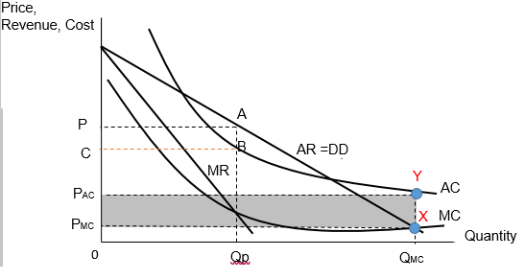
The Benefit/Advantage of MC pricing as the choice of price control is that the price can be flexibly adjusted by the government in line with the dynamic changes in revenue and costs conditions in the free market. This will ensure that P = MC condition is met, achieving allocative efficiency.

The Cost/Limitation of MC pricing is that the monopoly will now make subnormal profits P_{AC}P_{MC}XY. While its monopoly power is now mitigated, it is done so at the expense of its survival. If there is no government support, it will have to shut down. Instead of the intended Q_{MC} amount, zero output would result instead, denying consumers of any satisfaction. This is particularly of great concern if the good involved is an essential one like a transport service. To sustain this price control, government subsidy (at least the quantum of the subnormal profit) is of paramount importance.

Pro-competition policy
Explain Benefit by establishing How the Policy works:
Pro-Competition policy aim to prohibit monopolisation of a market by any firm. For example, any mergers / acquisitions of firms will have to be approved by the regulatory authority. In Singapore, the Competition & Consumer Commission Singapore (CCCS) plays this regulatory watchdog role to ensure that dominant firms do not abuse their power, at the expense of consumers. These laws prevent certain monopolistic behaviour, such as price-fixing practices (collusion) and territorial arrangements between firms in the same industry. In recent times, Grab and Uber proposal to merge was dismissed by CCCS due to the projected overbearing extent of market dominance on the ride-hailing industry.

With more competition, the AR and MR shifts left, with a higher PED value. The profit maximising output falls from Q₁ to Q_{2,} resulting in price from P₁ to P_{2. .} As a result, the gap between P₂ and MC₂ will now be smaller (as compared to the gap between P₁ and MC₁), reducing the extent of allocative inefficiency issue in society.

MR₂

Price, Revenue, Cost ($)
Q₂ Q₁

Quantity

AR₁

MR₁

MC

P₁

AR₂

MC₁
MC₂
P₂

Benefit/Advantage:
This policy directly addresses the root cause of the issue – both by curbing the power of existing monopolies or by proactively rejecting any merger request by dominant firms. The policy directly reduces the gap between P and MC. The hefty fines imposed on guilty firms as well as monetary awards given to whistle-blowers are strong deterrents.

Cost/Limitation:
However, it takes considerable amount of time for the government to investigate the lodged cases to prove that indeed the firm(s) involved are abusing market power by price-fixing, etc. The firms in question would naturally withhold crucial information (such as emails and texts), leading to further delays. A case in point is that the case of poultry (a necessity good) sellers in Singapore took 4 years of investigation before they were proven guilty and fined. Meanwhile, consumers continued to be charged a higher price which they assumed to be reflecting the prevailing market conditions. This time lag resulted in the society persistently incurring DWL.

Evaluation – which factor is of greater importance
Possible responses include:
Criterion 1: Likelihood of government failure
Price control is the preferred policy as it is a decisive policy that can be enacted almost immediately. This is especially important for a market concerning necessities. In the case of the poultry market in Singapore, the government could have considered imposing MC pricing in the short run while investigations were ongoing and then impose the Competition Act to the guilty firms in the longer term. This will better look after the interests of low income households who are currently feeling the effects of the economic disruption due to the Covid-19 pandemic.

Criterion 2: Budget constraints (apart from comparing net benefits)
Pro-competition policy is the preferred policy since it involves little expenditure. In fact, the fines collected from non-compliant firms can add on to its budget. Conversely, the government has to incur a long-term expenditure to support the regulated monopoly to ensure that it continues producing at Q_{MC} while still earning at least normal profit. Thus governments that are in a poor budgetary position would likely prefer pro-competition policy and free up the use of its budget to other pressing issues such as funding supply-side policies to reduce structural unemployment.

2 | Mask wearing aid in reducing viral transmission. A Facebook post that lists dangers of wearing face masks contains false and misleading information. The surge in demand for face masks resulted in a spike in the prices of face masks causing some governments to impose price controls on face masks.
 | (a) | Explain why governments intervene in the market for face masks. [10]
 | (b) | In light of the trade-off between efficiency and equity, discuss if imposing price controls or allowing market forces to respond to the higher demand would result in the more desirable allocation of face masks. [15]

Part (a)

Introduction

- Governments can intervene in the market for face masks for efficiency or equity reasons.
OR
- Governments can intervene in the market for face masks due to market failure arising from positive externalities and imperfect information.

Body

2 | Mask wearing aid in reducing viral transmission. A Facebook post that lists dangers of wearing face masks contains false and misleading information. The surge in demand for face masks resulted in a spike in the prices of face masks causing some governments to impose price controls on face masks.
 | (a) | Explain why governments intervene in the market for face masks. | [10]
 | (b) | In light of the trade-off between efficiency and equity, discuss if imposing price controls or allowing market forces to respond to the higher demand would result in the more desirable allocation of face masks. | [15]
Positive externalities
Figure 1
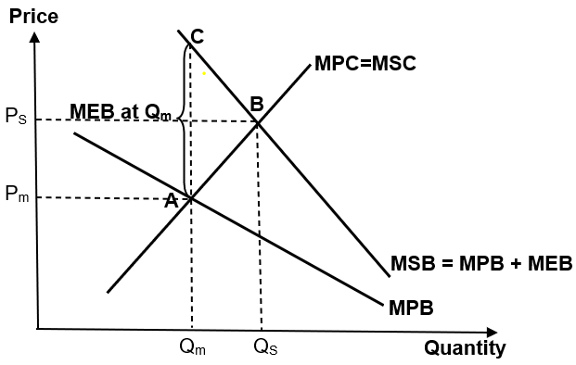

- Face mask consumption generates external benefits to third parties such as those who do not wear face masks as lowering their risks of contracting contagious diseases. As less people fall sick, other third parties like employers can also benefit from their workers being more productive and incur less medical subsidies for their staff.

- These third parties do not compensate mask consumers for the external benefits that they enjoy. Hence such external benefits are unpriced by the market and not reflected in the marginal private benefit (MPB).

- As shown in Figure 1, these external benefits cause a divergence between private and social benefits, with MSB lying above MPB as MSB = MPB + MEB.

- The socially efficient quantity of face masks is at Q_{S} where MSB = MSC, where the full costs and benefits to society are considered. However, the free market will only consider its private costs and benefits and hence the market equilibrium quantity will only be at Q_{m} where MPB = MPC.

- For the under-consumption of Q_{S} – Q_{m} units of masks, the MSB exceeds the MSC, resulting in a welfare loss of area ABC, prompting government intervention to correct this market failure.
Figure 2
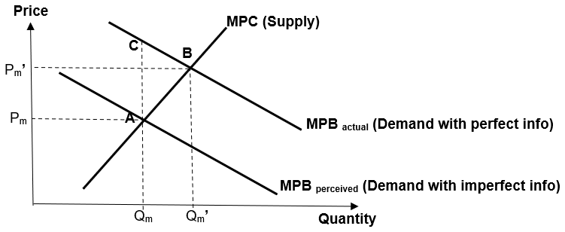
Imperfect Info

- The market can also fail due to imperfect information.

- Social media like Facebook posts can contain false information about the benefits of face masks such as that masks are not helpful in protecting one against viruses. This results in the perceived benefits of masks to be below their actual benefit as seen in Figure 2.

- (Students can also explain from a misperceived costs perspective.)

- With imperfect information, Q_{m} represents the free-market equilibrium output where MPC = MPB perceived.

- With perfect information, consumer demand is higher and Q_{m}’ represents the free-market equilibrium output where MPC = MPB actual.

- Hence for the underconsumption of quantity Q_{m}’ – Q_{m}, the MPB_{actual} exceeds the MPC, resulting in a welfare loss of area ABC, prompting government intervention to correct this market failure.

- Since at the individual level smokers do not make optimal consumption choices due to imperfect information and suffer from welfare loss, at the collective level, there is also failure in the market as the demand for masks will be lower under imperfect information than under perfect information, leading to overconsumption and welfare loss in the market as well.

Inequity
Figure 3
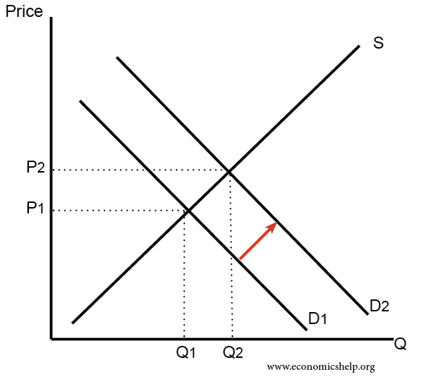

- Due to the Covid-19 pandemic worldwide, there has been a spike in the number of consumers of face masks. Since the total market demand is the horizontal sum of individual demand, this increases the total market demand from D1 to D2 shown in Figure 3 and increases the price of face masks from P1 to P2.

- The price mechanism allocates face mask to those who are willing and able to pay for them. However, face masks are likely deemed as a basic necessity during this pandemic. The spike in the price of facemasks due to the large increase in global demand can make this basic good out of reach of the lower income households. It can also lead to the hoarding of face masks by the financially more able people and may even result in lower income people who may need the masks the most being denied having this basic need. Hence societies and governments may deem the way the free market allocate the scarce face masks to be inequitable and hence intervene to ensure a more equitable distribution of face mask.

Conclusion:

In conclusion, governments may intervene in the market for face masks due to reasons such as positive externalities, imperfect information and inequity.

Part b.

Introduction

- To achieve greater equity, the government can intervene by imposing price controls in the market for face masks to ensure they are affordable, but this can result in a trade-off between equity and efficiency.

Body

Explain how price controls (price ceiling) work to achieve greater equity

Figure 4
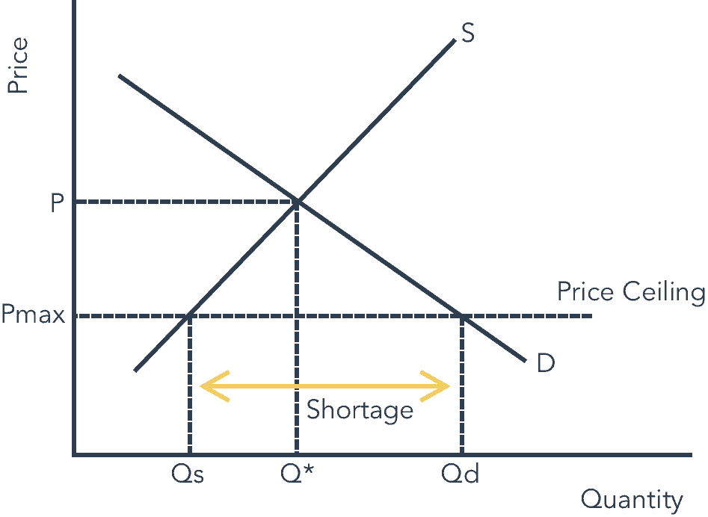
c
d
e
a
b
- Price ceiling reduces the price from P to Pmax.
- This makes masks more affordable and improves equity in the allocation of face masks.

Limitations of price controls (price ceiling) in achieving greater equity
- However, the lower prices cause quantity demanded to rise from Q* to Qd while quantity supplied falls from Q* to Qs, resulting in a shortage of Qd – Qs.

- The reduction in availability of face masks as quantity supply falls means that the face masks are affordable only to those who are fortunate enough to get their hands on them at the controlled price.

- This shortage can result in the formation of black markets where the black-market price can be even higher than the original market equilibrium price P.

- Hence the reduced availability of face masks or the problem of black markets can still result in low-income households having no access to the face masks, limiting the effectiveness of the price ceiling in achieving an equitable distribution of face masks.

Trade-off with efficiency
- Moreover, price controls distort the workings of the price mechanism and results in allocative inefficiency.
- At the original market equilibrium, consumer surplus is of area aeP while producer surplus is of area Ped.
- With the price control, consumer surplus changes to area abcP_{max} while producer surplus becomes area P_{max}cd.

- The price ceiling introduces a welfare loss of area bec, which is the area by which the total social/economic welfare (i.e. the sum of the consumer and producer surplus) has fallen by.

- Hence even if price controls can achieve a more equitable outcome, the tradeoff is that there is greater allocative inefficiency due to the welfare loss that it causes.

OR
Moreover, price controls distort the workings of the price mechanism and results in allocative inefficiency.
- The price consumers are willing to pay reflects the marginal benefit society places on the last unit of face mask available with the price ceiling in place. At quantity Qs, this is given by point b on the demand curve.
- The price producers are willing to accept reflects the marginal cost society incurs from the production of the last unit of face mask with the price ceiling in place. At quantity Qs, this is given by point c on the supply curve.
- Since point b is higher than point c, it is clear the marginal benefit exceeds the marginal cost of producing the last unit of face masks, resulting in allocative inefficiency as total social welfare could be increased by producing more face masks till quantity Q* where the marginal benefit equals the marginal cost at point e.

oR

Figure 5
E
Qm’
D
Pmax

- With the price ceiling, the market equilibrium quantity will fall further from Q_{m} to Q_{m}’. This worsens the issue of underconsumption of face masks from Qs – Q_{m} to Qs – Q_{m}’.

- Between Qm’ and Qs, the MSB of each additional unit of face masks exceeds its MSC, increasing the deadweight loss from area ABC to area DBE.

- Hence the price ceiling can worsen the market failure and result in greater allocative inefficiency.

(An equally acceptable approach can be made if student use the imperfect info diagram to show greater allocative inefficiency instead.)

Explain how market forces (of responding to the higher demand) work to achieve greater efficiency

Figure 6 (need not redraw if already shown in part a)
d

e
c
b
a

- If market forces are allowed to respond to the higher demand, the market equilibrium will change from point b to point e and increase the sum of consumer and producer surplus (i.e. economic surplus) from area abc to area dec.

- Compared to the price ceiling, the increase in equilibrium quantity from Q1 to Q2 reduces the underconsumption of face masks instead of worsening the underconsumption like the price ceiling.

- It also results in a greater economic surplus than with the price ceiling (best seen if Figure 3 is superimposed onto Figure 4), resulting in a more allocative efficient outcome.

OR
Figure 7
Qm’
P_{m}’
(= MPB’ + MEB’)
MPB’
E
D

- A higher market demand will shift the marginal private benefit from MPB to MPB’ and increase the market equilibrium quantity of face masks from Qm to Qm’, where MPB’ = MPC, & reduce the underconsumption to Qs – Qm’. Hence the welfare loss falls to area DEB, reducing the allocative inefficiency due to the positive externalities.

(Note: MEB falls too as with more wearing face masks, there will be less third parties too.)

(An equally acceptable approach can be made if student use the imperfect info diagram to show smaller allocative inefficiency instead.)

Limitations of market forces in achieving greater efficiency
- However, the extent to which greater efficiency can be achieved with market forces depends on the extent to which the demand increases to achieve the socially efficient quantity of face masks.

- If the demand is higher due to greater awareness of the benefits of masks and less imperfect information, coupled with regulations that make mask wearing a rule, it is more likely that the rise in demand will be high enough to achieve the socially efficient outcome.

Trade-off with equity
- However, the higher demand will increase the market equilibrium price and make this basic good even more unaffordable to low-income groups, worsening the inequitable distribution of face masks based on purchasing power alone.

Conclusion (Which is more desirable)

- The surge in demand and prices for face masks prompted some government to intervene with price ceilings to achieve a more equitable outcome.

- However, with the shortage and potential formation of black markets, we can see that this approach may not necessarily result in a more equitable outcome.

- Furthermore, it is clear that such price controls distort the workings of the price mechanism and introduces greater inefficiencies into the market, worsening the inefficiencies already present due to the existence of the causes of market failure like positive externalities and imperfect information.

2021 JPJC Prelim H2 P2 Question 3
A new coastal and flood protection fund, with an initial injection of $5 billion, will be set up to help protect Singapore against rising sea levels. In addition, Singapore’s healthcare expenditure will triple to about $12 billion a year, to ensure that every Singaporean has access to affordable and quality healthcare.

- Explain what needs to be considered when a government makes a rational spending decision about such projects like flood control. [10]

- Discuss whether government intervention will always lead to an efficient allocation of resources in the healthcare market. [15]

Flood control is a public good, hence there is no market and there is a need for the government to provide for the same. The reasons why Singapore government allocate funds for flood control is due to both her microeconomic and macroeconomic objectives.

The government would need to consider the benefits, costs, constraints, information required, different perspectives required and unintended consequences, when a government makes a rational spending decision.

An example of flood control is the use of a flash flood alert system, which relies on the meteorological forecast of the weather, ie, whether will there be impending heavy rainfall and rising sea levels. If there is an impending heavy downpour, a flash flood alert will broadcasted to the neighourhood near the vicinity to warn people of likely occurrence of a flash flood.

In this case, an additional person consuming or receiving the flash flood alert does not diminish the information available to the others in the vicinity. In addition, once the flash flood alert is being broadcasted to the public, it is not possible or is costly to prevent non-payers from receiving the flash flood alert. Therefore, flood protection is a public good as it has both characteristics of non-rivalry and non-excludability.

The characteristic of non-rivalry in consumption shows that the marginal cost of provision of public goods to an additional user is zero. This is because once the flash flood alert system is set up; the government does not incur extra cost in providing one additional person with the broadcast information. When a public good is provided to one person, it is provided to all.

Due to the characteristic of non-excludability in consumption of public goods, this leads to the problem of free ridership here where individuals do not want to reflect their wants in the market system. Hence leading to zero production resulting in complete market failure.

The benefits of a government intervention in flood control would be to correct the complete market failure as mentioned above. In addition, the said project would safeguard lives, property and livelihood as it would prevent enormous economic losses.

Other than the flash flood alert system, there are also plans to build sea walls, widen and deepen canals. Such engineering feats will definitely be costly and will cause a dent in the nation’s coffers. The $5billion coastal and flood protection fund mentioned in the preamble is only an initial injection and the fund will be topped up subsequently whenever Singapore’s fiscal situation allows. It is estimated that $100 billion or more may be needed over 100 years to protect Singapore, her citizens’ livelihood and quality of life against rising sea levels caused by climate change.

There may be fiscal constraints in terms of funds availability where the topping up of flood protection fund is ultimately dependent on Singapore’s fiscal situation. Further, the current economic catastrophe due to Covid-19 may have drained Singapore’s national reserves substantially. Hence, due to limited funds, the Singapore government may need to make tough decisions in identifying her salient areas of needs and placed that as her economic priority. Such spending on flood control would incur opportunity cost given that funds are limited, needless to say the next best alternative will be forgone. Hence, if the government was to go ahead with the provision of flood control, spending on other areas such as the education sector will be forgone. Such a sacrifice may have serious implications on the quality of workforce, bringing about unintended consequences on productivity of workforce and hindering potential growth.

The amount of funds required by the Singapore government to intervene in this market depends on the seriousness of climate change issues and cost requirements of various infrastructure needs. Hence, the government would need to gather information on the scale of this problem and make necessary provision for provision of various flood control projects. The government would also need to gather different perspectives before making the decision on how much funds to devote to such a project. The government may seek the advice of geologists, consult the help from overseas experts on this matter and also the views of businesses and citizens. Further, the current estimate on infrastructure needs may also change overtime due to the scale of destruction by the volatile climate change.

In the context of healthcare market, there exists imperfect information and positive externalities that warrant government intervention. The government intervenes through public education and subsidy to address these root causes of market failure, resulting in an efficient allocation of resources.

This is on the assumption that the government is able to accurately estimate the extent of market failure and hence provide the optimal degree of intervention.

Referring to the Figure 1 below, the marginal private benefit (MPB) to an individual would be a better physical and mental health state for each additional unit of healthcare consumed. On the other hand, the marginal private cost (MPC) would be his healthcare costs incurred in visiting the doctor or medication fees for each additional unit of healthcare consumed.

Individuals may not be able to value their private benefits correctly due to a lack of knowledge and thus undervalue the private benefits of consuming them. For example, consumers may put off health screening as they are not aware of the full extent of benefits such as early detection which will increase the chances of recovery and reduce the cost of treatment. Thus their MPB_{perceived} is less than the MPB_{actual}. Consumers will consume healthcare up to the point, Q_{p} where their MPB_{perceived} is equal to MPC. However the consumer optimal level with perfect knowledge is at Q_{p1} where MPB_{actual} is equal to MPC. This leads to under-consumption, resulting in welfare loss equivalent to area abc.

0
Costs / Benefits ($)
a
b
c
MSC=MPC
MPB_{actual}
Quantity of healthcare
Q_{p1}
MPB_{perceived}
Q_{p}

Figure 1

Positive externalities are benefits to third parties who are not directly involved in the production or consumption of the good. It is not reflected in the price of the good and the third parties do not need to pay for it. The existence of positive externalities in the consumption of healthcare also leads to market failure. Positive externalities include reducing the chances of 3rd parties falling sick from contacting the diseases from a sick worker and the increase in productivity of the workforce due to healthier individuals, leading to higher economic growth. Referring to the Figure 2 below, due to the presence of positive externality, which is shown by the marginal external benefit (MEB) at a particular level of consumption, marginal social benefit (MSB) will be greater than marginal private benefit (MPB), i.e. MSB>MPB. There is a divergence between MPB and MSB. This means that the benefits of consumption to society include not just the benefits to the consumer but also the benefits to others enjoying the positive spillover effects, shown as MEB. Assuming that MPC=MSC. Since consumers will only consider their private benefit and cost while ignoring the benefits to third parties, he will consume until the level Q_{p1} where MPB=MPC. However, the socially optimum level of consumption occurs at Qs where MSC=MSB. Since Q _{p1} is less than Qs, it means that the price mechanism on its own cannot achieve an efficient allocation of resources. There is an under-consumption of the good. Between Q_{p1} and Qs, the social benefit of an additional unit of healthcare consumed is higher than the social cost resulting in welfare loss equivalent to area def. Market failure is deemed to have occurred due to the under consumption of healthcare and government intervention is required to ensure that Qs amount of healthcare is consumed.

MSB = MPB + MEB
0
Costs / Benefits ($)
d
e
f
MSC=MPC
MPB
Quantity of healthcare
Q_{s}
Q_{p1}

Figure 2

Through public education, consumers will be more aware about the true benefits of healthcare and will increase their demand for healthcare services. This will lead to an increase of MPBperceived to MPBactual as seen in Figure 3 below, where consumption of healthcare increases from Qp to Qa, tackling market failure due to imperfect information.
0
Costs / Benefits ($)
a
b
c
MSC=MPC
MPB_{actual}
Quantity of healthcare
Q_{p1}
MPB_{perceived}
Q_{p}

Figure 3

Assuming that the government provides a subsidy per unit amount, which is equivalent to the MEB at Qs, the government aims to lower the cost of producing healthcare. Hence, supply of health care services rises in the market, which leads to lower prices of health care. In view of the lower prices of health care, the private costs incurred by consumers will fall and this is reflected in Figure 4 below. MPC shifts to MPC¹ that causes the equilibrium output to increase to the socially efficient level Q_{s}.

MSB = MPB + MEB
0
Costs / Benefits ($)
d
e
f
MSC=MPC
MPB
Quantity of healthcare
Q_{s}
Q_{p1}

MPC¹

Figure 4

The government’s subsidy for healthcare may not result in allocative efficiency if there is government failure – the government might over or under-estimate the amount of subsidy to provide, thereby not achieving the social optimum output level. In addition, the government incur high costs when they spend on public education and providing subsidies, leading to opportunity cost due to limited funds. This may result in spending on the education sector forgone. Further, the use of public education is highly dependent on the receptiveness of consumers.

There may also be government failure as well in terms of bureaucracy, and lack of public support for government policies. Although the socially optimal level of output may not be attained due to limitations of implementing measures, government intervention usually ensures a better allocation of resources and results in an output level that is closer to the socially optimal level.

To conclude, government intervention will always lead to efficient allocation of resources if their policies are able to address the various root causes of market failure in the healthcare market. In addition, the government is able to estimate the extent of market failure accurately, and hence provide the optimal degree of intervention.

2 | Imperfect information can lead to overestimation or underestimation of benefits and costs.
(a) Using real-world examples, explain three ways resources may be allocated inefficiently due to imperfect information. [10]

Introduction
- When resources are allocated inefficiently in markets, we say that market failure has occurred and this can be caused by imperfect information, where benefits or costs are over- or under-estimated.
- These will be explored from a consumer’s perspective and we will be looking markets such as those where there are heavy advertisements, vaccinations, education and cigarettes.
- In this essay, to simplify the analysis to focus on imperfect information, we will make the assumption that their no positive or negative externalities in the markets to be analysed.

In the answer below, we present four key arguments but three would suffice. Students who have explained asymmetric information will also be credited, but take note that such answers could have taken better reference to the preamble.

Key Argument 1: An overestimation of benefits due to advertisements can lead to overconsumption and allocative inefficiency
- In markets where there are heavy use of advertisements, e.g. for luxury brands, consumers may over-estimate the benefits of buying these goods, as they over-estimate the benefits that it brings to their social standing or general well-being.
- When left to the free market, this creates a divergence between the actual benefits (MPB_{ACTUAL} such as durability and functionality) and the perceived benefits (MPB_{PERCEIVED}) of the good.
- As seen in Figure 1, when making a decision of how much to consume, consumers only consider their perceived private benefits and private costs (e.g. the costs of the luxury bag) and may end up over consuming the good at Q_{p} (where MPC = MPB_{PERCEIVED}) instead of Q_{s} (where MSC = MSB = MPB_{ACTUAL}).
- This would lead to a deadweight loss of area abc and hence allocative inefficiency.
Information
gap
Price, Benefit, Cost
Quantity
MSC=MPC
0
MPB_{PERCEIVED}
Qp
MSB = MPB_{ACTUAL}

Qs
a
c
b
Figure 1 – overconsumption due to overestimation of benefits

Key Argument 2: An overestimation of costs in markets such as vaccinations and surgery can lead to under-consumption and allocative inefficiency
- In markets such as vaccinations, consumers may over-estimate the costs in terms of their chances of side-effects or the pain of injections.
- When left to the free market, this creates a divergence between MPC_{ACTUAL} (the actual costs) and MPC_{PERCEIVED} (the perceived costs).
- When making a decision of how much to consume, consumers only consider their private benefits (safety from disease) and perceived private costs and may end up under-consuming the good at Q_{p} (where MPC_{PERCEIVED} = MPB) instead of Q_{s} (where MSB = MSC = MPC_{ACTUAL}).
- This would lead to a deadweight loss of area abc and hence allocative inefficiency.
Information
gap
Price, Benefit, Cost
Quantity
MSC = MPC_{ACTUAL}
0
MPC_{PERCEIVED}
Qp
MSB = MPB

Qs
a
c
b
Figure 2 – underconsumption due to overestimation of costs
Key Argument 3: An underestimation of benefits in markets such as education can lead to underconsumption and allocative inefficiency
- In markets such as education, consumers may under-estimate the benefits of education in terms of the increased future income or the joy of the learning process.
- When left to the free market, this creates a divergence between MPB_{ACTUAL} and the MPB_{PERCEIVED} of the good.
- When making a decision of how much to consume, consumers only consider their perceived private benefits and private costs (e.g. school fees) and may end up under-consuming the good at Q_{p} (where MPC = MPB_{PERCEIVED}) instead of Q_{s} (where MSC = MSB = MPB_{ACTUAL}).
- This would lead to a deadweight loss of area abc and hence allocative inefficiency
Info
gap
Price, Benefit, Cost
Quantity
MSC=MPC
0
MPB_{PERCEIVED}
Qp
MSB = MPB_{ACTUAL}

Qs
a
c
b
Figure 3 – underconsumption due to underestimation of benefits
Key Argument 4: An underestimation of costs in markets such as cigarettes can lead to overconsumption and allocative inefficiency
- In markets such as cigarettes, consumers may under-estimate the costs in terms of the chances of getting lung diseases.
- When left to the free market, this creates a divergence between MPC_{ACTUAL} and MPC_{PERCEIVED}.
- When making a decision of how much to consume, consumers only consider their private benefits (‘high’ from smoking) and perceived private costs (monetary cost of the cigarettes) and may end up over-consuming the good at Q_{p} (where MPC_{PERCEIVED} = MPB) instead of Q_{s} (where MSB = MSC = MPC_{ACTUAL}).
- This would lead to a deadweight loss of area abc and hence allocative inefficiency
Information
gap
Price, Benefit, Cost
Quantity
MSC = MPC_{ACTUAL}
0
MPC_{PERCEIVED}
Qp
MSB = MPB

Qs
a
c
b
Figure 4 – overconsumption due to underestimation of costs

Essay discussion 1
All countries are providing Covid-19 vaccines for free, and some advanced countries have supported patent waivers. Critics warned that lack of research and healthcare infrastructures will remain a challenge, along with growing public hesitancy towards vaccination in developing countries.

- Explain the economic case for free provision of vaccines in developing countries. [10]
b) Discuss whether free provision is the best way to achieve an efficient allocation of vaccines in developing countries. (15)

Essay discussion 2

 | (a) | Explain why labour immobility is a source of market failure and how it may worsen.(10)
 | (b) | Discuss whether labour immobility rather than other sources of market failure is the main reason for government intervention in markets. (15)

Essay Discussion 3

In the recent budget, the Singapore Government announced that it will set up a flood protection fund with an initial injection of $5b. In addition, it will also top up SkillsFuture credits for mid-career workers to upgrade their skills.

Assess the reasons for Singapore government to allocate funds for flood protection and skills upgrading.[25]

Essay Discussion 4
The Singapore Ministry of Education (MOE) has set up a new task force in the midst of an ongoing debate on social equality and the role played by schools in closing the socioeconomic gap. MOE is stepping up its provision of more MOE kindergartens to provide more affordable and quality early childhood services as research shows early intervention is crucial for a good start in life.

Source: Adapted from The Straits Times, 21 December 2018

  - Explain why markets might fail in the case of public goods and where information is imperfect. [10]
  - Discuss the factors that the Singapore government should consider in their decision to increase their intervention in the education market. [15]
Essay Discussion 5
- In situations of public goods or where there is consumer ignorance, reliance on price signals alone will not lead to an optimal allocation of resources.
  - With the use of appropriate examples, explain why this may be the case. [10]

  - Discuss the considerations a government may have when deciding how to intervene in such situations.[15]

