Question 2: Economic Development of Vietnam

Extract 5: Vietnam's Economic Outlook

The Vietnamese economy maintained robust growth of 8.5% in 2007. Accession to the World Trade Organisation in January 2007 and a surge in Foreign Direct Investment inflows highlighted an impressive course of economic reforms as the economy continues its transition to a market-based economy.

These reforms have led to strong economic performance - an average of 7.5% annual growth over the past decade, one of the fastest rates in Asia. Consumption, boosted by wage increases and remittances inflows, also continued to grow strongly. Strong growth spurred a surge in imports, resulting in a sharp widening of trade and current account deficits in 2007.

Source: Asia Development Outlook, Vietnam

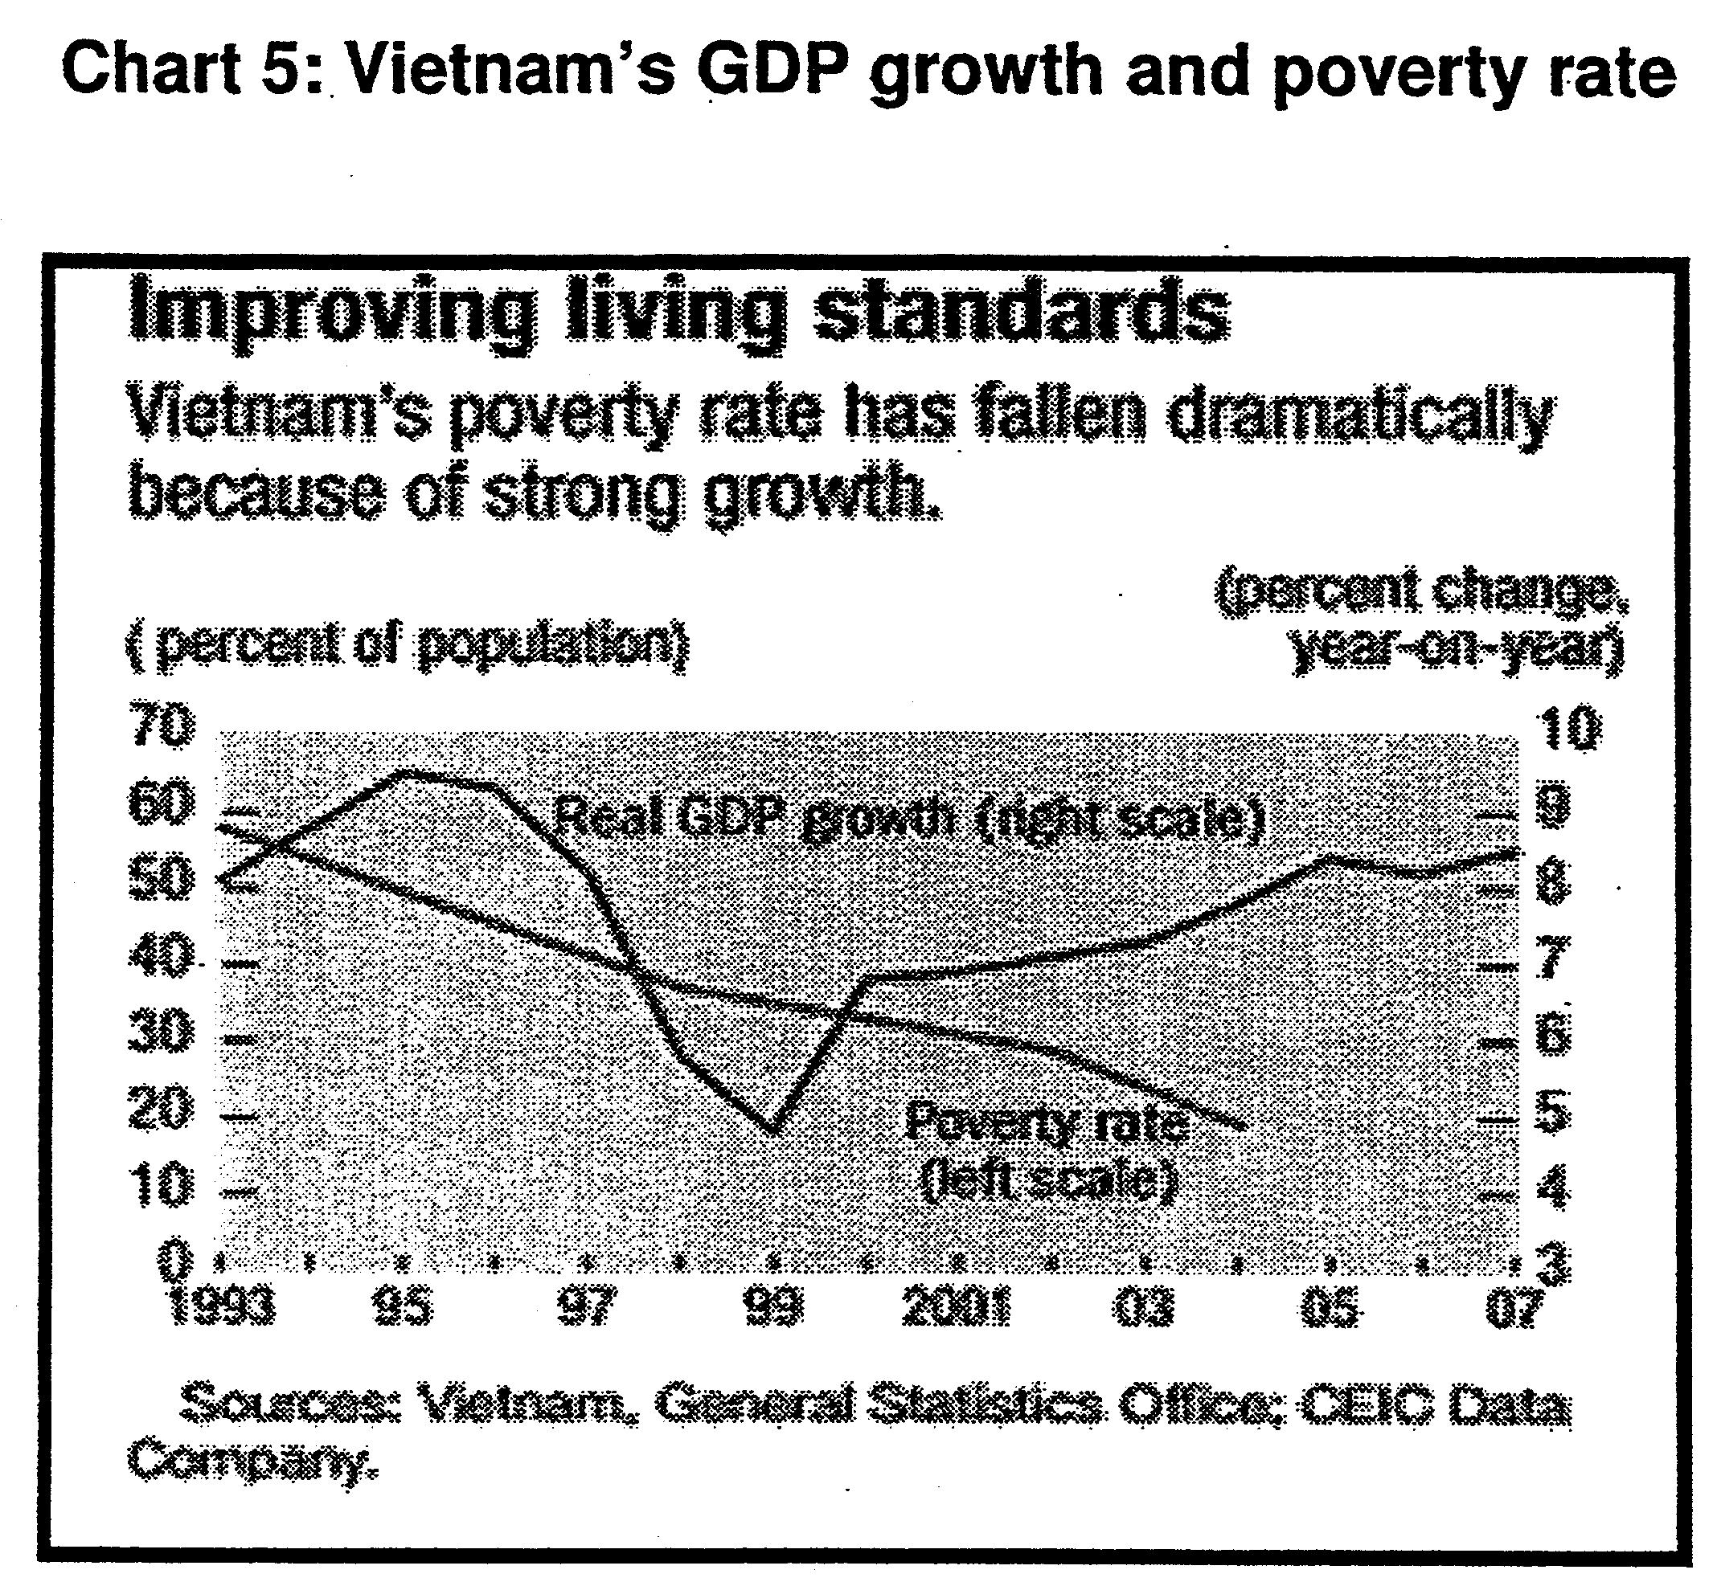

Extract 6: Less haste, more quality investment

Vietnam's rapid growth has been marked more by massive rather than efficient investment. For many developing countries, just managing to accomplish the targets set in their five-year development plans is a matter of satisfaction. Not for Vietnam.

A country in haste, Vietnam aims to achieve middle-income country status by 2010 and cut its poverty level to under 10 per cent. These are ambitious targets for a country whose serious economic development took effect, in a real sense, only in the 1990s.

In 1993, nearly three out of five Vietnamese were living below the poverty line and nearly all of the country's infrastructure was heavily damaged. Today, poverty rate has dropped from 58 to 15 per cent. Vietnam's nominally socialist economy has acknowledged and encouraged the rise of the private sector. That sector has been creating new jobs for more than 90 per cent of the 1.6 million entrants to the labour market each year.

Another key reason for its success is the country's determined emphasis on a high level of investment, especially in physical infrastructure. During its fifth five-year plan (2001-2005), Vietnam's total investment stood at 37.5 per cent of its GDP. It aims to raise this ratio to 40 per cent during the ongoing sixth five- year plan (2006-2010). The only country in the region with a higher investment rate is China.

But despite all the positive developments, Vietnam's challenges in the coming years are going to be many and complex.

Continuing to rely on increased investment for higher growth will have a limit. Merely increasing investment quantity may not deliver the expected result for several reasons:

Vietnam has performed well in terms of investment quantity but less so in terms of quality. A 2004 World Bank study covering 23 countries placed Vietnam in third position in terms of investment rate but 17th in terms of investment quality.

In addition, future FDI commitments may be contingent upon Vietnam's ability to undertake more reforms and provide efficient infrastructure support and competitive skilled human resources.

In view of these factors, it is only prudent that focus be given to not just raising the quantity of investment but, more importantly, to enhancing its efficiency and productivity. It is time for Vietnam to shift from input-driven growth to efficiency-led growth.

Source: The Straits Time, 28 February 2008

a) Based on the extracts given, assess the advantages and disadvantages of Vietnam's transition towards a market-based economy. [8]

A market-based economy relies more on market forces of demand and supply (price mechanism) to allocate scarce resources. This economic system also allows more private ownership of resources and this leads to greater competition and more incentives of individuals such as workers and firms to be efficient in order to reap higher income and profits.

Benefits of such a move towards a market-based economy:
-high rates of economic growth for the last decades since Vietnam opened up its economy; one of the highest rates of EG in Asia ( extract 5). (7.5% of annual growth over the past decade) – higher level of standard of living – increase in real GDP will raise real GDP per capita (poverty level is decreasing)

These high rates of EG is due to the greater dependence on the private sector, especially foreign firms, to generate more income and growth for the economy. With more private ownership of resources, there are greater incentives for workers and firms to increase efficiency in order to earn greater income and profits. In addition, greater reliance on the price mechanism also results in more efficient allocation of resources. Hence, Vietnam is able to achieve greater economic growth compared to other economies around the region.

-The increased in reliance on the price mechanism and private sector to determine how resources are "allocated to attract more foreign investments in the country. This increase in foreign investment is an important factor to generate more jobs in the economy (Ext 5 mentioned that 90% of the jobs were generated by the private sector). With more jobs generated, the citizens experience a higher standard of living. (increase in GDP per capita)

-higher growth and an increase in real GNP also reduce the poverty rate as shown in Chart 3. As national income increases, more resources and funds are available to help the poorer sector of the economy. Also, with the jobs generated by trade and foreign investments, more job opportunities for the labour force in the economy. Higher growth also means the government has more funds available to give more assistance to the low income group. Hence, there is a sharp decline in the poverty rate from 58% in 1993 to 15% in 2007.

Disadvantages
However, the move towards a market-based economy may also bring about negative impact such as the worsening of income gap between the rich and the poor. As Vietnam becomes part of the global economy, she will also experience the adverse impact of globalization. For example, the lowly skilled and educated in the workforce experience a slower growth in their income compared to those who are more productive and possess skills needed in the globalised economy.

The lack of experiences in the management of a market economy also can be seen from its failure to have a high rate of efficient utilization of investment, leading to the situation whereby ‘Vietnam has performed well in terms of investment quantity but less so in terms of quality’. ( a form of market failures – rise in inefficiency in the economy).

The Vietnamese economy benefitted greatly from the move towards a more market-based economy and free trade. Vietnam experienced high economic growth of 7.5% for the last decade and her citizens SOL have improved with a reduction in poverty rate. Thus, moving towards a market-based economy is the right choice for Vietnam if she wants to continue with her economic success. However, the govt must also intervene to ensure that the negative impact of a free market is minimized.

