Question 1: India’s Troubles

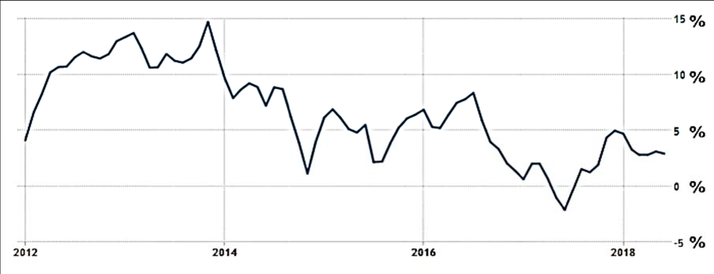
Figure 1: Food price changes in India
Source: Trading Economics, accessed 26 July 2018

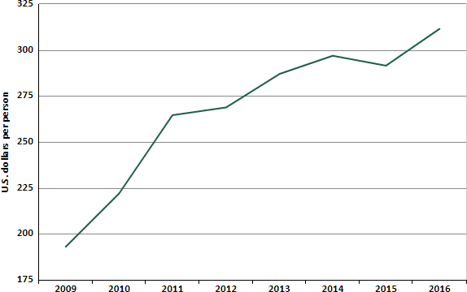
Figure 2: India’s food expenditure (USD per capita)
Source: Knoema, accessed 7 August 2018

Extract 1: Rising food prices to hit rural India

India’s villages will face a sharp spike in food prices in 2016, as a second year of drought drives up the cost of ingredients such as sugar and milk, and poor transport infrastructure stops falling global prices from reaching rural areas.

Prices of vegetables like onions, tomatoes and potatoes have already been rising, with some staples up as much as 20 percent in a month. Palm oil prices have also climbed in the last two months, while milk prices have risen by 10 percent. Food accounts for more than 50 per cent of rural consumer price inflation in India, compared with a third of urban inflation, while categories like fuel, which has seen a considerable price drop, has a much smaller impact in rural areas, where families use firewood or biogas from manure.

Source: Reuters, 10 November 2015

Extract 2: Rising food prices push India’s December retail to 17-month high

Rising food prices pushed India’s retail inflation to a 17-month high in December, breaching the central bank’s medium-term target for the second straight month, which could intensify pressure for it to raise interest rates in the next few months.

India’s measure of consumer price inflation, the CPI index, rose 5.21 percent in December from a year earlier, against a backdrop of faster economic growth, the Ministry of Statistics said on Friday. Annual retail food inflation rose 4.96 percent in December from 4.35 percent in the previous month.

The Reserve Bank of India (RBI) held its interest rate steady at 6.0 percent last month and said all possibilities were on the table, depending on how price pressures and growth panned out. The RBI, which has a medium-term inflation target of 4 percent, has raised its inflation estimate to 4.7 percent for the six months through to March 2018. But some analysts feel inflation could overshoot its estimates, forcing the central bank to change its policy stance.

Analysts said any sharp rise in government spending in the budget that fuels inflation could force the central bank to raise rates earlier than expected. The world’s seventh largest economy is expected to grow at 6.5 percent in the current fiscal year ending in March but a continued rise in inflation has alarmed policymakers in New Delhi. To make matter worse, crude prices have rallied, sending Brent crude above $70 a barrel on Thursday for the first time since December 2014, which is a worry since India imports most of its energy needs.

Source: Reuters, 12th Jan 2018

Extract 3: Pollution in India

A recent report from the World Health Organization (WHO), drawing on measurements and calculations as of 2016 from air monitoring stations in 4,300 cities, establishes clearly that air pollution is a global problem. A whopping nine in ten people on Earth breathe highly polluted air, and more than 80 percent of urban dwellers have to endure outdoor pollution that exceeds health standards, according to the WHO’s World Global Ambient Air Quality Database.

But there are certain places on the planet where the air is now consistently, epically terrible. India, for instance, is home to 11 of the 12 cities with the highest levels of particulate pollution.

Two-thirds of India’s population lives outside of cities, and 80 percent of these households rely on biomass like wood and dung for energy needs. The smoke released from these activities then waft over major cities such as Chennai and Mumbai, where it mixes with traffic exhaust, factory emissions, and construction dust. India’s hills and mountains also act as basins that trap such toxic air over the country, leaving few areas in the country where Indians can breathe easy.

An emergency air-quality warning system was created in 2016 to warn citizens residing in the capital territory of Delhi of hazardous levels of air pollution. Delhi residents would receive an alert, warning them that air quality index (AQI) readings were breaching danger levels and that they ought to safeguard their health.

Source: adapted from Vox, 9th June 2018

Extract 4: India to clean up its air

According to Veerabhadran Ramanathan, professor of Atmospheric and Climate Sciences at Scripps Institution of Oceanography at University of California, there are three main solutions that can have maximum impact on air pollution in India. One, cleaner sources of energy need to be subsidised, two, pollution rights need to be issued and three, banning open burning of fossil fuels and biomass. It may take a long time but Ramanathan thinks that this would greatly reduce the air pollution in India, if done correctly.

Source: Adapted from World Health Organisation, 7th July 2016

Extract 5: Singapore not on track to achieve WHO targets

Singapore is not on track to achieve its air quality targets by 2020 which are benchmarked against the guidelines set by the World Health Organization (WHO). According to figures from the Ministry of the Environment and Water Resources (MEWR), in the past two years, Singapore fell short in meeting its targets for pollutants such as fine particulate matter (PM2.5), particulate matter (PM10) and ozone. Industries, power stations, and motor vehicles are the main sources of air pollution. However, these are essential functions we cannot forego. Speaking at a pre-Budget focus group discussion, Minister for the Environment and Water Resources, Mr Masagos Zulkifli, said Singapore is committed to finding ways to address air pollution.

To ensure good air quality, Singapore sets emission standards which have been progressively tightened over the years. Before industries are allowed to operate in Singapore, they are screened to ensure that they do not pose un-manageable pollution problems and health and safety hazards. In addition, they have to incorporate pollution control measures to comply with the National Environment Agency’s (NEA) air emissions standards and regulations. All new vehicles in Singapore have to meet minimum emission standards while existing vehicles on the road are required to undergo regular inspections to ensure that they do not emit excessive smoke.

The carbon tax is an important step to sustain Singapore’s clean, green and liveable environment. The Minister for Finance announced at Budget 2017 plans to introduce a carbon tax from 2019. The tax will be applied on facilities that emit 25,000 tCO₂e or more of greenhouse gas (GHG) emissions annually. To give the industry more time to adjust and implement energy efficiency projects, the tax will start at $5/tCO₂e in the first instance, from 2019 to 2023. The first payment of the carbon tax will be in 2020, based on emissions in calendar year 2019.

Source: www.channelnewsasia.com, 26 January 2017 & National Climate Change
Secretariat, 19 February 2018

Questions

- (i) Describe the trend in India’s food prices from 2012 to 2018. [2]

  - What might Figure 1 and 2 suggest about the price elasticity of
demand for food in India? [3]

- With the aid of a diagram, explain and comment on how a food subsidy might
affect the consumers, producers and the government in India. [8]

- In the light of rising inflationary pressure, discuss whether the Indian government should raise interest rates. [10]

- (i) Explain how the activities mentioned in Extract 3 results in market
failure. [6]

  - Clearly explain why, if left to market forces, “air quality warning services” will not be provided. [4]

- Using evidence from the case study and your own knowledge, discuss whether the Indian government should adopt Singapore’s policies to improve
air quality. [12]

[45 marks]

