Market structure II (GCE A Level 2021 Q3)
- Explain why Singapore’s telco market might be considered to be an oligopoly and how economic theory suggests this market structure would affect the firms pricing and output decisions
- Discuss how government intervention in Singapore’s telco market could protect
consumers, and consider the extent to which such intervention will be successful.

The telco industry is often occupied by a few large firms and is considered to operate as an oligopolistic market structure due to the special nature of the firms and their pursuit of profit maximisation. Their price and output decisions are influenced in certain ways unique to oligopolies.

In the oligopolistic form of market structure, there is imperfect market information and immobility of factors of production. There are a few firms, and the product is differentiated or homogeneous. The firms have strong market power as they can create barriers to entry, making them price setters, though they are mutually interdependent.

Singapore’s telco market is considered as oligopolistic as it is dominated by four firms, with the market concentration ratio reaching 94%, selling slightly differentiated telco services. The telco industry in Singapore also set strong barriers to entry due to the existence of technological barriers, the need for huge capital investments, as well as licensing requirements. This will allow the firms in this industry to have few firms as it is not easy to set up business in this industry. As such, Singapore's telco industry is oligopolistic. Lastly, the product is homogenous as they are serving one single function but the product is differentiated in different bundled package to the consumers.

Oligopolies decide their price based on the profit maximising level of output, where MR=MC. If the MR exceeds MC, there will be net profit gain, incentivising the firms to increase output. If the MR is lower than the MC, there is net profit loss. Incentivising firms to decrease output. As the firms have downward-sloping curve as there is imperfect market information, allowing the firm to set price and shaping the curve to be downward-sloping.

When there is price collusion among the telco firms, their MR and AR curve will be downward sloping from the left to right as it can exercise as a price setter due to the market power gained from collusion. The firms will follow the prices set by the market leader and thus avoid price competition to maintain the market power. The firms are willing to abide to price collusion as it reduces market unpredictability to raise their market power and raise price. This will allow the firms to raise their profit level as they abide to the price set by the price leader.
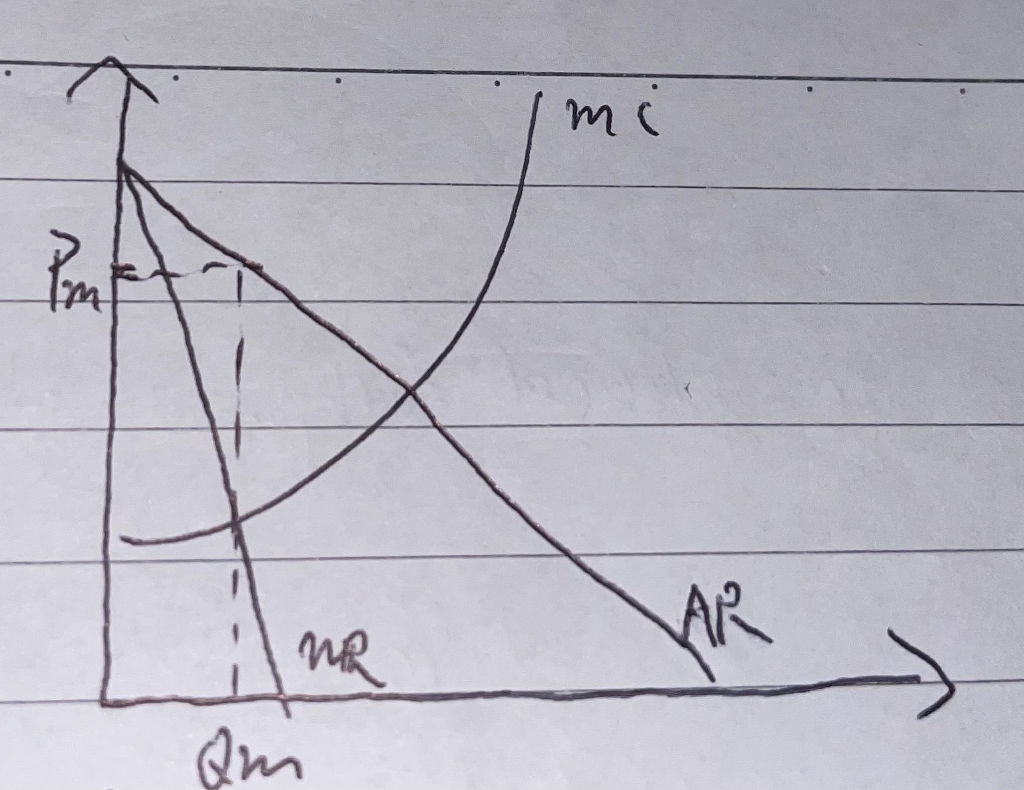

As seen from the diagram, the profit maximisation level of output is at Qm, where MR=MC, the price, Pm, is then determined based on output Qm, given that the MR and AR is downward-sloping and has become price inelastic while the M is rising upward.

However, for non-collusive oligopolistic firms, they behave differently. If one firm increases price, other firms will not increase their price as the rival firms can gain greater market share, when consumers switch consumption to them. This will lead to a fall in quantity demanded for the firm which increases price since the degree of substitution is large, contributing to a price elastic portion of the demand curve. However, when the firm decreases the price, the rival firms will quickly follow suit as they will lose out if consumers switch demand away from them. This will lead to less degree of substitution, contributing to a price inelastic portion of the demand curve. This also implies that there is price rigidity as the firm is unlikely to change price as there is little to gain from price changes. This reflects mutual interdependence among the oligopolistic telco firms, leading to the development of a kinked demand curve.

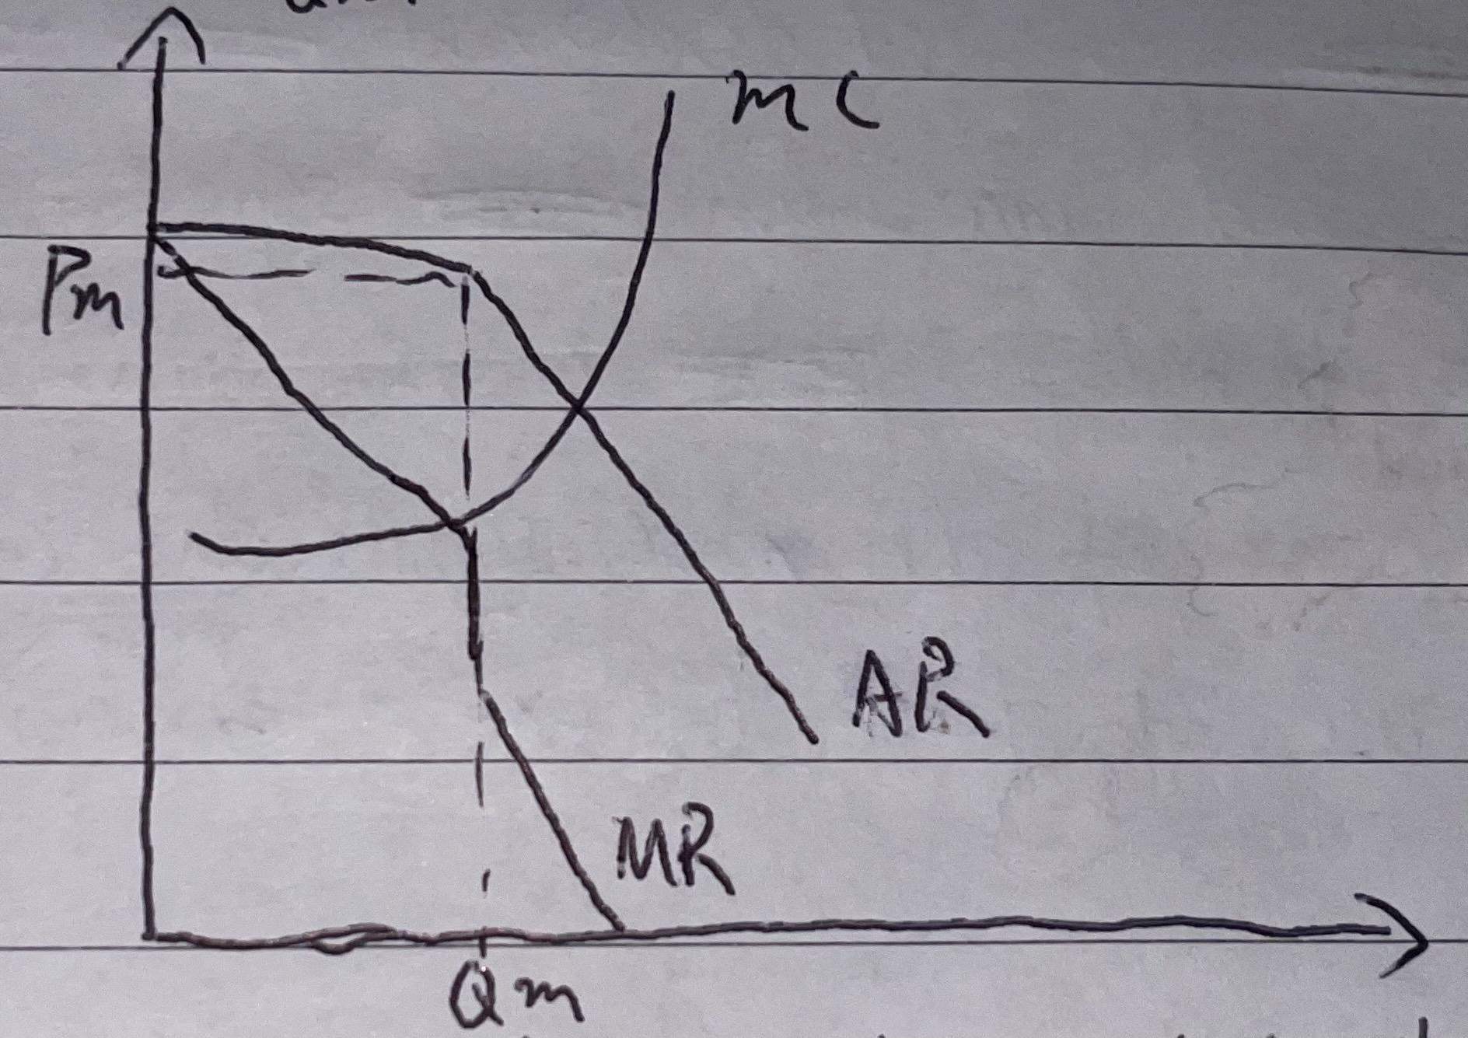

As seen from the diagram, the MR and AR are kinked with the portion being price elastic when prices increase and portion being price inelastic when price decreases. The production equilibrium, or the profit maximising level of output is set at Qm, where MR=MC, while the price is determined at Pm.

In conclusion, the key determinant of how oligopolistic firms make price and output decisions is firstly the nature of their operation, whether they are collusive or non-collusive. For the non-collusive firms, their mutual interdependence which gives rise to quick reactionary behaviours to price competition determined a stable, market-oriented price despite their strong market power. However, the firms abide to profit maximization regardless whether they are experiencing price rigidity and price collusion.

