CSQ 2010 MAQn 1C - National Income Indicators (SOL)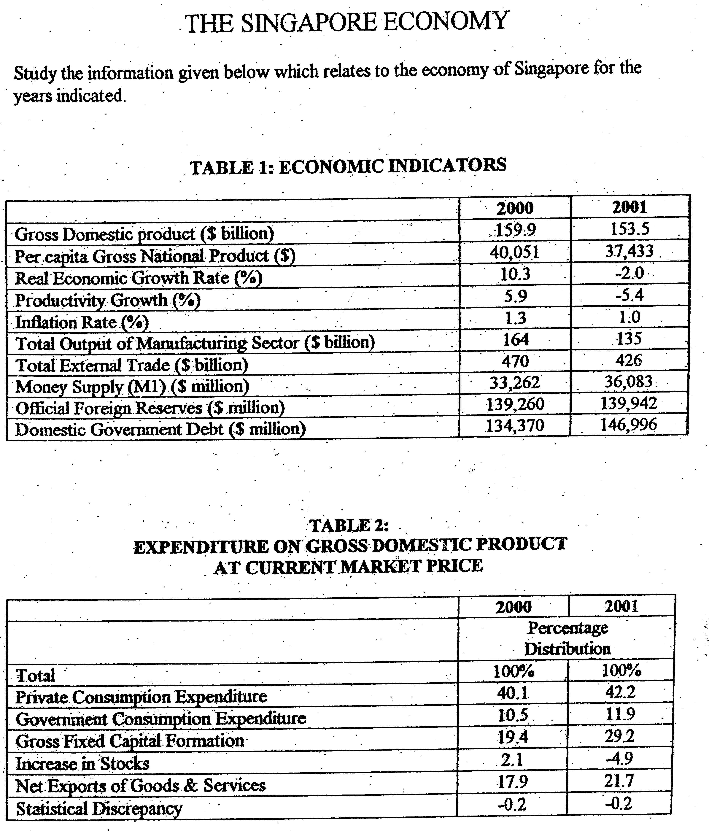

- GDP + Net property income from abroad (NPIA )= GNP
For SG, NPIA is negative, GNP will be less than GDP.
- Nominal GDP growth rate = Real GDP growth rate + inflation rate
- Total external trade = Import expenditure + export revenue
Total trade is 5 times GDP – implies that trade is significant to GDP growth

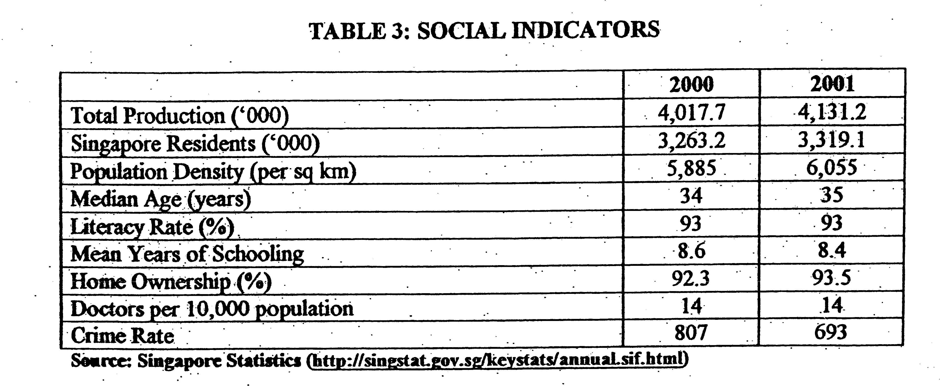

HDI – progress of the well-being of the individuals – literacy rate, mean years of schooling, crime rate, median age

MEW (measurement of economic welfare) – doctors per 10000 population, home ownership
Answer all questions

(a) (ii) How would you explain the change in productivity rate in 2001? [2]

(b) (i) Define Gross Domestic Product. [1]

(ii)With reference to Table 1, explain why the value of external trade is higher than the value of Gross Domestic Product for Singapore. [3]

(c) (i) Calculate the level of private consumption expenditure in 2000. [1]

(ii) Explain the change in Gross Domestic Product in Table 1 with the change in the level of private consumption expenditure in Table 2. [3]

(iii) Explain whether a change in consumption expenditure is sufficient to determine the economic well -being of the advantage Singaporeans? [5]

(d) What evidence is there that the government of Singapore may have adopted an expansionary fiscal policy in 2001 and comment on the effectiveness of such a policy in Singapore. [6]

[Total marks: 20]

Suggested Answers

(a) (ii) How would you explain the change in productivity rate in 2001? [2]
(change in total product / change in labour)
As seen from the diagram, the total Output of Manufacturing sector has fallen from $164 billion to $135 billion, indicating a fall in the total production. This fall can be attributed to the fall in gross fixed capital formation (fall in investment) , contributing to a fall in the production capacity. At the same time, the fall in external trade will lead to a reduction in external demand and import of resources, leading to a fall in production capacity. Besides this, the production efficiency of labour can also contribute to a fall in production capacity as result of lack of training skills and inefficient production process.

(b) (i) Define Gross Domestic Product. [1]

Gross Domestic Product is defined as the total monetary value of goods and services produced by all factors of production within a country, expressed at base year price level before discounting for inflation.

Real GDP – after discounting for inflation

(ii)With reference to Table 1, explain why the value of external trade is higher than the value of Gross Domestic Product for Singapore. [3]

Singapore relies greatly on the external trade for its import of resources and export of goods. Therefore, part of the external trade, which consists of imports are used as inputs for its production of goods for external demand. As the export demands are high-valued production, the export expenditure will have a large value. Secondly, as Singapore relies extensively on imports for most of its raw materials and consumption and capital goods, a large part of the external trade is for her own consumption. The rise in cost of resource will raise the value of import expenditures. Thirdly, entre-port trade also contributes to a high value of external trade whereby part of the external trade is due to import of goods from Europe and America and re-export to regional countries.

In recent years, the focus on high-valued production will raise our value of exports and this will mean that the total external trade to GDP ratio will be higher.

(c) (i) Calculate the level of private consumption expenditure in 2000. [1]

40.1% X 159.9 = $64.12 billion

(ii) Explain the change in Gross Domestic Product in Table 1 with the change in the level of private consumption expenditure in Table 2. [3]

why national income will lead to rise in consumption.

It can be seen that there is an increase in the percentage distribution of private consumption expenditure of 40.1% to 42.2% from 2000 to 2001. Though Gross Domestic Product has decreased from $159.9 to $153.5 billion, the private consumption expenditure has increased from $64.12 billion to $64.78 billion in absolute value. The fall in national income may still lead to an increase in consumption in 2001 as a result of the accelerating effect contributed by the increase in national income in year 2000 as compared to year 1999. (real economic growth in year 2000 is equal to 10.3%) increase in consumption will increase national income – multiplying effect – increase in national income – increase in consumption (accelerating effect)

The rise in price level as seen from the rise in inflation rate of 1% in 2001 will contribute to the rise in the level of consumption expenditure as inflation will raise the nominal value of consumption. Furthermore, the rise in the population from 3263200 to 3319100 will contribute to the growth in the total value of consumption, substantiating the rise in consumption without an increase in the disposable income.

(iii) Explain whether a change in consumption expenditure is sufficient to determine the economic well -being of the advantage Singaporeans? [5]

The increase in consumption expenditure can mean an increase in the economic well-being of average Singaporeans, as there will be greater material comfort due to greater consumption which is usually made possible by the rise in the rise in disposable income. This will indicate the rise in standard of living as the purchasing power is higher.

However, there is an increase in inflation rate of 1%, implying that there may not be greater consumption in real term as price level is higher as compared to previous years. This will imply that the actual level of physical goods consumed by the individuals has not increased.

Secondly, there is also an increase in population and this may mean the increase in consumption will be in aggregate value but not in average value. If there is a high income disparity in Singapore, the consumption level for the lower income group will be lower and thus, the standard of living is not uniform and it will be lower for the lower income group.

Furthermore, the consumption can only be used to reflect the quantitative aspect of SOL and it can be used to reflect the qualitative aspect of SOL. This is more reflectively determined by the measurement of Economic Welfare (MEW) or Human Development Index (HDI) which will depict the intangible aspect of well-being. It is important to measure SOL from this measurement as well-being needs to be considered from a wider view.

(d) What evidence is there that the government of Singapore may have adopted an expansionary fiscal policy in 2001 and comment on the effectiveness of such a policy in Singapore. [6]
Involves the change in government expenditure and taxation
The evidence of an expansionary fiscal policy can be seen from several aspects. One such indicator would be the increase in Government Consumption Expenditure whereby it has increased from $16.79 billion (10.5% X $159.9billion) to $18.24 billion (11.9% X $153.3 billion). At the same time, the rise in domestic government debt from $134,370 billion to $ 146,996 billion implies that the government may increase its debt to finance the expansionary fiscal policy.

At a time of falling national income, an expansionary fiscal policy is critical in aiding the economy to recover from economic recession. Increase in government expenditure has a direct impact on the economy through the multiplier, which will lead to a rise in national income. Taxation reduction will help stimulate local demand, as disposable income of individuals will increase while corporate investment may increase, as the return on investment is higher.

Nonetheless, expansionary fiscal policy is inadequate in several ways. First, there is the problem of time lags during the research stage, planning stage and implementation stage. This delay may render the fiscal policy ineffective. Second, fiscal policy is rigid in its effect as it can only serve to induce growth in certain sectors and all sectors. It implementation can be cut off once the recovery of the economy is achieved and this may encourage budget deficit, an unhealthy economic condition.

