5

CSQ 2010 Qn 1B - National Income Accounting

Extract 5: Ready for the Future, Ready for the World

In his Budget Statement for the Financial Year (FY) 2007, Second Minister for Finance, Mr Tharman Shanmugaratnam announced a 2 percentage point reduction in the corporate income tax rate to 18% to sharpen Singapore's competitive edge; a 1.5 percentage point increase in the employer CPF contribution rate to add to the financial security of Singaporeans; a new Workfare Income Supplement (WIS) Scheme to help older low-wage workers; and an increase in the GST rate from 5% to 7% from 1 Jul 2007 to provide critical additional revenues, together, with a $4 billion GST Offset Package to help Singaporeans adjust to the GST increase. Mr Shanmugaratnam said that Singapore's prospects for the next 5 to 10 years were excellent.

With increasing globalisation, capital, enterprise and talent are flowing to countries where government can be trusted, where the workforce is well-educated and skilled, and
where the quality of life is high. Companies and enterprising individuals from around the world were coming to Singapore, and Singaporeans were seizing opportunities abroad. However, like other countries, Singapore was facing a widening income gap and slow wage growth at the lower end despite healthy economic growth. Mr Shanmugaratnam emphasised that the solution was not to go for slower economic growth because that would only make everyone worse off, especially those at the bottom. He said that Singapore's strategy had to be to focus on growth while maximising opportunities for all Singaporeans.

Source: Adapted from the Singapore Budget, Ministry of Finance Media Release, February 2007

Extract 6: Singapore Dollar Strengthens to 10-Year High

The Singapore dollar rose to a 10-year high on speculation inflation will accelerate, giving the central bank reason to allow faster gains in its currency. The Singapore dollar advanced to S$1.4650 against the US dollar yesterday from S$1.4744 the week before, according to data compiled by Bloomberg. It was as strong as S$1.4610, a level unseen since 1997.

The Monetary Authority of Singapore, which manages the exchange rate within a trading range against a basket of currencies, "will continue with the policy of a modest and gradual appreciation," it said in a semi-annual report this week, adding it will "increase slightly the slope of the policy band" in which the currency is allowed to trade. Inflation will be between 1.5 percent and 2 percent this year and as much as 3 percent in 2008, the MAS said.
Source: Adapted from www.blooomberg.com, 12 October 2007

Extract 7: Singapore's economy grows 7.5%

Singapore's economy has grown 7.5 percent for the whole of 2007, said Prime Minister Lee Hsien Loong in his 2008 New Year Message. The high growth has benefited all Singaporeans - a record of 172,000 jobs has been created between January and September and unemployment is down to 1.7%, the lowest in almost a decade. In 2007, the Economic Development Board drew in a record S$16 billion of fixed asset investments in manufacturing and projects generating S$3 billion of total business spending in services.

For 2008, Mr Lee said he is cautiously optimistic. The US may go into a recession because of the financial market problems and a US downturn would affect Asia too. But he believes the impact on Singapore would be offset somewhat by the strong momentum in the dynamic Asian economies.

For Singapore, 2008 will see the realisation of several major projects, among them the inaugural F1 Singapore Grand Prix. All things considered, Mr Lee expects the Singapore economy to grow by 4.5 percent to 6.5 percent in 2008.
He however noted that inflation has picked up in recent months and this has caused concern to Singaporeans. But, while tackling immediate cost issues, Prime Minister Lee reminded Singaporeans of the need to continue to focus on long term strategies.

Source: Adapted from www.channelnewosasia.com, 31 December 2007

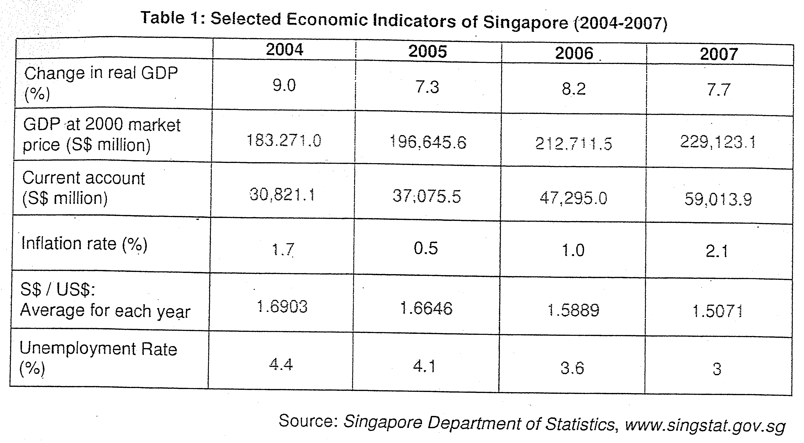

Questions
a) i) Describe the trend of current account balance. (1)
ii) What is meant by GDP at 2000 market price? (2)

b) To what extent does Table 1 suggest that the living standard of Singapore residents has improved between 2004 and 2006? (7)

Suggested Answers

a) i) Describe the trend of current account balance. (1)
There is a current account surplus balance from2004 to 2007 and it has improved for this time period.

The current account balance has experienced surplus from 2004 to 2007 and the rate of change in the surplus balance has increased at an increasing rate from 2005 to 2006 but at a decreasing rate for 2007.

- direction of change / rate of change / surplus condition

Reasons for the change – for Singapore – high valued- added production

ii) What is meant by GDP at 2000 market price? (2)

It refers to Real Gross domestic Product which is the total monetary value of goods and services produced within a country for the given year, expressed in base year price after it is corrected for inflation. The value of real GDP represents the value of actual production capacity which reflects the economic growth of a country.

b) To what extent does Table 1 suggest that the living standard of Singapore residents has improved between 2004 and 2006? (7)
definition of material SOL
As Singapore has experienced positive economic growth rate over these years, it does imply that the standard of living measured quantitatively will rise since real per capita income increases, indicating higher purchasing power which will enable Singaporean to have a higher level of material comfort. The rise in GDP will also mean that there is greater quantity of goods and services for consumption and more tax revenue can be collected to improve the infrastructure and facilities of the country to provide Singaporeans a more comfortable and convenient way of life.

(How increase in GDP leads to higher SOL?)

As unemployment rate has decreased, it will mean that more Singaporeans are working and will have the disposable income to sustain their livelihood. As the economy moves towards full employment, the tight labour market will surface and this will raise the salary scale of the workers to enable them to attain a higher level of income. Along with a low inflation rate as seen from the table, the real income of Singaporeans is likely to be higher.

The appreciation of Sing dollar over the period will enable Singaporeans to increase their purchasing power as the cost of imports can be lowered. Since most goods consumed by Singaporeans are imported and the lower cost of import would mean a decrease in the prices of goods and this will raise the purchasing power of the consumers.

(Problems of time comparison)

However, there are certain limitations of the validity of the data. Population growth rate must be taken into consideration whereby a higher population growth rate than the real GDP growth rate will imply that the real per capita income may not rise.
The table does not reflect the extent of distribution of income. Growth in real GDP per capita does not mean the real income of every Singaporean will rise if there is a high degree of unequal distribution of income when the Gini ratio is high or wage to GDP ratio is low. Furthermore, the unemployment rate is still at a certain level which means that a certain faction of population may have no income at all.

The table also does not reflect the composition of production which will determine the level of goods and services that Singaporeans can enjoy and thus, determining the level of welfare that Singaporeans can have. If the production is in term of capital goods, the current level of consumption will be lower which means that the standard of living is lower. Besides this, the high level of export demand will mean that the level of goods and services for local consumption is low.

The data in the table can only reflect the quantitative value of standard of living. There is a need to have information on the qualitative aspect of SOL which can be identified from indicators such Measurement of Economic Welfare (MEW) and Human Development Index (HDI). ( qualitative assessment is needed as it reflects the value of intangible aspect of well-being)

In sum, the data from table 1 reflects quantitative SOL but not on a qualitative basis. It is also important to take note of the limitations of these indicators.

c) i) With the help of data provided, discuss the challenges that Singapore might face in the light of globalisation and financial market problems in US. (6)

(link the impact of US recession on Singapore via the explanation of globalization)

In the light of globalisation and financial market problems in US, Singapore will be greatly affected as our economy is very export-and-FDI dependent and greatly influenced by US as it is one of the main market for export and source of FDI.

The financial problems in US have led to a state of recession whereby the economy experiences higher level of unemployment and reduction in national income. This would lead to a reduction in the purchasing power of the consumers in US and thus, implies that the reduction in demand for Singapore’s export. As US is one of the main export market, this will affect Singapore’s production capacity and thus, leads to unemployment. Furthermore, the competition for the external market due to the rise of China and other developing economies like Vietnam, the reduction in external market demand will be further exacerbated.

The recession in US will also mean that the firms in US or other MNCs will cut down production and reduces their willingness to invest overseas. This will mean a reduction in foreign direct investment into Singapore which will reduce the production capacity and thus, employment condition.

The economic stimulus adopted by the US government through quantitative easing will affect Singapore as the increase in money supply in US will mean the inflow of more hot money or fund from US, made possible by globalization which promotes the free flow of fund as financial markets in the world becomes more integrated. This increase in flow of fund into Singapore will lead to increase in money supply and the lowering of interest rate that contributes to asset-based inflation or property bubbles which can be devastating for the economy.

