JC Economics
CSQ – Lesson 4 – AD-AS Model & National Income Accounting – Q1

Tale of Two Economies

Extract 4: Indonesia aims for FDI growth
Indonesia is aiming to increase foreign direct investment by 23 percent this year, after record inflows in 2012 helped insulate Southeast Asia's largest economy from a slowdown in exports. Strong investment was driven by the mining, transport and chemicals sectors, showing firms shrugged off worries over policy uncertainty, corruption and weak infrastructure to seek returns in an economy growing at more than 6 percent.

It was also reported that investors at home and abroad have responded positively to efforts to improve the investment climate. Foreign inflows to the G20 economy have increased significantly since Indonesia regained investment grade status from two rating agencies a year ago. Investment makes up around 30 percent of the G20 economy. Although it’s FDI is less than that attracted by China in 2012, Indonesia remained attractive to foreign investors compared with its Southeast Asian neighbours. Vietnam, for example, estimated its FDI fell by 5 percent to $10.46 billion in 2012.

Foreign investors are not expected to stop coming into Indonesia, especially noting the fact that infrastructure upgrades are ongoing in the country over the next three to five years. There is a need to continue enhancing workers’ productivity, especially in the manufacturing sector, which has been a laggard relative to the region."
Adapted from Reuters, 22 June 2013

Extract 5: Abenomics and the Japanese Economy
Just weeks after taking office in December 2012, Japanese Prime Minister Shinzo Abe, who had also led the country from 2006 to 2007, announced plans for a new suite of policies geared toward jolting the stagnating economy out of its deflationary malaise. Japan, having fought deflation for more than two decades, remains mired in weak growth despite repeated attempts to revitalize the economy.

Abenomics refers to an aggressive set of monetary and fiscal policies, combined with structural reforms, geared toward pulling Japan out of its decades-long deflationary slump.

Fiscal stimulus began with economic recovery measures totaling 20.2 trillion yen ($210 billion), of which 10.3 trillion ($116 billion) was direct government spending. Abe ordered a hefty stimulus package focused on critical infrastructure projects, such as building bridges, tunnels, and earthquake-resistant roads. This was earmarked to stimulate private investment

The Bank of Japan (BOJ) simultaneously pursued an unorthodox injection of liquidity into the economy, a policy known as quantitative easing, seeking to push inflation to 2 percent to spur spending. The goal of easy monetary policy is to reduce real interest rates. In Japan’s case, it has a significant side effect of weakening the yen.

Finally, structural reform—including slashing business regulations, liberalizing the labor market, cutting corporate taxes, and increasing workforce diversity—aims to revive Japan’s long-term competitiveness.
Adapted from Business Insider, 16 March 2013

Extract 6: Abenomics needs an overhaul

Japanese Prime Minister Shinzo Abe must rethink his Abenomics program in its entirety. So far, only Abenomics' third and final arrow, reform, has come in for widespread criticism. But arrows one and two – monetary and fiscal stimulus – are also flagging in their efforts to pull Japan out of its economic funk. Annualized GDP growth fell to 1 percent in the second half of 2013 from more than 4 percent in the first half. If Abe does not refocus his reform program, the country risks a dangerous reliance on the Bank of Japan and its ultra-loose monetary policy.

Barring substantial reforms elsewhere in the Japanese economy, using the 'first arrow' to repeatedly weaken the yen is an unsustainable source for growth in the long-run. Under Abenomics, growth in Japanese exports has failed to keep pace with the rising cost of imports.

In a country with an aging and shrinking population, real long-term growth can only be realized through improved productivity. To stimulate productive investment, Japan must revamp the second arrow of Abenomics and focus on tax incentives rather than government spending. The new tax breaks tied to capital investment are surely too small to encourage significant new domestic investment, and only apply if companies can meet a 15 percent return on investment hurdle, a level which may be unrealistic in such a stagnant economy. These kinds of measures should prove more effective, and safer, than fiscal stimulus. Japan's government debts are already more than twice its GDP and further increasing it would prove problematic.

The third arrow of Abenomics, reform, also requires redirection. First, Japan needs to ensure its businesses use its people properly. To do this it will need to address a rigidity that has led to the development of a 'dual' labor market. Around 40 percent of workers are now deemed 'temporary,' in jobs which provide low pay, a lack of social insurance, and little opportunity to develop skills. There is scope to increase the use of foreign labor. There is also a need to use more flexible labor contracts so you can bring people into the labor force
Adapted from CNBC News, 27 March 2014

Using the given data, compare and evaluate the economic performance of Indonesia and Japan the period 2009 to 2013.(10)

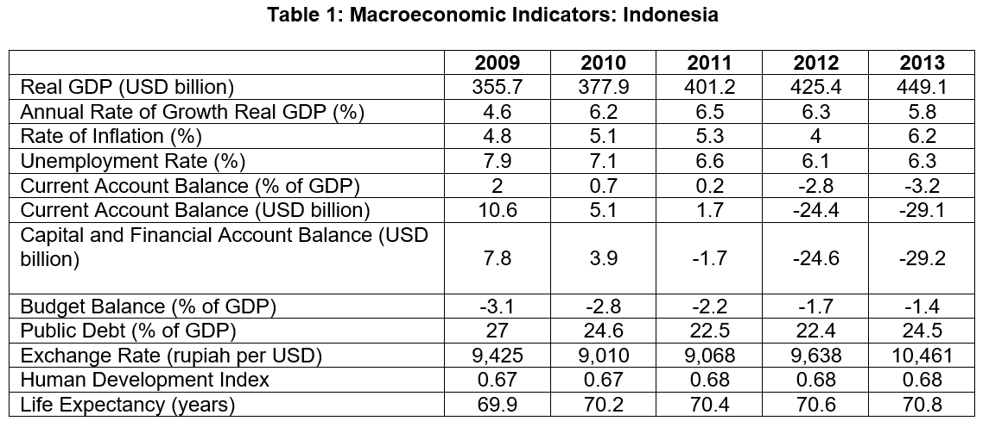
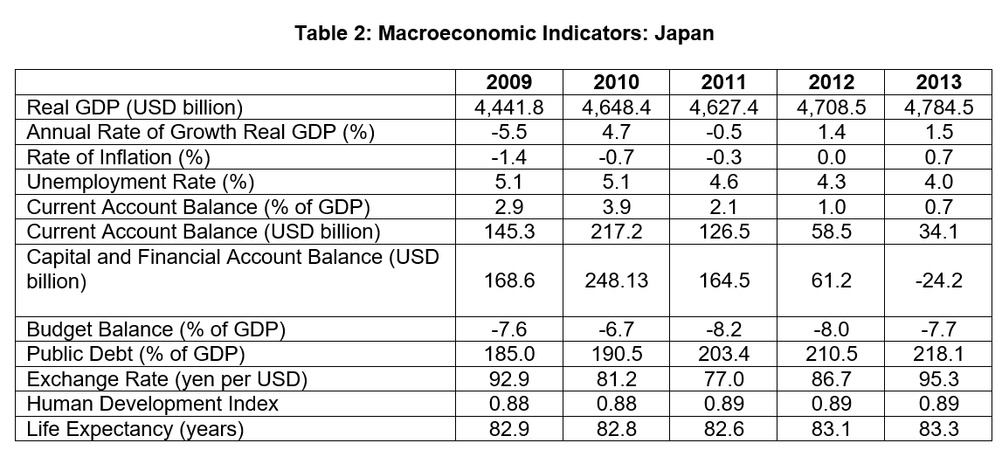
Source: Organisation for Economic Co-operation and Development
Questions
(a) (i) With reference to Table 1, describe the trend in the government budget balance as a percentage of GDP of Indonesia between 2009 and 2013. [2]

(ii) Explain how the government budget could have affected GDP growth rate in Indonesia. [2]

(b) (i) How far does the data support the changes in the capital and financial
in Indonesia from 2009 to 2013? [4]

(ii) Explain the rationale for Indonesia’s aim “to increase foreign direct investment by 23 percent this year”. [4]

(c) Comment on the view that residents in Japan enjoyed a higher standard of living compared to those in Indonesia in 2013. [8]

(d) Discuss the view expressed in Extract 6, which suggests that “Japanese Prime Minister Shinzo Abe must rethink his Abenomics program in its entirety.” [10]
[Total: 30 marks]

Suggested Answers
(a)(i) With reference to Table1, describe the trend in the government budget balance as a percentage of GDP of Indonesia between 2009 and 2013. [2]

Indonesia’s government budget balance is in deficit throughout 2009 and 2013. However, Indonesia’s government budget balance as a percentage of GDP has been improving (Or deficit has become smaller).

(a)(ii) Explain how the government budget could have affected GDP growth rate in Indonesia. [2]

Indonesia’s budget deficit means that its government is pursuing an expansionary policy, i.e. Government spending is greater than its revenue. This would lead to an increase in Aggregate Demand with an increase in Govt spending, consumers expenditure and investment expenditure. National income will rise as there would be an increase in production to meet the increase in the aggregate demand. Hence GDP growth rate would be positive.

(b)(i) How far does the data support the changes in the capital and financial account in Indonesia from 2009 to 2013? [4]

From Table 1, capital and financial account shows a falling positive net inflow from 2009 to 2010 to an increasing negative net inflow for the rest of the period. Thus, the statistics shows that there is more outflow than inflow from 2011 till 2013.

According to Extract 4, evidence seems to indicate that there is a greater net inflow of FDI from 2012 to 2013.
- “increase foreign direct investment by 23 percent in 2013, after record inflows in 2012”
- “Indonesia remained attractive to foreign investors”

However, because inflows < outflow, this may indicate that while FDI into Indonesia is rising, there could be relatively more long-term investment flowing out of Indonesia. Moreover, data of other components of capital and financial accounts, e.g. ST capital flow, has not been provided.

Therefore, the data given does not fully explain the position of the Indonesia’s capital and financial account.

(b) (ii) Explain the rationale for Indonesia’s aim “to increase foreign direct investment by 23 percent this year”. [4]

Indonesia aims to increase foreign direct investment as it helps it in achieving its macroeconomic objectives of sustained economic growth as well as lowering unemployment in the face of falling exports.

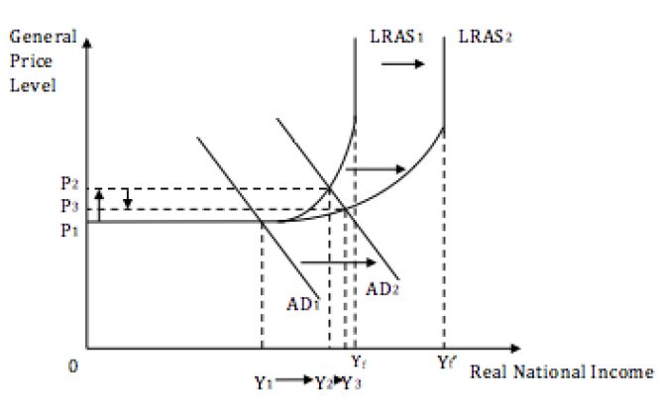

In the short run, an increase in foreign direct investment greater than the fall in exports would bring about an increase in AD. When AD increases from AD1 to AD2, at the original equilibrium price of 0P1, there would be an excess demand for goods and services and this causes a rundown in inventories stocks. In response, producers would have to increase production of goods and services. To meet the increase in production of goods and services, producers would have to increase their demand for
both labour and capital goods to increase output, resulting in lower unemployment. As such, this would bring about an increase in real national income from Y1 to Y2.

In the long run, due to the increase in foreign direct investment, the quantity of factors
of production would have increased and this brings about an increase in the productive
capacity of the economy leading to an increase in LRAS. This is represented by the rightward shift of LRAS1 to LRAS2 in the diagram above. This would bring about an increase in national income from Y2 to Y3 and reduce GPL from 0P2 to 0P3.

(c) Comment on the view that residents in Japan enjoyed a higher standard of living compared to those in Indonesia in 2013. [8]

Define SOL and explain how it is measured; and make comparison
- Definition: Refers to the well-being of average person residing in the country. It includes both the quantitative and the qualitative aspects of living
- Measurement
  - Quantitative measure – real GDP per capita
  - Qualitative measure
    - Quality of life – hours worked, pollution access to education, health care and housing
    - Equity - fairness, ease of access to goods and services, (Supplementary data HDI, includes life expectancy data)

Quantitatively, from the data
Japan real GDP in 2013 is 10 times higher than that of Japan. But one cannot deduce that Japan’s residents SOL is 10 times better that those living in Indonesia. Residents in Japan are able to consumer more goods and services compared to those in Indonesia.

However, there could be an over estimation of the difference in the SOL as there is insufficient data to make accurate assessment as some key information were missing:
- Population figure to calculate GDP per capita.
- Gini coefficient – measure on income distribution – link to equity issue
- Indonesia – developing economy – existence of non-marketed transaction not included in the national income calculation, inaccurate data
- Use of common currencies – exchange rate – PPP value?

Qualitatively from the data
Life expectancy is given and it shows that Japan is experiencing a higher SOL. Higher life expectancy indicates that the Japanese are enjoying better standards in healthcare, sanitation, etc.

However, more information is needed to assess the non-material SOL – e.g. leisure hours, pollution index, literacy rates, etc.

It is therefore reasonable to agree with the view that Japan has a higher SOL than Indonesia as HDI, a composite index which considers income, literacy rates and life expectancy is higher. But the difference in the level of SOL cannot be ascertained or accurately assessed as more information is needed.

(d) Discuss the view expressed in Extract 6 which suggests that “Japanese Prime Minister Shinzo Abe must rethink his Abenomics program in its entirety.” [10]

Introduction
Identify the objective of Abenomics program
- ‘Abenomics” as explained in Extract 5, “refers to an aggressive set of monetary and fiscal policies, combined with structural reforms, geared toward pulling Japan out of its decades-long deflationary slump.”

Main Body
- Policies adopted – Fiscal Policy, Monetary Policy and structural reform
- Explain how the program works (Use AD/AS analysis – demand side management for FP & MP and AS-structural reform) to solve the problems and its ineffectiveness, and its positive effects on the economy.

Policy #1: Monetary policy
Japan undertook “quantitative easing” and increased money supply, resulting in a fall in interest rates. This also has the added effect of causing the Japanese yen to weaken. (Extract 5)

The aim of the policy is to stimulate C & I so as to boost AD and real national income by the multiplier effect thereby achieving positive growth and higher GPL.

The weakening of the Japanese yen could help spur Japan into a recovery, as it would make its exports relatively cheaper in terms of foreign currency. When this happens, assuming Marshall-Lerner condition holds, this would increase net exports revenue (X-M). Assuming ceteris paribus, this increase in (X-M) would increase AD and real national income by the multiplier effect.

Need to rethink:
While the aim of this policy is to increase domestic consumption (C) and investment (I), Japan’s domestic demand is weak given the fact that is has been facing deflationary pressures in the past.

The increase in money supply could also run into a situation known as the liquidity trap, whereby any further increase in money supply by the Bank of Japan (BoJ) would not cause any fall in the interest rates. This would then render the effectiveness of this policy to be limited as C & I may not increase as desired.

Moreover, as mentioned in Extract 6, the weakening currency did not increase export competitiveness as “growth in Japanese exports has failed to keep pace with the rising cost of imports”. The weakening of the Japanese yen would cause price of imports to be relatively more expensive in Japanese yen and could lead to imported inflation reducing competitiveness of domestic goods which are highly dependent on imported raw materials. This, according to Extract 6, “is an unsustainable source for growth in the long-run.” Thus Japan would need to adjust in response to the challenges faced for monetary policy.

Policy #2: Fiscal policy
Japan undertook an expansionary fiscal policy and spent a large amount on capital spending to improve its infrastructure. Tax cuts were also introduced to encourage both consumption (C) as well as investment (I).

According to Extract 6, it seems that the focus of fiscal policy seems to be more on government spending. The increase in AD due to higher G would result in higher real national income by the multiplier effect.

Need to rethink:
“To stimulate productive investment, Japan must revamp the second arrow of Abenomics and focus on tax incentives rather than government spending.” (Extract 5)

Also focus on government spending would prove to be problematic for an economy like Japan as based on Table 2 as well as Extract 6, we know that Japan is facing a public debt amount of more than twice its GDP. Further increasing the public debt amount would have dire consequences to the Japanese economy as it may erode confidence in the Japanese economy and raise questions of the government’s ability to repay the debt.

While the intent of the government spending is to encourage households and businesses to increase C and I, it may not be sustainable for the government to spend in the long term to boost its AD. Thus, Japan would need to adjust in response to the challenges faced for fiscal policy.

Policy #3: Structural reforms
Japan embarked on “structural reforms—including slashing business regulations, liberalizing the labor market, cutting corporate taxes, and increasing workforce diversity—aims to revive Japan’s long-term competitiveness. “(Extract 6). These policies aim to reduce cost of production to improve competitiveness of domestic goods and services. While these reforms help in making Japan more attractive to businesses, with the slashing of business regulations which is more business-friendly, as well as the reduction in corporate taxes which contribute to higher post-tax profits for businesses, stimulating I.

Need to rethink:
However, these policies fail to address the issues that are plaguing them, namely, aging and shrinking population as well as improving the rigidity in the labour market in Japan.

To tackle the aging and shrinking population, Japan may wish to relook its policy on allowing foreign labour in to help plug the gap caused by the aging and shrinking population. The aging and shrinking population could cause labour cost and wages to increase and this would add on to businesses’ cost of production. This may lead to firms looking elsewhere where cost of production is much lower. Allowing foreign labour in would help to reduce the pressure of the rising wages.

In addition to the above problem, there is also mention of rigidity in the labour market which leads to a ‘dual’ labour market. To improve this condition, the government may wish to embark on retraining and upgrading programmes to help the development of skills in the workforce. It could focus on retraining and upgrading for those who are stuck in “temporary” jobs so that with the completion of the training programme, they could go out and look for a job which would ensure that his/her skills are put to good use and contributing to the Japanese economy.

Thus, Japan would need to adjust in response to the challenges faced for structural reforms.

Evaluation and Synthesis
Based on Table 2, Japan seems to be on the rebound as they returned to positive economic growth in 2012 and 2013. In addition, Japan is also starting to move from a state of deflation to inflation again. Unemployment rate also fell during the period of 2009 to 2013. All these are positive signals and could imply that the Japanese economy is seeing an increase in economic activity.

Typically, these policies undertaken would require time for the effects to slip in and thus it may be too premature to suggest rethinking of Abenomics in its entirety to solve the problems faced by Japan. There are still some areas of concern. That is when the FP is seen ineffective and may lead to the possibility of over-reliant on the loose MP, there is the need to counter the undesirable effect of a weakening Yen.

Moreover, given the ageing population, demand-side management to stimulate the economy is to be supplemented by structural reform which would affect the long-term capacity to produce. The policies have to be reviewed, performance to be monitored so that they are adjusted, if necessary, in a timely fashion to help Japan and its economy to achieve its macroeconomic objectives and recover from their predicament.

