Question 2: Case Study

AN EMERGING CHINA - THREAT OR OPPORTUNITY?

EXTRACT 1

China's Competitiveness: A Threat to East Asian Manufactured Exports?

The rapid emergence of the Chinese economy has raised much concern about China's competitive threat. In East and Southeast Asia, in particular, China's, burgeoning exports—backed by cheap and productive-labour, a large stock of technical manpower, huge and diversified industrial sector, attractiveness to foreign investors, use of industrial policy, and, now, freer access to world markets under World Trade Organization (WTO) - lead to apocalyptic visions of export losses. China is most threatening to neighbours that rely primarily on low wages for their export advantage. As it upgrades its export structure, however the more advanced economies (Singapore Hong Kong, Korea and Taiwan) also fear for their competitiveness. The current hollowing out of their low-end manufacturing may soon extend to complex production, design, development and related services.

Offsetting this threat is the promise of the dynamic Chinese market arid the potential for collaborating with it to export to the rest of the world. Trade with East Asia is flourishing. China imports from the region are growing faster than its exports, not on of resources but also of manufactures. Its advanced neighbours are selling it consumer goods, intermediates and machinery and using it as a base for processing exports to the rest of the world:

It is difficult to assess whether such complementarities between China and regional economies offset its competitive threat. The dynamics and complexity of the interactions make it impossible to quantify the outcome, even to predict its broad directions: The main issue is hot so much as direct competition between China-and its neighbours—this is clearly growing—but how the latter specialization changes in response. lf the neighbours, most with higher wages than China, can upgrade into more advanced activities enough to justify their wage premium as China moves into their present activities, they can continue with rapid export growth. If they cannot, they risk export deceleration: a shift to primary products (most of which grow slower than the manufactures that have driven their export growth recently). Or they may be forced to specialize in lower value-added segments of manufactures as China moves rapidly up the technology and quality ladder.

Source: Adapted from World Development, 2004

Extract 2

Singapore Lessons for China

As China aggressively started its second-wave ascent via a manufacturing and trade development model in 1994, most people expected the high-wage Asia Tiger economies - Singapore, Hong Kong, Taiwan and S. Korea - to quickly hollow out their manufacturing sectors and surrender their manufactured export shares to China. The economic rationale was simple - indigenous S. Korean and Taiwanese and MNC industrialists based in Hong Kong and Singapore would not be able to resist the competitive manufacturing outsourcing platform offered by China, and would move manufacturing aggressively to China.

However, things did not quite turn out that way. China has hollowed out manufacturing, but mainly in the developed economies. For the Asian Tigers, S. Korea has increased its domestic manufacturing production substantially and raised, its global share of manufactured exports, while Singapore, Taiwan and Hang Kong have experienced varying degrees of manufactured export share losses (of the three, Singapore's losses were the smallest. However, these losses do not accurately portray the countries’ domestic manufacturing strengths or weaknesses. In the case of Singapore, the fact that its ASEAN neighbours are handling more of their own cross-border trade may have contributed to its moderate loss of global share

Over 1994 to 2004, Singapore's growth averaged 6.2% versus China's 9.9%. Singapore's domestic investment-to-GDP ratio fell from 33.1% in 1994: to a mere 18.3% in 2004. By comparison, China has enjoyed strong growth in both domestic investment and exports over that period. Given China's competitive manufacturing platform, however, Singapore's manufacturing sector has remained resilient, expanding its share of GDP from 24.3% to 27.1 %. Its manufacturing output has risen sharply from US$17.1 billion to US$28 billion

Singapore's manufacturing sector is more capital-intensive and higher value-added. It is also diversified away from its dependence on electronics. In contrast, China is focused on volume expansion in low value-added mass-manufactured products.

Source: Singapore Lessons for China, Asia Pacific Economics.

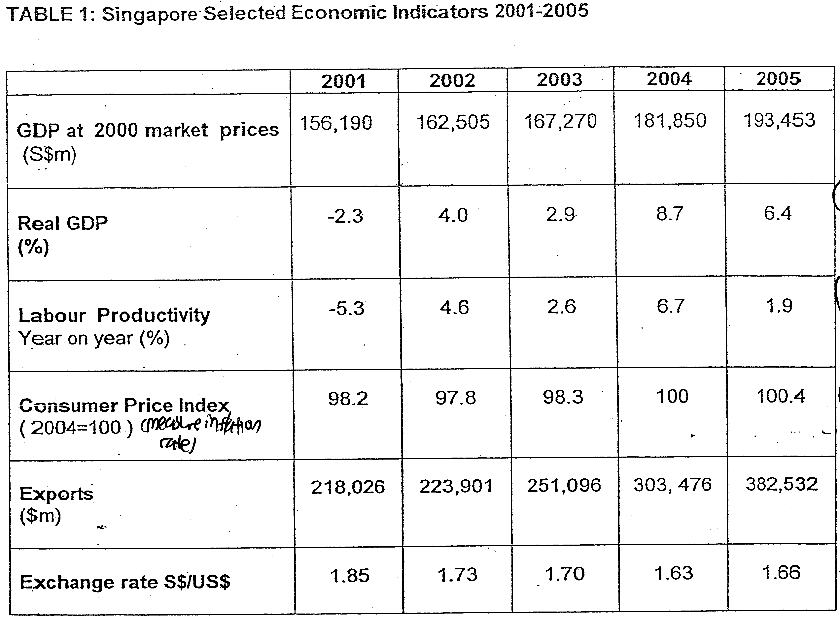

Source: Economic Survey of Singapore, 2004 and 2005

- From table 1, identify and explain two factors that may affect the global competitiveness of Singapore’s goods and services. (4)

- Based on the extract 2 and table 1, assess the economic performance of Singapore from 1999 – 2005. (6)

- Explain and evaluate the extent of reduction in FDI will affect the equilibrium level of national income. (12)

Case Study – Theory of Income and Employment / National Income Employment
Ref : CSQ 2010 MAQn 2

Title: AN EMERGING CHINA – THREAT OR OPPORTUNTY

- From table 1, identify and explain two factors that may affect the global competitiveness of Singapore’s goods and services. (4)

As seen from table 1, one of the factors that would affect price competitiveness would be the exchange rate. The appreciation of exchange rate would lead to the rise in the export price level which would lead to the fall in quantity demanded of export. As seen from the table, the US$ has depreciated against S$ from S$1.85 per US$ to S$1.66 per US$ from the year 2001 to 2005. However, Singapore’s export revenue may not decrease as the price elasticity of demand for Singapore export demand is inelastic. The appreciation of the Sing dollar against US$ can still help the country raise its competitiveness as it will help to lower the cost of imports which will lead to the reduction in cost of production since most of the resources required for production by the industries in the economy is imported. The reduction in the cost of production will enable the firms to decrease the price of exported goods, raising the price competitiveness of the economy.

Another critical factor that influences the competitiveness of the economy would be labour productivity which has improved on a year on year basis from 2001 to 2005. Improvement in labour productivity will mean that the production capacity will increase and lower down the unit cost of production. This will also enable the local producer to decrease their price of exported goods. Furthermore, the improvement in labour productivity may raise the quality of exported goods, raising the demand for Singapore exported goods.

- Based on the extract 2 and table 1, assess the economic performance of Singapore from 1999 – 2005. (6)

From the data attained from table 1, it can be observed that Singapore has attained positive economic growth over the period and the economy has made an economic recovery from the economic downturn in 2001. After year 2001’s negative real GDP growth rate, the country has been able to attain positive real GDP growth rate from 2001 to 2005 and, if the growth rate is accounted for a longer period from 1994 to 2004, it has attained an average rate of 6.2%. It is considered quite credible for Singapore to grow at such pace, given the keen competition for FDI due the rise of China and the reduction of domestic investment that contribute to rise in Singapore outward investment to China.

Labour productivity of the economy has improved although the rate of growth has been inconsistent. As the manufacturing sector upgrades itself to a higher production ladder, the basis of the Singapore’s manufacturing sector is more capital intensive and higher value-added which will contribute the growth in the productivity. However, the consistent adjustment to the comparative advantage will undermine the growth of the productivity as the adjustment will raise the inefficiency of production.

The inflation rate has been kept low after 2004 while the economy experiences a period of deflationary condition for the period 2001 to 2003 as compared to the base year at 2004. This is made possible with trading activities with China which helps to lower the cost of resources and goods and services through imports from China. Furthermore, the appreciation of the Sing dollars allows the employment of foreign workers at lower rate as the wage rate that is converted to the domestic value for the foreign workers is higher and thus enables the local firms to attain large quantity supply of foreign workers at lower rate which will lower the cost of production, keeping the rate of inflation low.

Despite the appreciation of the exchange rate, the total export values increases by 75.5% from 2001 to 2005. The appreciation of exchange rate will still contribute to an increase in the total export value as the price-elasticity of Singapore export demand is inelastic. The price-elasticity of demand is price inelastic as the goods have a low degree of substitutability due to its high-valued and capital-intensive nature of production.

- With reference to table 2, compare the direct foreign investment (DFI) of Singapore and China. What economic relationship exists between DFI and economic growth? (8)

The level of FDI inflow of Singapore has decreased from 2000 to 2003 from US$12.4 bn to US$5.5 bn at a fall of 125% while the level of FDI inflow of China has increased from US$ 38.3 bn to US$ 53.5 bn at 39.6%. It thus implies that China has been able to attract more investment than Singapore due to its ‘cheap and productive labaour, a large stock of technical manpower, huge and diversified industrial sector” The focus of FDI into China is based on low value-added manufacturing sector while Singapore’s FDI focuses on capital and high valued-added products.

Economic growth will induce an increase in the level of the foreign direct investment as the growth of GDP will lead to the rise in the disposable income and thus, contributes to the rise in the aggregate expenditure. This will demand a higher level of production which will induce the rise in FDI, implying that the direct relationship of the influence of economic growth on the level of FDI as seen in the accelerating principle.

FDI is of critical importance of economic growth. In China and Singapore, FDI has contributed greatly the employment opportunities as the investment provides massive employment with its large scale production. It also induces the growth of national income as the increase in FDI will raise aggregate expenditure and via the multiplier increase the national income.

FDI will also provide the economy with a larger market demand, allowing the firms in the economy to enjoy economies of scale to lower cost of production. This will raise the efficiency of the industries and it will able to further expand the production capacity as the productivity is higher. The MNC can also induce greater production capacity as they can expand the source of supply of resources through their connections. This will raise the potential growth of the economy.

FDI can also raise the technological level of the economy as some of these investments are in research and development which will help to raise the potential growth of the economy. The higher level of technological level will raise the productivity of the worker, allowing it to lower the cost of production to increase production capacity. The investment can also develop infrastructural development to raise the productivity of the industries which will give rise to higher level of external economies of scale. This will attract more investment for the economy.

- Explain and evaluate the extent of reduction in FDI will affect the equilibrium level of national income. (12)

The equilibrium level of national income is attained when there is no tendency of change in the economic activities whereby the level of aggregate demand is equal to the value of aggregate supply. Any adjustment of the aggregate demand components will contribute to a change in national income.

As FDI is part the of aggregate demand components, the reduction in FDI will reduce the value of aggregate demand which will lead to the reduction in national income of the nation via the multiplier process.

In the multiplier process, the initial reduction in the aggregate expenditure due to a fall in the FDI will contract the circular flow of income, reducing the income of the factor earners to make further transactions which will reduce the circular flow of income as a result of the reduction in transaction. The circular flow of income will continue to reduce until the withdrawal effects is equal to the level of reduction in the level of aggregate expenditure which will cease the contraction of the circular flow of income. Consequently, the national income will reduce by several folds, depending on the value of the de-multiplier which is determined by the sum of the MPW (Marginal Propensity to withdraw – MPS + MPT +MPM).

As seen from the diagram, the reduction in the FDI will contribute to contribute to the fall in aggregate demand from Ado to AD1 and this will lead to a fall in national income from Yo to Y1. If the level of national income is below full employment as seen in the diagram, it will mean a fall in the real production capacity and a fall in the price level.

The extent of reduction in national income as a result of the fall in the level of FDI will depend on several factors. Firstly, the percentage of the composition of the investment expenditure the FDI constitutes will influence the level of reduction in the level of investment expenditure. For Singapore, FDI constitutes a large percentage which implies that the reduction in the level of AD will be great, leading to a huge fall in the level of national income.

Besides this, the fall in national income will be lesser if the multiplier value is small as the contraction of the economic activities will be less extensive which means a smaller degree of contraction of circular flow of income. For Singapore, a small value of the multiplier will be beneficial as it is able to reduce the effect of the contraction on the economic activities. Singapore’s FDI is small as the value of MPS and MPM is large which is affected by the high level of compulsory CPF saving and high degree of imports substitutability (small resource capacity) respectively.

The extent of change in national income due to the reduction in the level of FDI will also depend on the level and direction of change in other components of AD. If the is a rise in the level of other aggregate demand components like an increase in the level of local consumption and the extent of increase is greater than the reduction in the FDI, the level of national income may not decrease. On the other hand, If there is a fall in other AD components along with the reduction in FDI and the level of reduction in AD is extensive, the fall in the level of national income will be extensive.

For Singapore, it is likely that the fall in FDI will contribute to a large fall in the level of national income as the level of reduction in FDI creates extensive reducing impact on other AD components. If the level of FDI reduces, there will be a huge fall in the export demand as most of the production of FDI is for the external market and Singapore’s extensive reliance on export demand for growth will undermine the level of AD and thus, reduces the value of national income. Similarly, the level of consumption will fall as the reduction in FDI and it spill-over impact on the export demand will reduce employment and the wage level of the workers which will reduce disposable income that reduces the level of local consumption.

In sum, it can be concluded that the reduction in the level of FDI is likely to reduce the level of national income but the extent of change in national or the direction of change in national income will depend on the determinants stated above.

- With reference to a full range of economic objectives, and to the data where relevant discuss the possible impact of a rapidly emerging China upon the Singapore’s economy. (10)

It is responsibility of Singapore government to achieve greater economic growth, higher level of employment, price stability, external stability of balance of payment and exchange rate and equal distribution of income.

The rapid emerging of China will affect Singapore extensively as there will be trade diversion and fall in inflow of FDI as identified in table 2 where Singapore experienced a fall in investment while China experienced a high growth in the inflow of FDI. It will lead to the fall in local investment as more local firms direct their investment to China. Export for Singapore may be affected as our trading partners may switch to buy China goods as the price of China goods is cheaper. Consequently, it will affect Singapore’s ability to attain the aims of the economy.

It is likely that Singapore’s economic growth in terms of GDP growth will be lowered as our export demand and investment will be reduced, leading to a fall in national income via the multiplier effect. However, over the period from 1994 to 2004, Singapore has been able to achieve average growth of 6.2% despite the fall in investment level. It is able to do so as it has diversified the economy in term of product and market base. It has moved to attract high valued investment and production of high valued gods which help to sustain its export competitiveness and thus its export value. Furthermore, the diversification of market to other areas likes Latin American nations and Eastern Europe has helped to sustain our export volume, enabling Singapore to sustain its economic growth.

As for employment, the global economic downturn along with the rising competition from China has dampened our production capacity, leading to a fall in employment. Nonetheless, Singapore has tried to diversified the economy to the areas which it has comparative advantage to maintain production capacity and employment. Workers are also provided with more training to allow them to switch other new industries which China is not so efficient in. Though this can help the economy to maintain employment, it is difficult for Singapore to avoid structural unemployment as not all workers can be trained to switch to another industry as their skill level is not so transferable.

It will be easier for the government to sustain price stability as Singapore can import in more resources or input of products at lower cost through trade with China. This will help to lower the price level in Singapore, enabling the economy to achieve lower cost of living and production.

As the flow of foreign direct investment and export demand is reduced while there will be greater investment made abroad by local firms in China, it is likely for Singapore to experience balance of trade and balance of payment deficit which will lead to more outflow of currency. This will dampen the exchange rate which will create strong repercussion on our status as a financial centre as the yield given to equity investor will decrease. However, the government is likely to intervene into the economy to sustain the exchange rate at a suitable level to avoid this negative impact.

Singapore’s level of equality of distribution of income and wealth will be affected as the change in economic structure will create structural unemployment, leading to the disparity of income equality. The workers who are able to acquire the skills to work in the new industries and seize the opportunity of the growth in China will benefit, undermining those who are unable to gain from it. This situation had induced the government to introduce some welfare programme to help the lower income group.

In sum, it can be seen that the rapid economic development of China can create strong impact on the economy but the government has introduced remedy for Singapore to adapt so that the economy can attain its aims.

- Evaluate two policies which the Singapore government might use to increase competitiveness of the country’s goods. (8)

The government can introduce supply-side policies and trade development strategy to raise Singapore competitive edge in the international export market. In respect to supply-side management policies, the focus is on the resource management and manpower development and technological development. Through efficient resource management like land reclamation and urban planning along with raw material management, the government is able to keep the cost of production low which will help to reduce the price of export goods and services. Manpower development will enable our workers to improve their skills which will enable the firms to raise their productivity to lower the cost of production and innovate their production with more high-valued and quality products. Thus this raises the competitive edge of the economy in term of price level and quality of goods and services. Lastly, the government needs to engage in research and development to innovate the products and services and raise the productivity of the production with more efficient production process.
Furthermore, the government can embark on trade development through free trade agreements, development of trade network and trade exhibition to expand trading activities and raise the efficiency of trading process. Through the establishment of free trade agreement, the economy will be able to lower the cost of export of goods and services and Singapore will be able to attain more resources from import at lower cost, allowing the economy to lower the price of goods and services since the cost of production is lowered. The development of trade network through the set up of trade routes with more links of the air and sea ports will allow Singapore to standardize trading process and enhance connection of the trading partners. This will increase the efficiency of the trading activities and create more trading market. Along with more trade exhibition, this will help Singapore to have more trading partners to increase the export of our goods and services as the government can have more exposures of their goods and services as there is larger export market.

