J2 H1 Economics – Final Revision 2019 – Lesson 6

Lessons from Japan and the United States

Table 2: 2016 Selected Economic Indicators
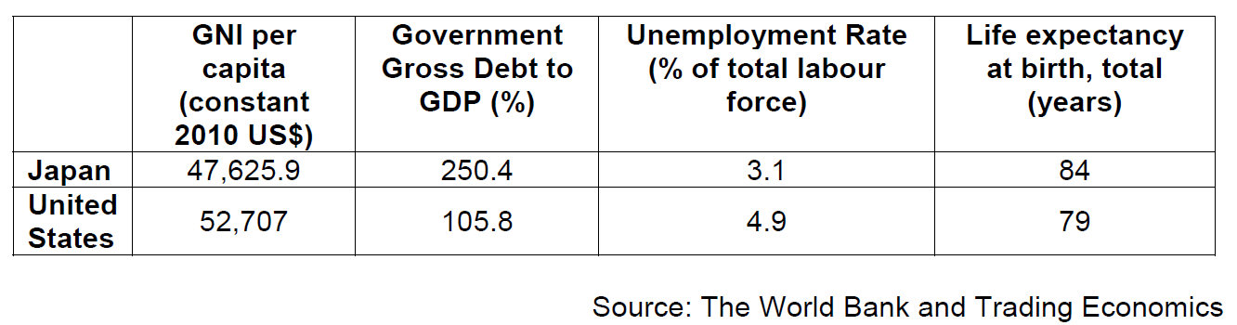
Extract 6: Reduce long working hours to maintain economic vitality: The Japan News

To maintain economic vitality in society amid a declining population, it is essential to improve the environment so women and elderly people can better exhibit their ability and more actively participate in society. The biggest challenge is to address long working hours. Working hours of regular employees in Japan remain high, at around 2,000 hours a year. The ratio of workers with long working hours is also conspicuously high when compared with Europe and the United States. Current labour practices, under which overtime has become normal, have prevented women - whose time is limited because of child-rearing and nursing care of elderly people - from actively participating in society. This has made it difficult for them to balance their work and family life, which has also become a major factor in the declining birth rate. In moving ahead with work style reforms, it is vital to enhance the productivity of every worker.

Non-regular workers must be helped to develop their competence by improving vocational training programs for them or expanding opportunities for them to pursue continuing education at colleges. The bill to revise the Labour Standards Law has, as its central pillars, proposals introducing an employment pattern under which wages will be decided based on work results rather than by number of hours worked.
Source: The Straits Times, 30 September 2016
Extract 7: What’s wrong with Japan’s Economy

Japan’s economy has been in trouble for decades. Massive monetary and fiscal stimulus have so far failed to spur faster growth. This week, the Bank of Japan meets to decide whether to apply yet more economic shock therapy. Here’s the situation the country’s leaders face:

Table 3
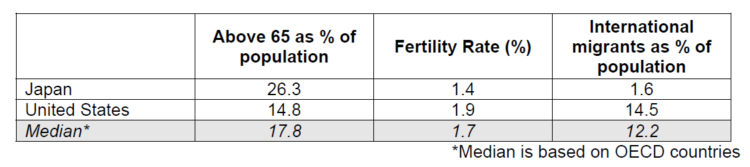

Japan has the world’s oldest population, as well as a low birth rate and little immigration, but its growth problems go far deeper.

With the Japanese unwilling to spend, companies are increasingly investing overseas rather than at home. Wages are stagnant and growth has stayed low, with frequent recessions.

Japan’s debt burden far outstrips that of other countries, largely a result of the stimulus introduced to help fix the economy. Higher debt led the government to consider a sales tax increase for revenue. Abenomics, Prime Minister Shinzo Abe’s rescue plan, which initially relied too much on financial and fiscal measures, has run short of solutions for tackling the structural problems facing Japan's economy. Issues such as an aging population, a weak domestic market and erosion of Japanese firms' competitiveness in the global economic system have not been fundamentally addressed. Given that the real economy has not substantially improved, persisting with monetary easing policies can only be counterproductive. Abenomics has helped to weaken the yen and boost corporate profits but wages and domestic spending have remained fragile.

The monetary stimulus weakened the yen, and until earlier this year exporters felt the benefit but consumer spending hasn’t followed and—with the central bank still far from its 2 percent target—neither has inflation.

The Bank of Japan says it will keep taking whatever action is needed to meet its targets and Abe has pledged “bold” measures this fall. Yet with stimulus failing so far to spur growth, economists and policy makers say broader, more dramatic strategies are needed.

Adapted from: Bloomberg and Guardian, 2016

Questions

(a) Using Table 2, explain why any one indicator might have been a concern to the Japanese government. [2]

(e)(i) How is the rate of inflation and standard of living related to each other? [1]

(ii) With reference to the data where relevant, explain and comment on whether Japan will have a higher standard of living than US. [8]

(f) With reference to Extract 7, explain possible reasons why Japanese are unwilling to spend. [4]

[Total: 45 marks]

