Economics MCQ – Chapter 6 – Role of Government in an Economy

Part B – Taxation

Q1. A country has a proportional system of taxation. A person pays $500 tax when earnings are $5000. How much tax will be paid if earnings rise to $12 000?
- $120
- $500
- $1200
- $7500
( )

Q2. A government wishes to stimulate economic recovery. Which action will assist this?
- Decreasing government investment
- Decreasing income tax
- Increasing indirect taxation
- Increasing interest rates
( )

Q3. Which type of tax is a sales tax (VAT)?
- A direct tax
- An indirect tax
- A progressive tax
- A proportional tax
( )

Q4. A tax on which of the following is usually progressive and is paid by a large number of taxpayers?
- Company profits
- Goods and services
- Incomes
- Sales of shares

( )

Q5. Which government policy would be likely to help local companies expand?
- Encouraging investment by foreign companies
- Increasing income tax
- Providing a subsidy
- Raising interest rates
( )

Q6. A government decides to subsidise a major industry that is making a loss and also reduce sales tax (VAT) to increase consumer demand.

Which aim would these policies be likely to help and which aim would they be likely to hinder?

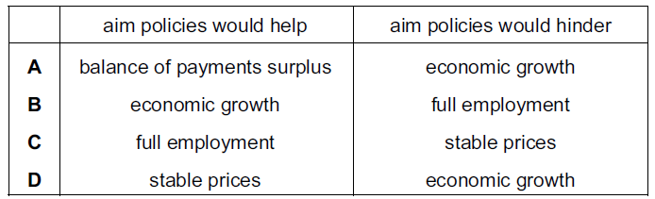

( )

Q7. Direct taxes can be used to
- place the burden of tax on sellers not buyers.
- protect domestic industries from foreign competition.
- raise revenue without affecting the number of hours employees work.
- redistribute incomes from rich to poor.
( )

Q8. Brazil is a highly taxed economy. Some Brazilian economists have suggested that if the government were to cut tax rates, the government would actually receive more tax revenue. Why may cutting taxes increase revenue?

- It may encourage emigration.
- It may increase the tax burden.
- It may lead to a fall in investment.
- It may reduce tax evasion.
( )

Q9. In September 2008, the Chinese government increased the sales tax on cars with large engines whilst it reduced the sales tax on cars with small engines. Most cars in China with large engines are imported whilst most cars with small engines are home produced.

Which effects would the changes in sales tax be expected to have on China’s trade surplus and the demand for home produced cars?

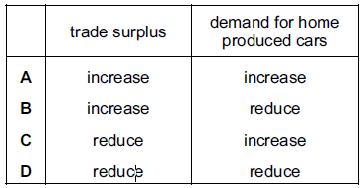
( )

Q10. A government decreased the tax on all goods imported into the country. What is the most likely result of this?
- A decrease in domestic production
- An increase in economic growth
- An increase in exports
- An improvement in the balance of trade in goods

( )

Q11. In 2003 in the UK, income tax raised £110 billion at a cost of 1.4 pence per £1 raised. Company tax raised £21.1 billion at a cost of 1.2 pence per £1 raised. What can be concluded from comparing this information on the two taxes?
- Company tax was the more productive tax
- Company tax caused less tax avoidance
- Income tax was the more progressive tax
- Income tax was less economical to collect
( )

Q12. The diagram shows the price per litre paid for petrol in four countries in a year. The amount of tax included in that price is shown by the shaded area.

If there was no tax on petrol, which country would have the highest petrol price?

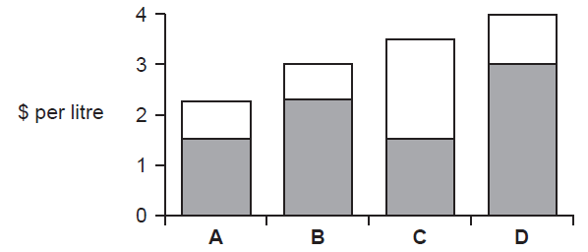
( )

Q13. What is meant by a regressive indirect tax?
- A tax on income that falls more heavily on the poor
- A tax on income that falls more heavily on the rich
- A tax on spending that falls more heavily on the poor
- A tax on spending that falls more heavily on the rich
( )

Q14. What is most likely to happen if a regressive tax replaces a progressive tax?
- The amount of tax paid by richer people increases
- Incomes before tax become less equal
- The majority of people continue to pay the same tax
- The amount of tax paid by poor people increases
( )

Q15. A government decides to reduce income tax. Which aims of government policy would this help to achieve?
- A smaller balance of payments deficit and lower inflation
- A smaller balance of payments deficit and more economic growth
- Lower unemployment and lower inflation
- Lower unemployment and more economic growth
( )

Q16. What is meant by the incidence of a tax?
- How the revenue raised by the tax is spent
- How the tax is collected
- Why the tax is imposed
- Where the burden of the tax is finally felt
( )

Q17. The graph shows the percentage of tax taken from different levels of income by four different taxes. Which illustrates a regressive tax?
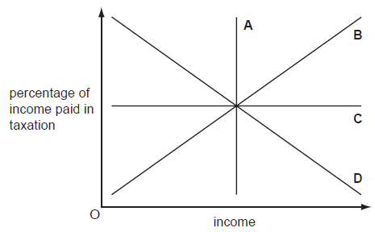

( )

Q18. The government of Kenya wishes to help people with very low incomes. Which policy would achieve this?
- Increasing housing subsidies
- Increasing income tax
- Increasing indirect taxation
- Increasing inheritance tax
( )

Q19. Which statement describes a progressive tax?
- A tax that increases government income over time
- A tax that places an increasing burden on the poor
- A tax that rises in line with the rate of inflation
- A tax that has a higher rate as income rises
( )

Q20. The government puts a $2.00 tax on each $8.00 video tape sold. As a result, the price of a video tape rises from $8.00 to $8.50. What can be concluded from this?
- The demand for video tapes is price inelastic.
- The government will receive only 25 % of its expected tax revenue.
- The incidence of the tax will fall mainly on the producer.
- The tax is progressive.
( )

Q21. In a country where the government pays the unemployed a small weekly income, there is a reduction in consumer expenditure and, as a result, unemployment increases. What will be the effect on tax revenue of the government and on government expenditure?

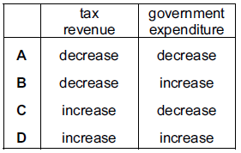
( )
Q22. Which is a description of indirect taxes?
- They are easy to avoid and deter effort.
- They are levied on income and cause inflation.
- They are levied on spending and are regressive.
- They are progressive and discourage consumption.

( )

Q23. In a country, income tax is charged at $50 on an income of $500. Compared with this, which of the following would indicate that the income tax scale was progressive?
- $150 tax on $2000 income
- $300 tax on $3000 income
- $450 tax on $4000 income
- $480 tax on $5000 income
( )

Q24. What describes a regressive tax?
- It is paid by a higher proportion of high income earners
- It is paid by a higher proportion of low income earners
- It takes a higher proportion from high incomes
- It takes a higher proportion from low incomes
( )

Q25. The table shows the tax paid at different levels of income

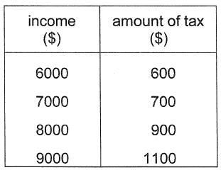

Which describes this tax?

- Progressive at all levels of income
- Proportional at all levels of income
- Proportional at lower incomes, progressive at higher incomes
- Proportional at lower incomes, regressive at higher incomes
( )

