J2 June Intensive Revision 2015
L3 – CSQ – Market Failures – Q1

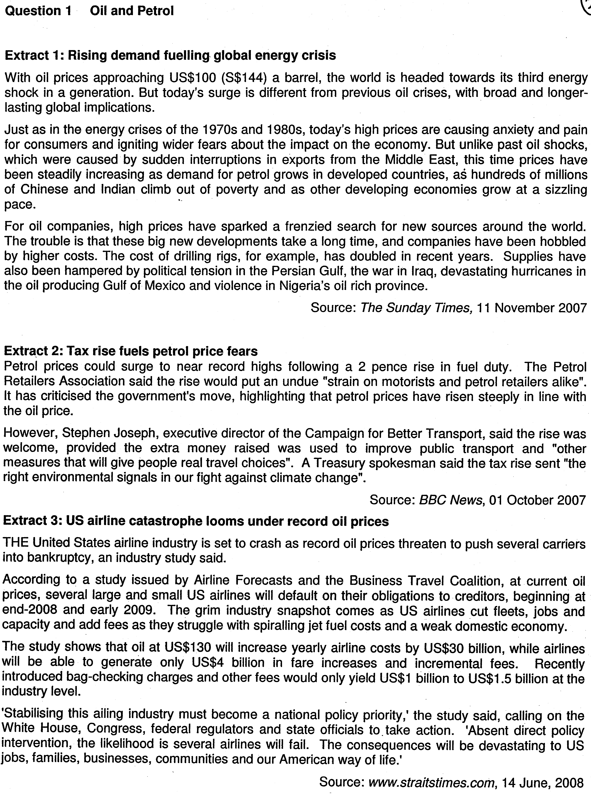

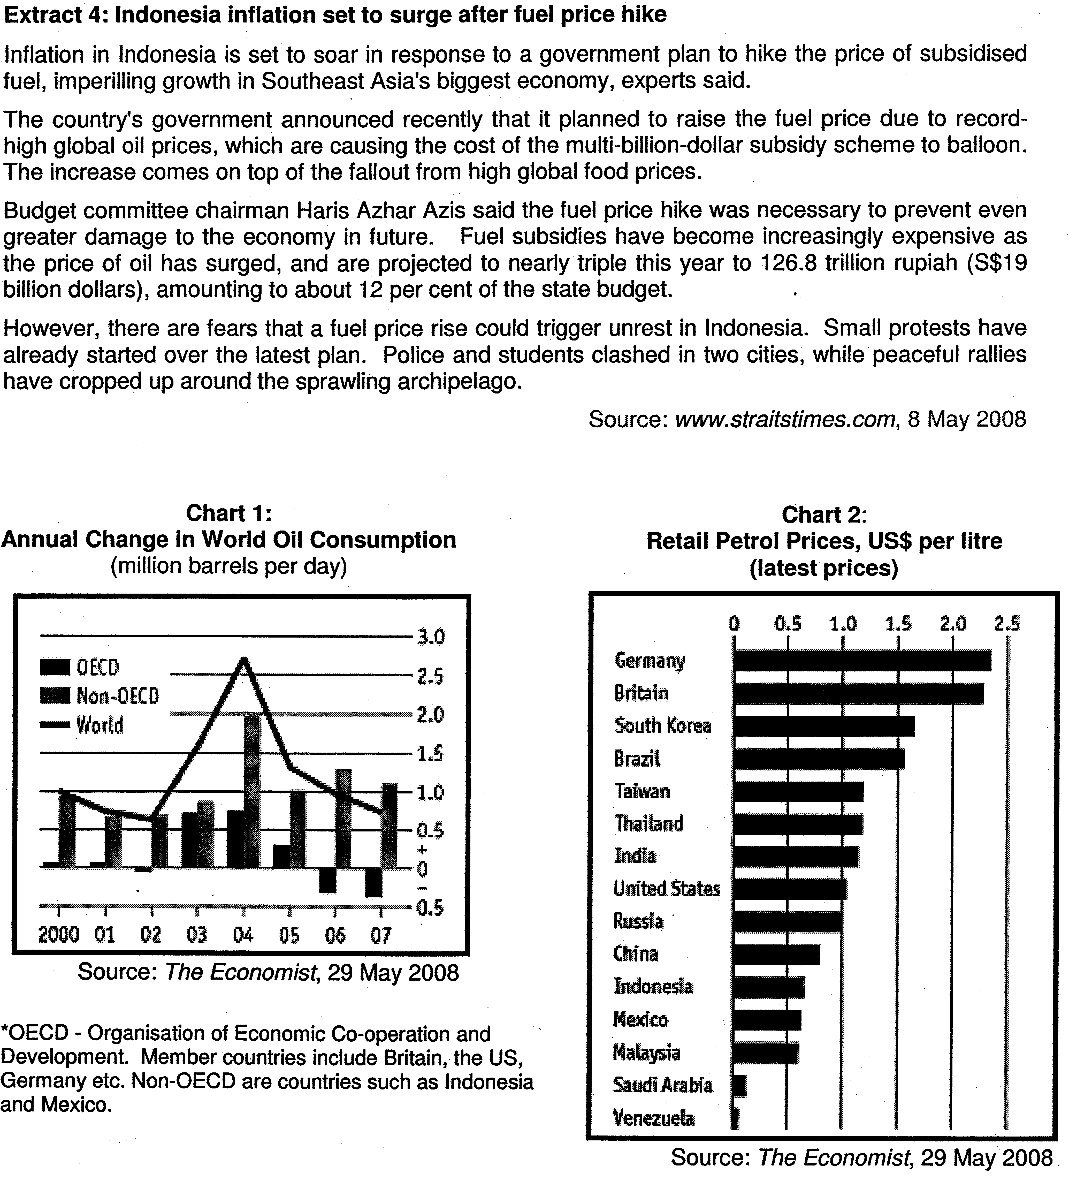

Questions
(a) (i) Compare the trend in oil consumption levels of OECD countries with non-OECD countries between 2004 and 2007 in Chart 1. [2]

(a) (ii) Account for this trend in the consumption of oil for OECD and non-OECD countries. [3]

(b) (i) Explain what is meant by allocative efficiency. [1]

(b) (ii) Using the data and your economic knowledge, discuss whether the imposition of a 2 pence fuel duty in Britain will lead to an efficient allocation of resources. [6]

(c) Based on Extract 3, analyse the possible impacts of an oil hike on the airline industry in the US and its economy. [8]

(d) In the light of the data provided, if you were an economic advisor to the Indonesian government, would you recommend the government to go ahead with the fuel hike in view of rising inflation? [10]

