J2 June Intensive Revision 2015
L3 – CSQ – Market Failures – Q1

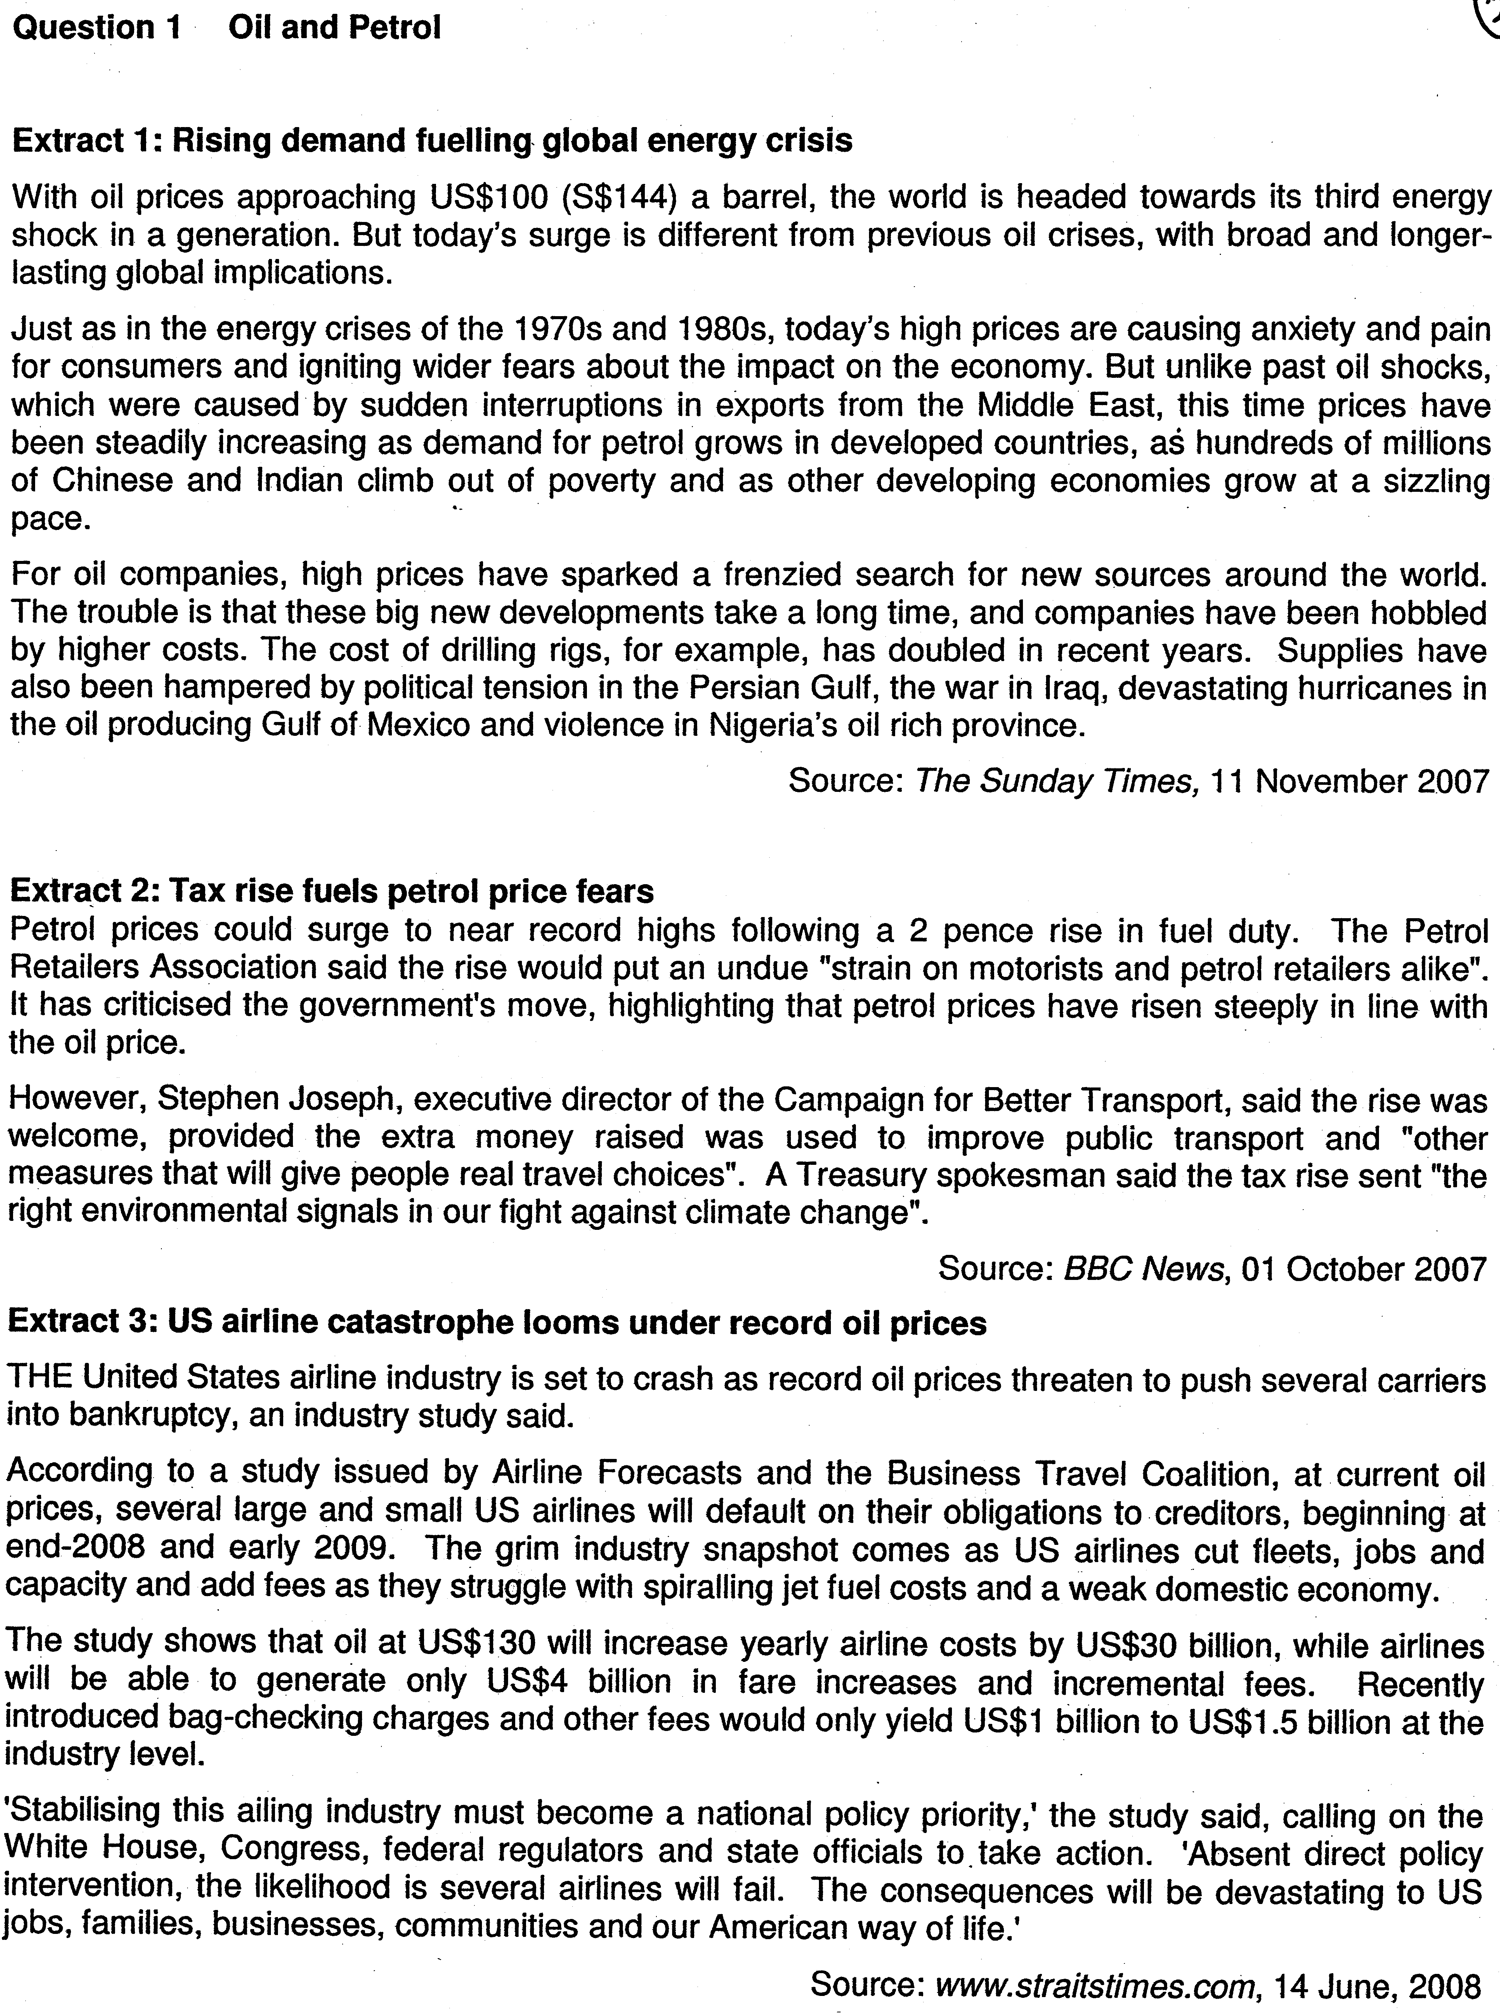

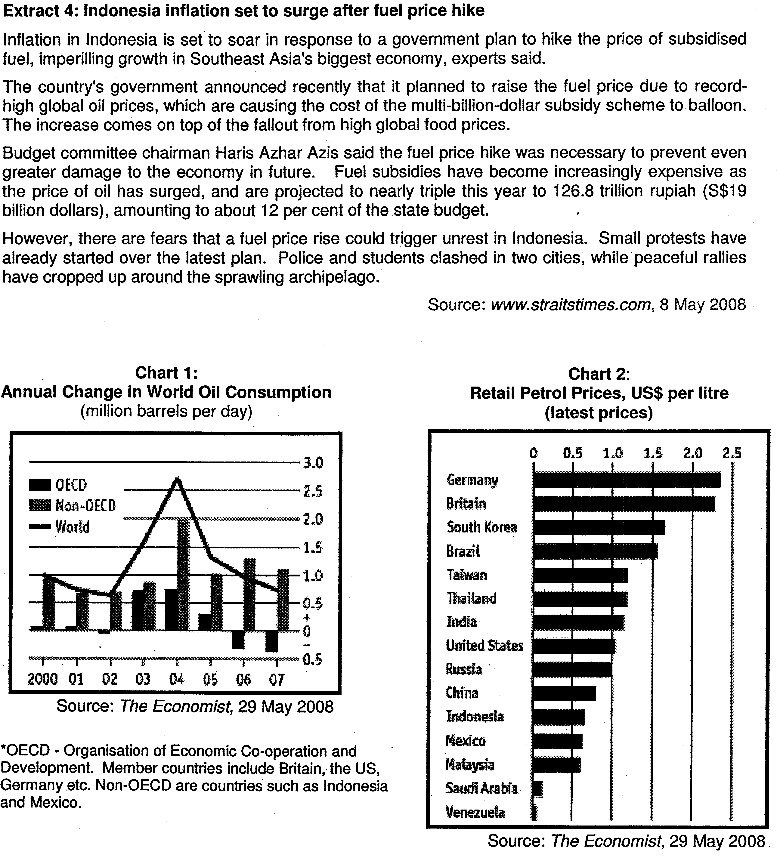

Questions
(a) (i) Compare the trend in oil consumption levels of OECD countries with non-OECD countries between 2004 and 2007 in Chart 1. [2]

(a) (ii) Account for this trend in the consumption of oil for OECD and non-OECD countries. [3]

(b) (i) Explain what is meant by allocative efficiency. [1]

(b) (ii) Using the data and your economic knowledge, discuss whether the imposition of a 2 pence fuel duty in Britain will lead to an efficient allocation of resources. [6]

(c) Based on Extract 3, analyse the possible impacts of an oil hike on the airline industry in the US and its economy. [8]

(d) In the light of the data provided, if you were an economic advisor to the Indonesian government, would you recommend the government to go ahead with the fuel hike in view of rising inflation? [10]

Suggested Answers
(a) (i) Compare the trend in oil consumption levels of OECD countries with non-OECD countries between 2004 and 2007 in Chart 1. [2]

Oil consumption by the OECD countries was decreasing over the period of time, whereas oil consumption by non-OECD countries was increasing but at a slower rate over the time period

(ii) Account for the trend in the consumption of oil for OECD and non-OECD countries. [3]

OECD countries' consumption of oil fell over the period due to higher retail prices of oil as the govt in these countries may have imposed higher fuel taxes. On the other hand, the non-OECD countries consumed more oil because the retail prices of oil were lower (Chart 2) possibly due to high subsidies given by the governments of these countries. Changes in consumption levels could also be due to other factors - such as higher consumption caused by higher growth leading to higher demand for oil.

(b) (i) Explain what is meant by allocative efficiency. [1]
Allocative efficiency is achieved when an economy uses resources to produce the right amount of goods which maximise the society's welfare. (SMC=SMB)

(b)(ii) Using the data and your economic knowledge, discuss whether the imposition of a 2 pence fuel duty in Britain will lead to a better allocation of resources. [6]

Thesis
Use of petrol fuel generates negative externalities (pollution and negative impact on environment)
- Costs to society more than costs to private motorists (SMC > PMC)
- Motorists do not take into account such side effects when using petrol
- So, may over consume it. (Qe > Qs)
- Inefficient allocation of resources as cost to society is more than benefit. (SMC > SMB)
- Welfare loss results
Increase in fuel tax will get more motorists to internalize the negative externalities → reduce usage of petrol to socially optimal level & thus maximize welfare → hence a more efficient allocation of resources.
- Tax is effective → it is easy to implement and the amount is only 2 pence (seems relatively small)
- Can also use the tax revenue to improve the public transport system to encourage to drive less in the long term, (maxi 4m)

Anti-thesis:
- To set an optimal tax rate, it should be equal to MEC.
However, difficult to impose the optimal level of tax because MEC is difficult to estimate (certain negative effects do not have a monetary value attached to it. Hence, may not be able to achieve allocative efficiency.

Explain how fuel tax results in internalisation of EC → reduction in usage of petrol
Explain the limitation of fuel tax

(c) Based on extract 3, analyse the possible impacts of oil hike on the airline industry in the US and its economy. [8]

- In the SR, a hike in fuel prices will have significant impact on the airline industry as fuel cost is a major component of total cost. Fuel costs increased by US$30b but airlines are unable to pass on the full costs to consumers resulting in a rise in revenue of only US$4b (Extract 3). Thus, many airlines may be faced with rising losses.
- In the LR, if more airlines reduce capacity or exit the industry, it would lead to other impact on the airline industry as well as the US economy:
- Airline workers lose jobs, unemployment rises & income falls in airline sector
- 4 Domestic travelling becomes more costly as businessmen find alternative ways to travel across the country. This raises the costs of certain business and may reduce profits.
- The fall in income in the industry also induce further fall in consumption and other sectors (such as retail and hotels) will suffer a fall in business and may be forced to cut costs by cutting jobs. Employment falls further.

- This reduces national income by multiple times and actual growth will decline. There may be a recession.
- Unemployment in the economy will also rise.
- SOL falls (i.e. American way of life)

- However, the fall in income may reduce import expenditure, which may improve the trade balance and current account although the fallout in the economy may lead to outflows of short term financial capital may worsen the capital account balance. Overall the impact on the balance of payment in the short run is not certain.

- In the long term, investments may decline as pessimism sets in.
- This reduces the capital stock and productive capacity of the country falls.
- AS may fall in the long run and potential growth is negatively affected.

(d) In the light of the data provided, if you were an economic advisor to the Indonesian government, would you recommend the government to go ahead with the fuel hike in view of rising inflation? [10]

As an economic advisor, the concern currently should be with the rising inflation which affects the purchasing power of the people (a fall in the internal value of money as GPL rises). A fuel hike will cause the price of fuel to rise which will worsen inflation in Indonesia.

Thesis: Give reasons why it should go ahead
Rising cost of oil → cannot keep on giving subsidies → strain on government budget
Fuel subsidies involve opportunity costs → less expenditure on other more important areas (such as infrastructure and education etc

Fuel hike may reduce consumption of petrol and improve efficiency in allocation of resources as prices of fuel move closer to eqm prices impact on efficiency and other macroeconomic goals (e.g. potential growth in LR)

Fuel hike also helps to reduce the usage of cars and reduce negative externalities and improve in allocation of resources.

Anti-thesis: Give reasons why it should not go ahead
Food prices are rising. If raise fuel prices now → inflation rate will rise further → Explain problems of rising inflation → rising rate of inflation has negative impact on investment, export competitiveness and SOL of the Indonesians.

Fuel hike will cause political fallout which may dampen investors' confidence and slow down Indonesia's growth in the SR → impact on NY and employment.

Synthesis
Fuel hike is a necessary action as subsidies on fuel put a strain on the govt's budget. In addition, subsidies also lead to a distortion in the prices of fuel and the artificially low prices of fuel encourage more consumption leading to allocative inefficiencies. However, given that the removal of subsidies may lead to a worsening of inflation, the govt may need to use other measures to dampen the inflationary pressure and also offer more assistance to help the people to better cope with the rising prices.

