CSQ 2010 Q3 – Inflation 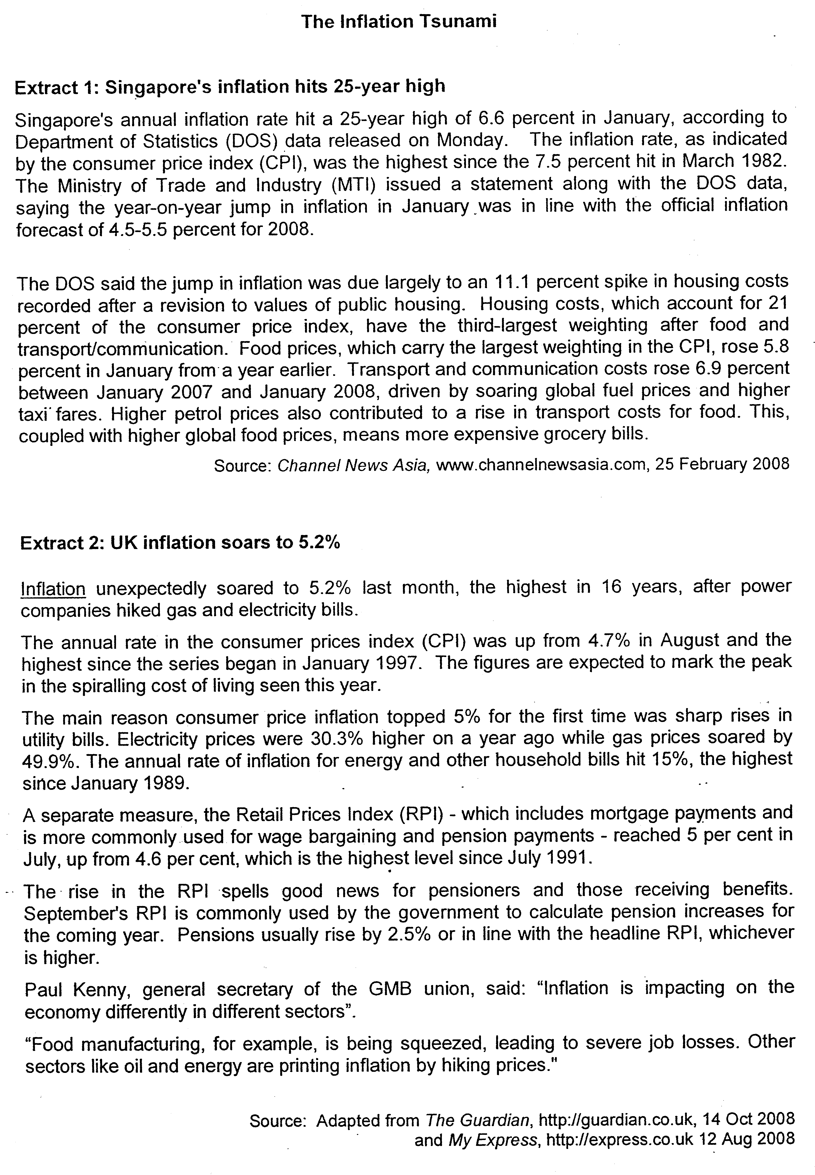
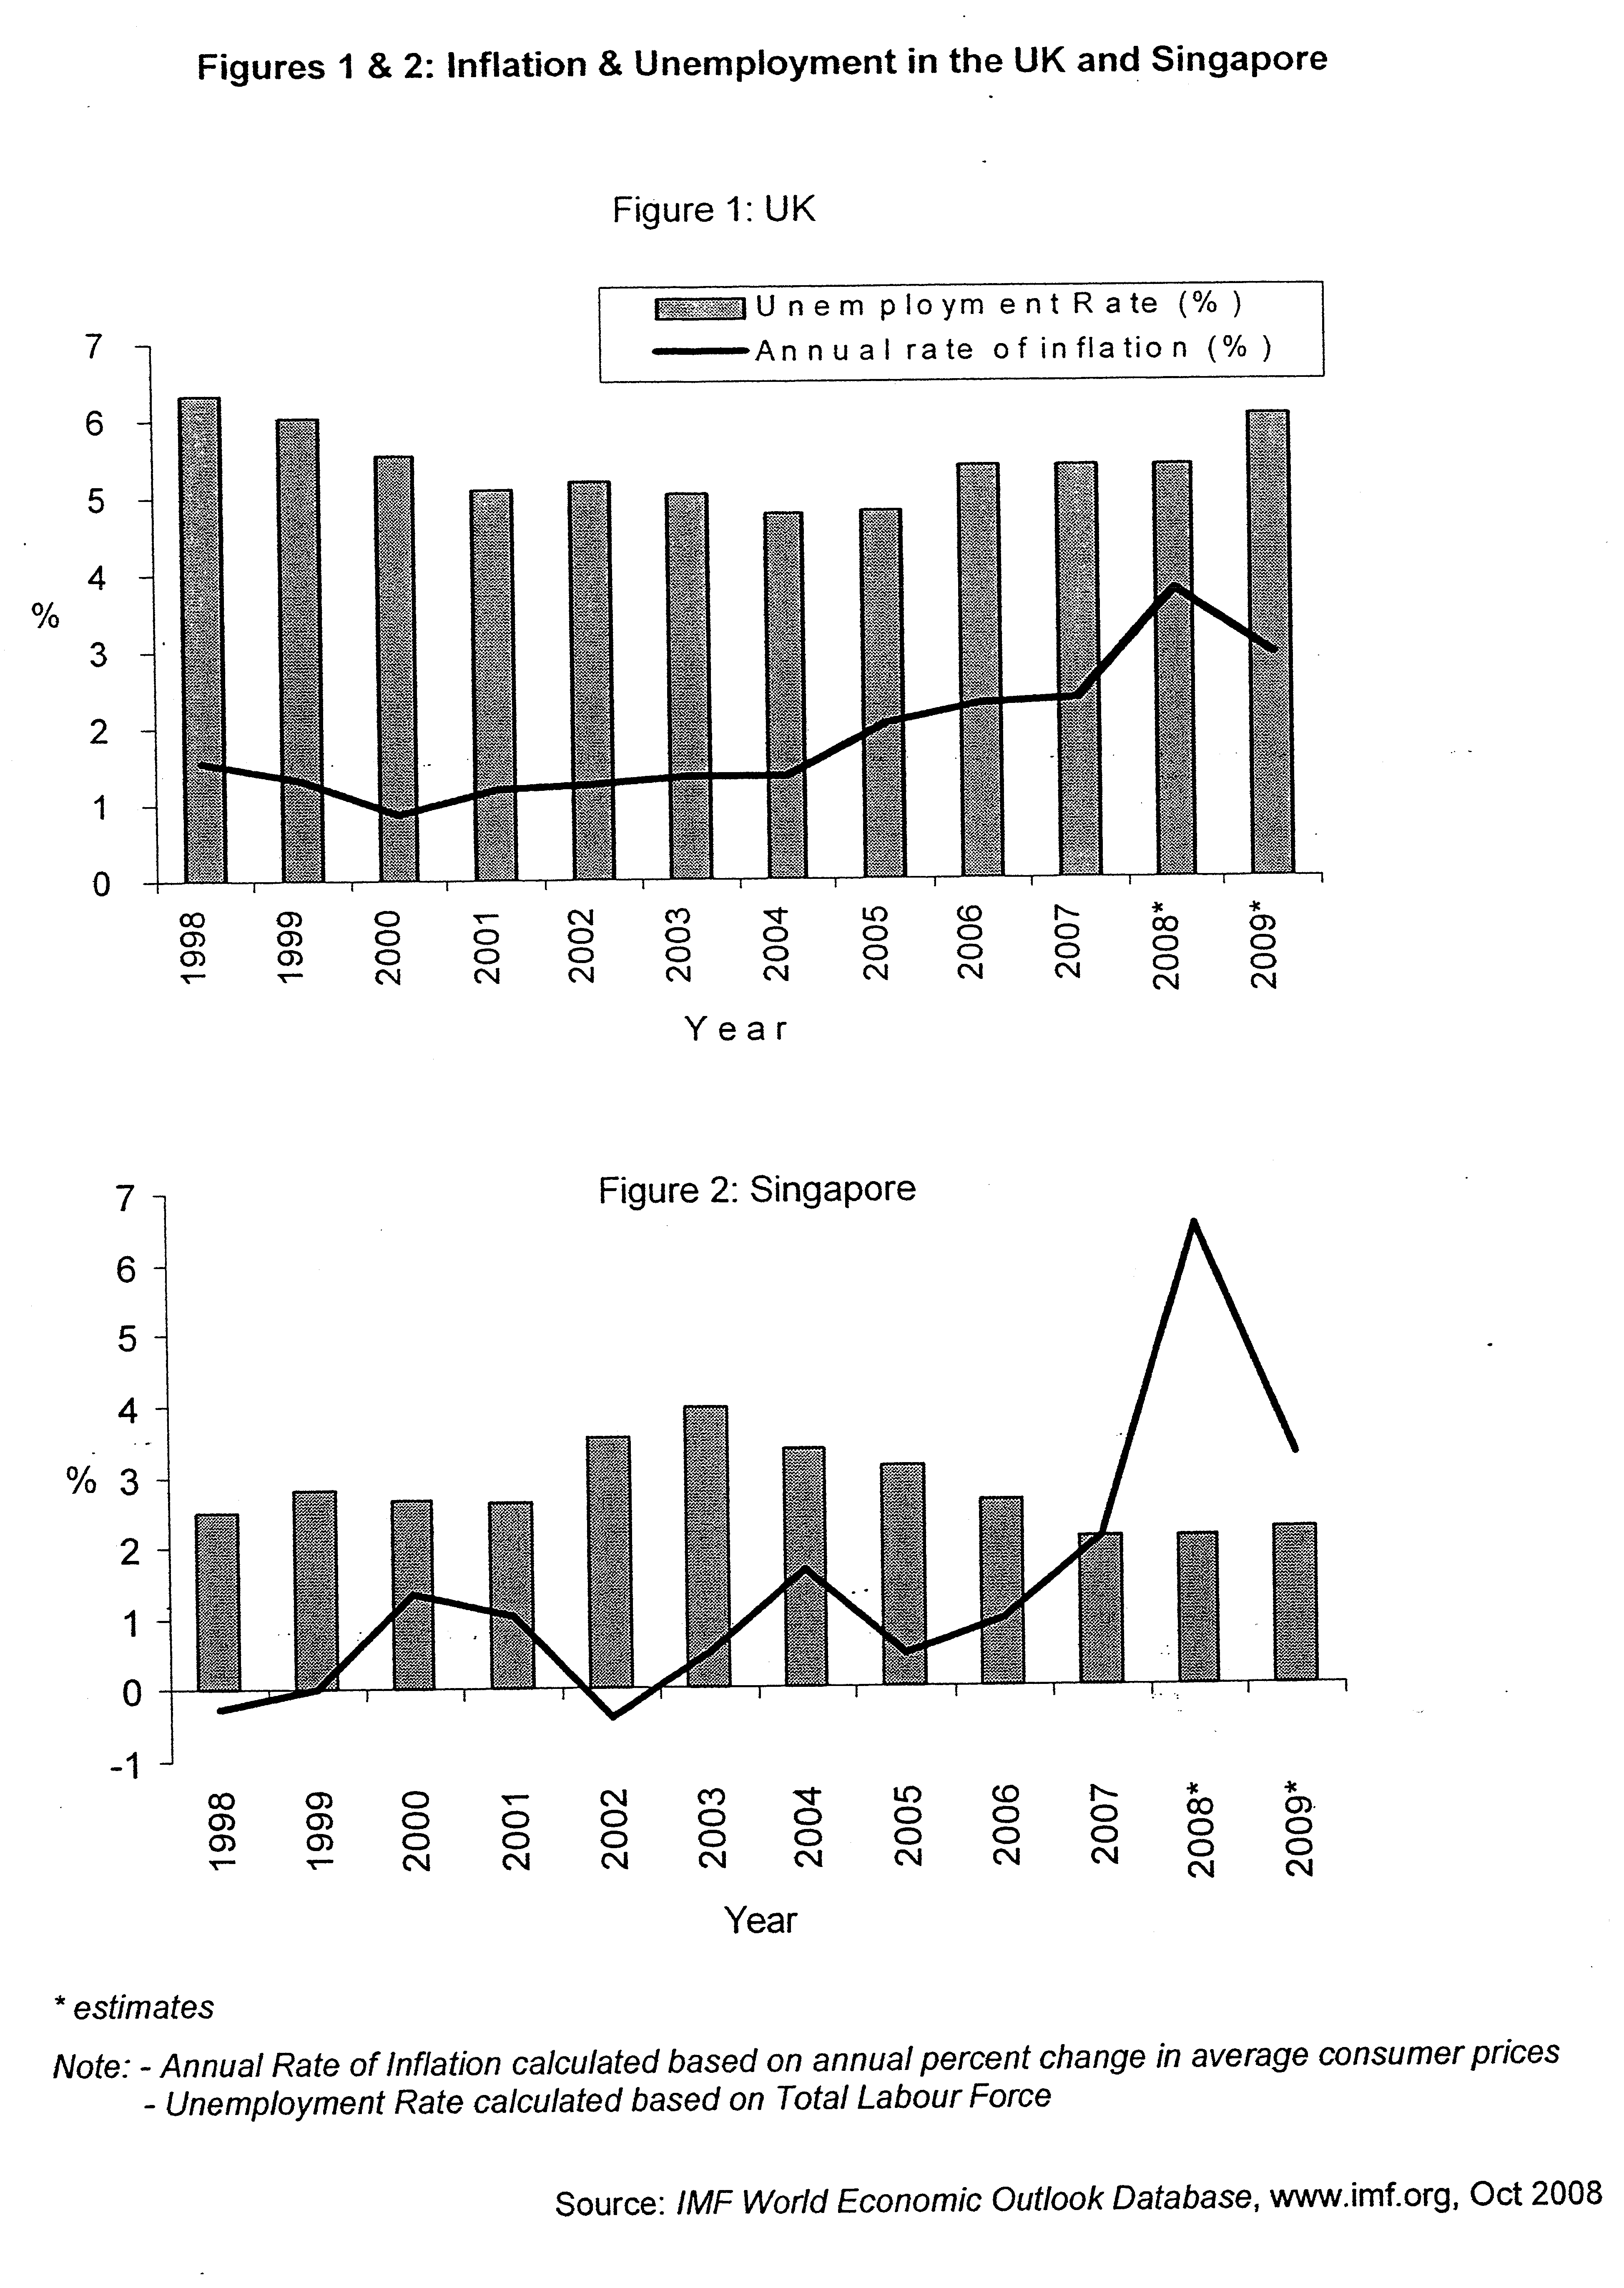

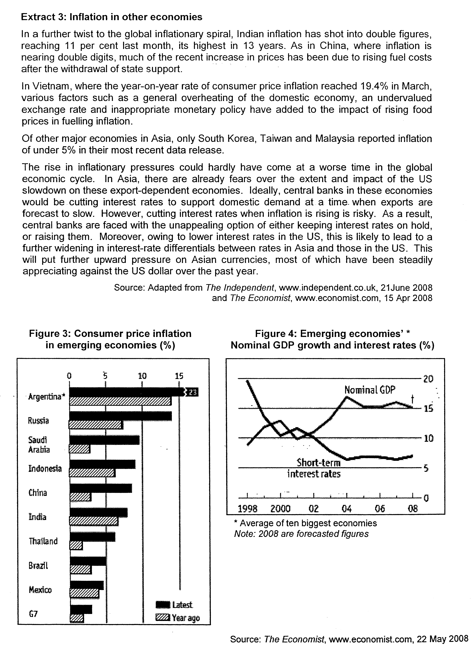

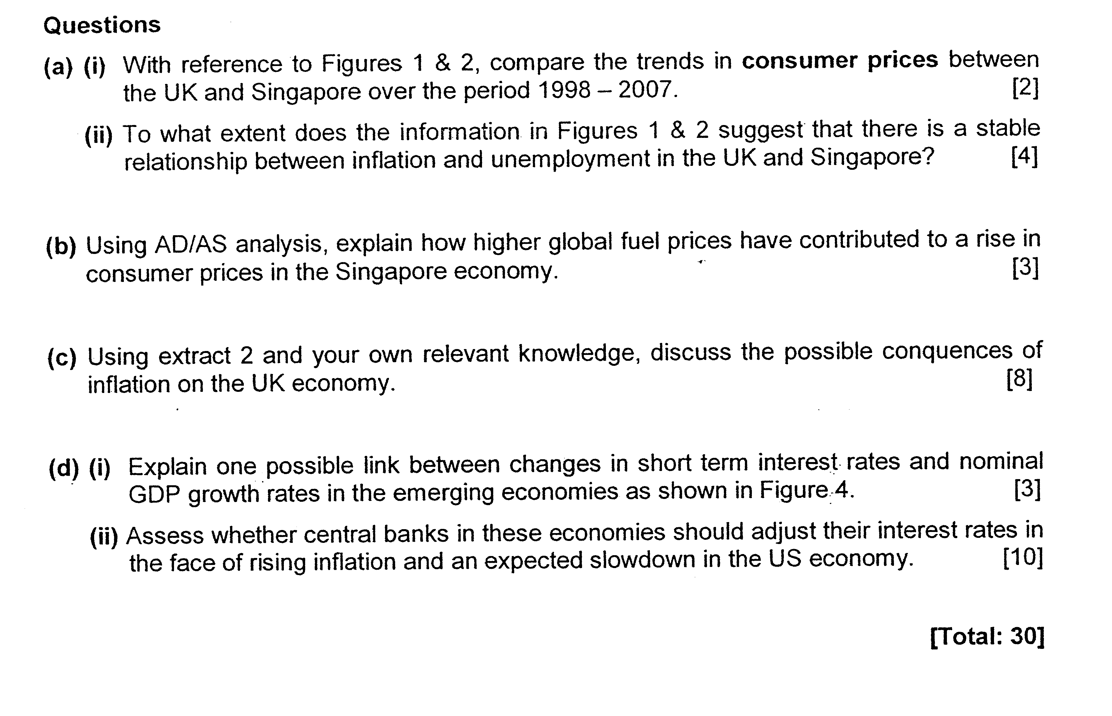

Case Study Q1 - Suggested Answers

(a) (i) Using Figures 1 & 2, compare the trends in consumer prices between the UK and Singapore over the period 1998 - 2007. [2] (identify similarity and differences)

Consumer prices have generally been rising in both countries over the years.

However, while prices in UK have been rising at a relatively steady rate, the rate of increase in prices in Singapore is more uneven. In addition, there were years where consumer prices fell in Singapore (2002 compared to 2001), unlike in UK where prices have always been rising every year.

Candidates need to recognise the similarities and differences.

(ii) To what extent does the information in Figures 1 & 2 suggest that there is a stable relationship between inflation and unemployment? [4]

A 'stable relationship' would exist if the both inflation and unemployment within the country exhibit a consistent trend with one another over the same period.
(inverse relationship)
As such, Figure 1 provided more evidence of a stable relationship. The variations in the rates of inflation and rate of unemployment are not significant. Throughout the period from 1998 to 2007, the year on year change in inflation and unemployment rate is consistent with each other.

However, such a stable relationship is not evident in Figure 2. There are greater fluctuations in inflation rate during the whole period compared to unemployment rate. While unemployment rate increases from 1998 to 2003, inflation rate fluctuates – it increases and falls and increases again - with the change in percentage point being greater.

Thus, the information in Figures 1 & 2 does not offer a clear conclusion that there is a stable relationship between inflation & unemployment.
(inflation can be stagflation, unemployment is structural)
A variety of responses as to whether there was a stable relationship between the 2 variables will be accepted provided the meaning of 'stable' is clearly stated and there are clear references to the data.

(b) Using AD/AS analysis, explain how higher global fuel prices have contributed to a rise in consumer prices in the Singapore economy. [3]

Higher fuel prices increase the petrol costs, which in turn raise the transport costs of firms.

Cost of shipping and importing goods becomes more expensive too.

Since Singapore imports all its raw materials, and many of its intermediate and final goods, this will inadvertently increase the average production costs for many firms.

This may cause producers to cut down on production to maintain profits levels, ceteris paribus, causing the aggregate supply to fall in the short run.

With a reduction in planned production and aggregate demand remaining unchanged, this will cause the general consumer prices to rise, as the higher costs is passed on down to the whole supply chain and ultimately to the consumers.

As seen from the diagram, the rise in fuel price will lead to a rise in the cost of production which can contribute to the leftward shift of the As from ASo to As1 and thus lead to rise in GPL from Po to P1 and a fall in real GDP from Yo to Y1.

(c) Using extract 2 and your own relevant knowledge, discuss the possible consequences of inflation on the UK economy. [8]

Inflation refers to a sustained and inordinate rise in general price level over a period of time. According to Extract 2, inflation in UK had soared to its highest level in 2008, based on changes in both CPI & RPL. This may likely bring about many negative consequences, although there are possible positive impacts as well.

With inflation, shoe-leather and menu costs are often incurred. Since each dollar can now buy fewer goods and services, households will demand more cash for transactionary purposes (e.g. for paying the utility bills etc) and this may necessitate more trips to the bank. This incurs time & effort. Firms, on the other hand, will have to adjust their price lists upwards to reflect the higher prices. Extra resources are again needed to carry this out. As a result, there are opportunity costs involved when there is inflation. Such opportunity costs will rise in UK if inflation rises.

Secondly, inflation can bring about inefficiency in the UK economy if it rises too rapidly and one is no longer able to anticipate the inflation rate correctly. When firms are no longer certain of the future costs and prices, they may find it difficult to predict the profitability of additional investments and are thus less willing to engage in such risky ventures. As a result, new investments may be less forthcoming. This can adversely affect the long run aggregate supply of UK as its productive capacity would now grow at a slower rate.

Inflation can also lower the ability of firms to invest. As mentioned in Extract 2, with energy prices rising by its highest rate since 1991, certain sectors in the UK are already suffering from lower profits (e.g. food manufacturers mentioned in Extract 2, para 7), causing unemployment to rise in these sectors. With fewer profits, such firms are less able to invest in capital goods and new technologies, negatively impacting on future growth.
Misallocation of resources
In addition, rising inflation may drive firms and household to hedge against the falling value of money. Resources may be diverted into other assets whose values are rising, such as properties and gold. However, these are usually non-productive assets, which do not really increase the productive capacity of the country. As a result, with more resources allocated in these areas, firms will have less funds to invest in new plants and machineries. Capital formation is adversely affected and growth in productive capacity may slow down in the long run. This will negatively impact on the potential growth of the UK economy.

Externally, inflation can adversely impact on the UK's balance of payments in the current account. If relative inflation rate in the UK is higher than its trading partners, then UK exporters (e.g. food manufacturers) will have difficulty selling their goods and services as the prices will now be relatively higher. Conversely, UK residents may turn to importing more as they are relatively cheaper than domestic goods. If export demand is price elastic, then export value will fall, while import expenditure will rise. This can worsen the balance of payments, assuming all other things are constant.

However, not all the consequences of inflation are necessarily undesirable. There are certain sectors that may actually benefit from inflation. As seen in Extract 2, oil and energy firms are actually earning more with inflation. This is because demand for such products is generally inelastic as they are basic inputs in the production of many goods and services. As such, with higher prices, their total revenue tends to rise as well. In addition, inflation can bring good news to pensioners and other people receiving state benefits (Extract 2, para 5) because such handouts are indexed to the inflation rates, although it remains debatable whether such nominal increases will actually raise their overall purchasing power.

In conclusion, the net impact of inflation on the UK economy depends very much on what are the underlying causes and whether it is anticipated or not. But given that the inflation is unanticipated (Extract 2 para 1), the soaring inflation that the UK is currently facing will therefore spell more trouble for the economy if it is not contained soon enough.

(d) (i) Explain one possible link between changes in short term interest rates and nominal GDP growth rates in the emerging economies as shown in Figure 4. [3]

There is inverse relationship between the 2.
Explanation: Any one:-
How decrease in interest rate affect investment through the concept of MEI – rise in GDP)
-Interest rate falls -> cost of borrowing falls -> If MEI > i/r -> profitable to borrow & invest more -> Investment rises -> AD rises -> stimulates production and output -> GDP growth rises (since GDP measures the total value of output produced within the country)

- Interest rate falls -> lower rates of returns from savings -> opportunity cost of consumption falls -> households have less incentive to save and more incentive to spend out of current income -> C rises -> AD rises -> stimulates production and output -> GDP growth rises

(how fall in interest rate affect the short-term capital flow – rise in GDP)
- SR interest rates falls (relative to other countries') -> lower rates of returns from saving in domestic currency -> more outflow of short term capital -> demand for domestic currency falls while supply of domestic currency rises -> currency depreciates -> export prices fall in foreign prices while import prices rise -> assuming Marshall-Learner condition is satisfied -> net X will rise -> AD rises -> -> stimulates production and output -> GDP growth rises

(ii) Using the information available, assess whether central banks in these economies should adjust their interest rates in the face of rising inflation and an expected slowdown in the US economy. [10]

(Consider the impact of a contractionary MP in controlling inflation)

- it influences the domestic source of expenditure - Consumption and Investment
- controlling inflation through market principle

- Limitations of the monetary policy (3 points)
- affect the capital flow is serious implication on the US as its capital flow is extensive, given the importance of US dollars
- sources of inflation – interest rate is not effective in controlling cost-push inflation and improted inflation
- impact of depreciation due tolow interest rate – stimulate rise in export demand on the economy, nullify the contractionary effect of low interest rate

Candidates should discuss the merits of using monetary policy to deal with the various economic problems plaguing the country.

First, they should consider the merits of changing interest rates. This can be done through various ways. For example, they could argue that by keeping interest rates constant, problems may worsen and then go on to explain how changing interest rates can at least help to deal with one of the economic problems, (for e.g., by raising interest rates, this can help curb inflation to a certain extent, or by reducing interest rates, this can help to deal with the unexpected slowdown in the economy). Alternatively, they could highlight some of the limitations of other policies (for e.g. fiscal policies involve more time lags etc) & then go on to explain how interest rates can be effective. Sound economic analysis should be evident when explaining how the policy works.

Secondly, candidates should consider the demerits of changing interest rates within the context of rising inflation and potential slowdown in economy. Focus should thus be on the potential conflicts in goals caused by changing the interest rates. (For e.g. lowering interest rates can worsen inflation).

Lastly, they should make a concluding assessment on whether central banks should adjust their interest rates. Judgement should be based on sound economic principles and the information provided in the case study (for e.g. using Figure 3 to decide which of the emerging economies will be more seriously harmed by adjusting the interest rates.).

