The oil market

Figure 1: World oil price
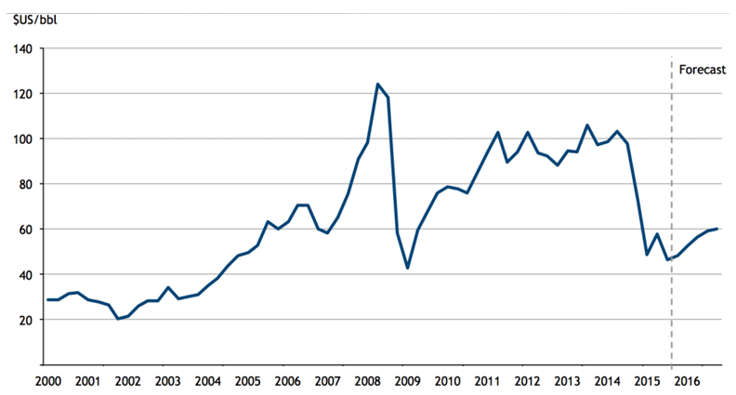
Source: Bloomberg, accessed 11 December 2015

Extract 1: Oil price plunge continues

The price of oil continued its steep fall on Friday, hitting five-and-a-half-year lows after the International Energy Agency (IEA) predicted demand next year would be lower than expected. Crude oil price has dropped 47% since June and fell to just over $61 a barrel. The oil price has plummeted in response to a massive build-up of shale-derived oil in the US through fracking, reduced fears of fighting in Iraq disrupting supplies, and due to the faltering world economy.

The Paris-based IEA singled out Venezuela as a potential flashpoint for trouble and the warning came as Venezuela’s currency, the bolívar, continued to lose close to 80% against the US dollar since the plunge in oil price. This is only part of an even bigger decline since Nicolas Maduro took office two years ago, and the oil price isn’t the only thing to blame. The fall in consumer investor confidence also contributes to the decrease in the economic activities that strongly affect the oil market in Venezuela.

But while the oil-producing countries face lost revenues and budget shortfalls, lower energy prices are expected to have a beneficial impact on the world economy. Many countries, particularly in Asia, are desperately dependent on foreign oil and gas imports, so cheaper prices should cut inflation and give impetus to manufacturing output and consumer spending. Analysts at investment bank ING said: “The recent fall in oil prices may not be sustained but, in the meantime, it provides a very welcome boost to real incomes for most major economies.”

Source: Adapted from The Guardian, 12 December 2014

Extract 2: US$20 Billion subsidy to fossil fuel industry

A joint investigative report by Oil Change International and the Overseas Development Institute reveals that, in the United States alone, the fossil fuel industry has benefitted from over $20 billion per year in government subsidies between 2008 and 2015.These subsidies occur throughout the fossil fuel exploration, production and transportation along the supply chain. This also means subsidizing oil spills, in which oil companies can write off the cost of clean-up as a business expense, including the 2010 BP oil disaster in the Gulf of Mexico. Subsidies are also used extensively in the research of new drilling technologies.

“Since the initial G20 commitment in Pittsburgh six years ago, US subsidies have increased dramatically in [the Obama] Administration, in line with the increase in US oil and gas production,” said Steve Kretzmann, executive director of Oil Change International. “The President can and must do more to eliminate subsidies at home amidst the growing government budget deficit and concerns on climate change.”

Source: Adapted from Overseas Development Institute, 12 November 2015

Extract 3: Renewable energy can’t replace fossil fuels entirely

While technological advancements have made it possible for renewable energy to be used in many of the same applications as fossil fuels, there are still some limitations. For example, the energy efficiency of electric vehicles is much lower than traditional cars. Additionally, renewable energy can never and will not replace oil, coal and gas entirely. As the world's higher-quality fossil fuel reserves rapidly deplete, no combination of alternative energy sources is likely to be enough to sustain industries at their current scale. Nonetheless, large government funds have been poured into the renewable energy industry as countries seek to increase their energy self-reliance, which may bolster their economic resilience and reduce their ecological footprint.

Alternative energy sources have their own issues, such as energy transfer or destruction of the natural habitat. Hydro energy involves building dams and this, in turn, will destroy the habitat of the river or lake they are placed in. The past and the foreseeable future still belong to hydrocarbons, and we can expect natural gas, the cleanest of the hydrocarbons, to garner a bigger share of the global energy pie in the near and long term.

Source: Adapted from The Straits Times Forum, 17 December 2015

Questions:
(a) Using Figure 1, compare the overall change in world oil price between 2000 and 2008 with that between 2009 and 2014. [3]

(b) With reference to Extract 1,

- Identify and explain two reasons for the fall in world oil price after 2014. [4]

- Is the price floor an effective solution to help the oil industry? [4]

(c) Extract 2 mentions subsidies implemented by the US government in the fossil fuel industry. Comment on the possible consequences of the imposition of such subsidies for the producers and consumers of fossil fuel, as well as the US government. [8]

(d) (i) Briefly explain the relationship between fossil fuels and renewable energy. [2]

(ii) Identify one possible opportunity cost of pouring large government funds into the renewable energy industry. [1]

