Economics CSQ – Wage Differences, Inflation and Unemployment

Workers in Sri Lanka

More people are being employed in Sri Lanka’s service sector. A number of skilled workers are, for instance, employed in the country’s banking industry. The manufacturing sector is also growing in importance. For example, the country’s clothing industry employs more than a quarter of a million workers out of a labour force of eight million people. Most of the workers in the clothing industry are young women, some of whom are relatively unskilled. In recent years, the industry has employed more capital goods, which has raised fixed costs as a proportion of total costs. The rise in investment has unsettled the industry and caused workers to become more concerned about their job security. Wage rates in the industry are low although bonuses increase the amount clothing workers can earn.

The largest clothing company in Sri Lanka is Brandix Lanka Limited. It uses its resources to produce both clothes and clothing accessories such as hangers. It sells its products to clothes shops in the European Union and in the United States of America. Brandix Lanka provides its workers with good medical facilities, as do many other clothing firms.

Sri Lankan workers and trade unions are pressing for wage rises for clothing workers. However, Brandix Lanka and the other clothing firms are concerned that higher wages may reduce their competitiveness against clothing firms in other countries, including Bangladesh, where wages are lower. The firms claim that increasing the wage they pay may cause unemployment and inflation. In 2010 there were half a million unemployed workers in Sri Lanka and its inflation rate was 5.9%.

Receiving higher wages might influence clothing workers in a number of ways. It might cause them to reduce the large amount of overtime they work. It may reduce the gap between their pay and the pay of bankers who, on average, are older than clothing workers. In addition, it might change their spending and saving patterns. Table 1 shows the income per head and the average amount saved per head in Sri Lanka from 2005 to 2010.

Table 1: Gross Domestic Product (GDP) per head and
the average amount saved per head in Sri Lanka 2005 – 2010

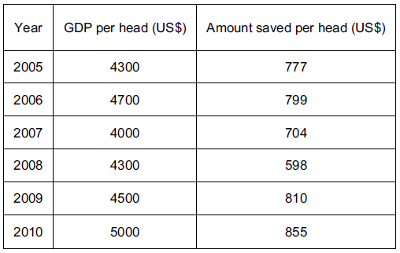

Questions
(a) What is meant by ‘fixed cost’? [2]

(b) Using a production possibility curve, explain how Brandix Lanka may allocate its resources between clothes and clothing accessories. [5]

(c) Using Table 1, comment on whether economists would expect to see the relationship shown between the changes in GDP per head and amount saved per head. [3]

(d) Using information from the extract, identify three reasons why someone may choose to work for a clothing firm despite the low wage. [3]

(e) Using information from the extract, calculate Sri Lanka’s unemployment rate in 2010. [2]

(f) Discuss whether trade unions increase unemployment. [5]

(g) Using information from the extract, explain two reasons why clothing workers are paid less than bankers. [4]

(h) Discuss whether an increase in wages paid to clothing workers will cause inflation. [6]

Suggested Answers
(a) What is meant by ‘fixed cost’? [2]

A cost that does not change with output in the short run.

(b) Using a production possibility curve, explain how Brandix Lanka may allocate its resources between clothes and clothing accessories. [5]

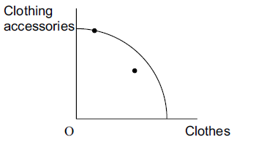

As seen from the diagram, Brandix Lanka would allocate its resources such that production is on the PPC, so as to optimize resource allocation. Production inside the PPC would be inefficient as not all resources have been fully utilized for production.

(c) Using Table 1, comment on whether economists would expect to see the relationship shown between the changes in GDP per head and amount saved per head. [3]

Yes, there is a relationship between changes in GDP per head and the amount saved per head. In 2008, there is an exception to this stated relationship. It is important to consider other factors that would affect the amount saved per head, such as the skill level of worker.

(d) Using information from the extract, identify three reasons why someone may choose to work for a clothing firm despite the low wage. [3]

Possible Reasons
- Unskilled worker
- Bonuses
- Presence of medical facilities
- Employment benefits

(e) Using information from the extract, calculate Sri Lanka’s unemployment rate in 2010. [2]

Unemployment rate for Sri Lanka in 2010 = 0.5m/8m x 100 = 6.25%.

(f) Discuss whether trade unions increase unemployment. [5]

Explain why trade unions would increase unemployment
- may raise wage costs for employers
- higher wage costs may encourage firms to use more capital intensive methods
- may cause firms to lose revenue through industrial action (lost production/sales)

Explain why trade unions would not increase unemployment
- may raise labour productivity through promoting training
- may reduce labour costs through collective bargaining and reducing conflicts
- may put pressure on the government to keep unemployment low

(g) Using information from the extract, explain two reasons why clothing workers are paid less than bankers. [4]

Possible Reasons
- differences in skills
- bankers, on average, are older
- many garment workers are women

Possible Explanation
- skilled workers are in shorter supply and higher demand than unskilled workers
- older workers have more experience/more likely to have been promoted
- there may be gender discrimination against female workers

(h) Discuss whether an increase in wages paid to clothing workers will cause inflation. [6]

Explain why increase in wages will cause inflation
- increase costs of production and so encourage firms to raise prices
- clothing industry is a significant part of the economy so a rise in clothing prices may have a noticeable impact (cost-push inflation)
- may encourage other workers to press for wage rises
- higher wages will be likely to lead to increased spending
- which may lead to inflation (demand-pull inflation)

Explain why increase in wages will not cause inflation
- higher wages may not raise costs of production if output rises by more/labour productivity rises
- other workers may not receive wage rises
- other factors may offset the rise in wages e.g. fall in raw material costs
- higher clothing prices may affect export markets more than the home market

