CSQ – Q3 – Aims and Policies
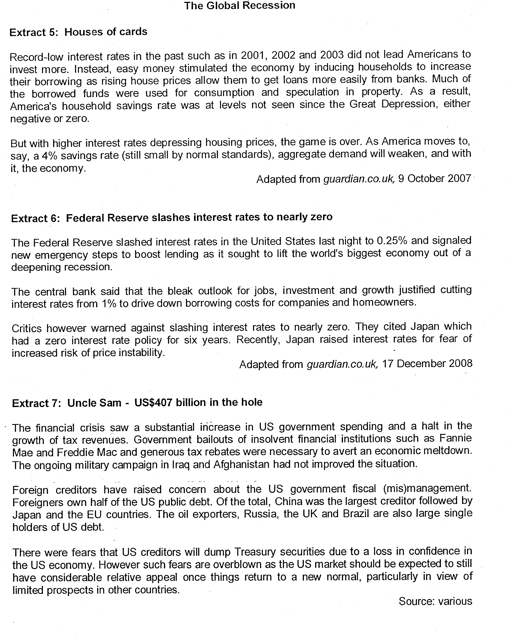

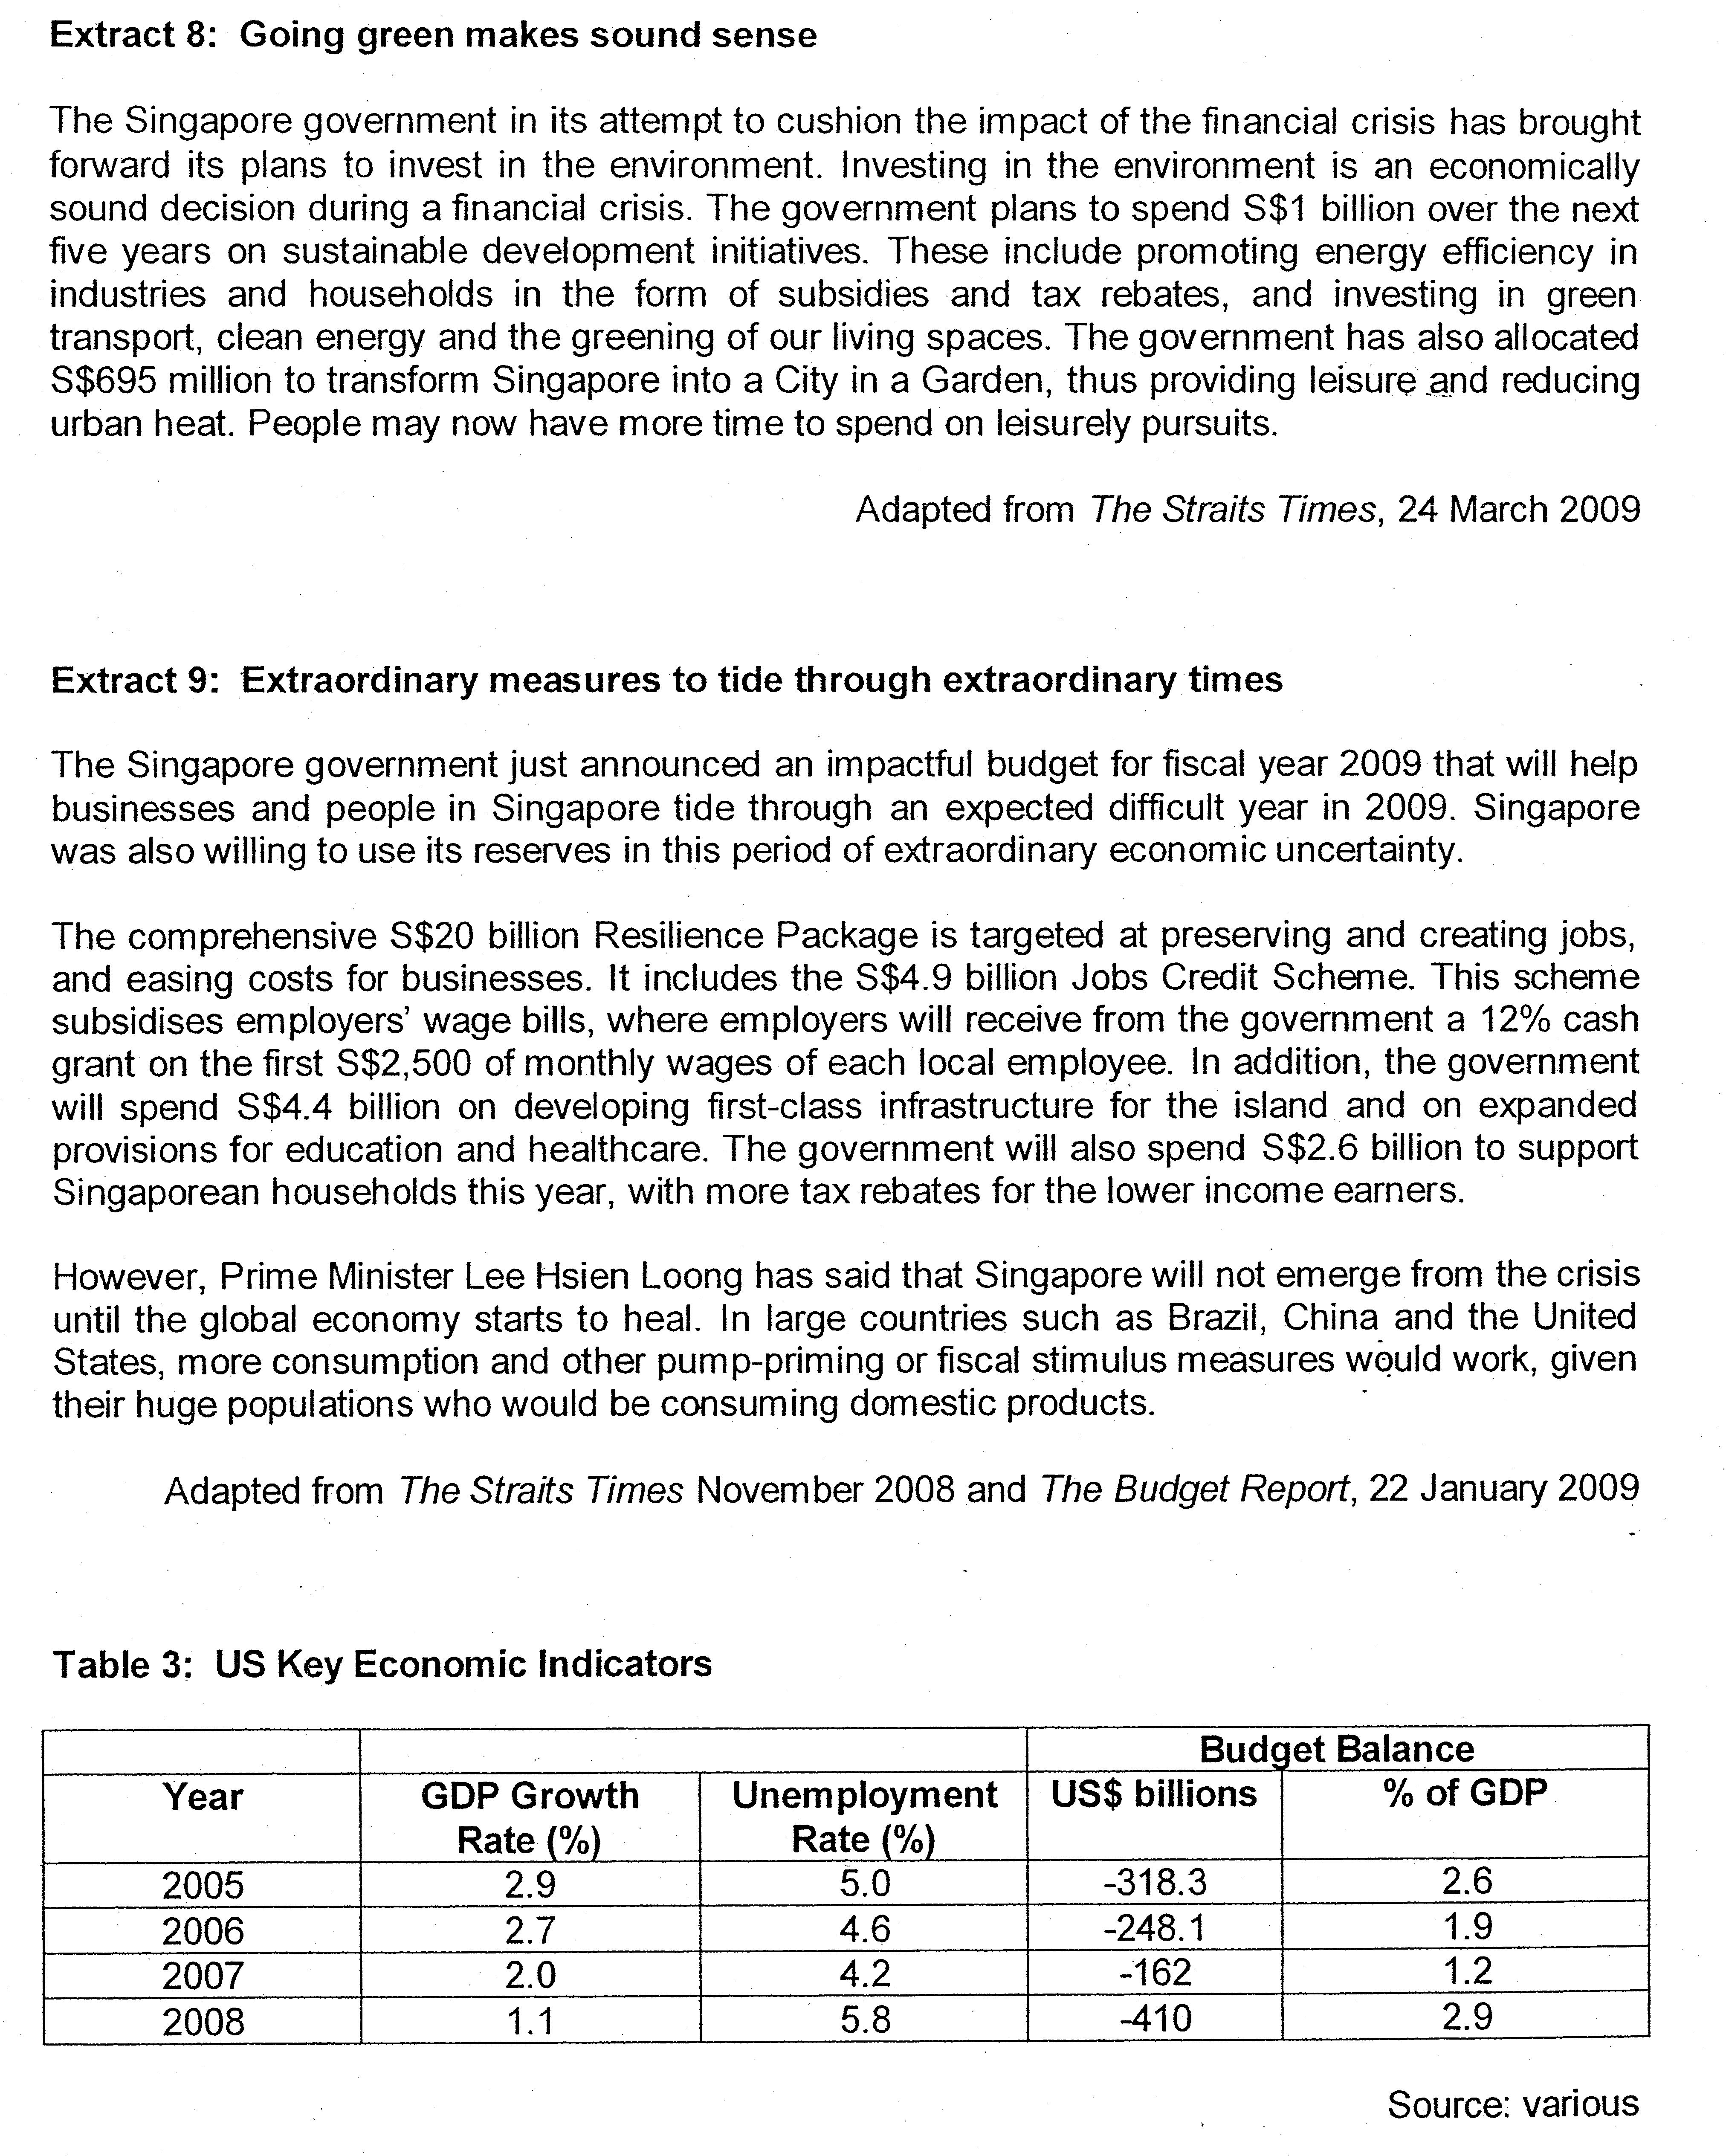

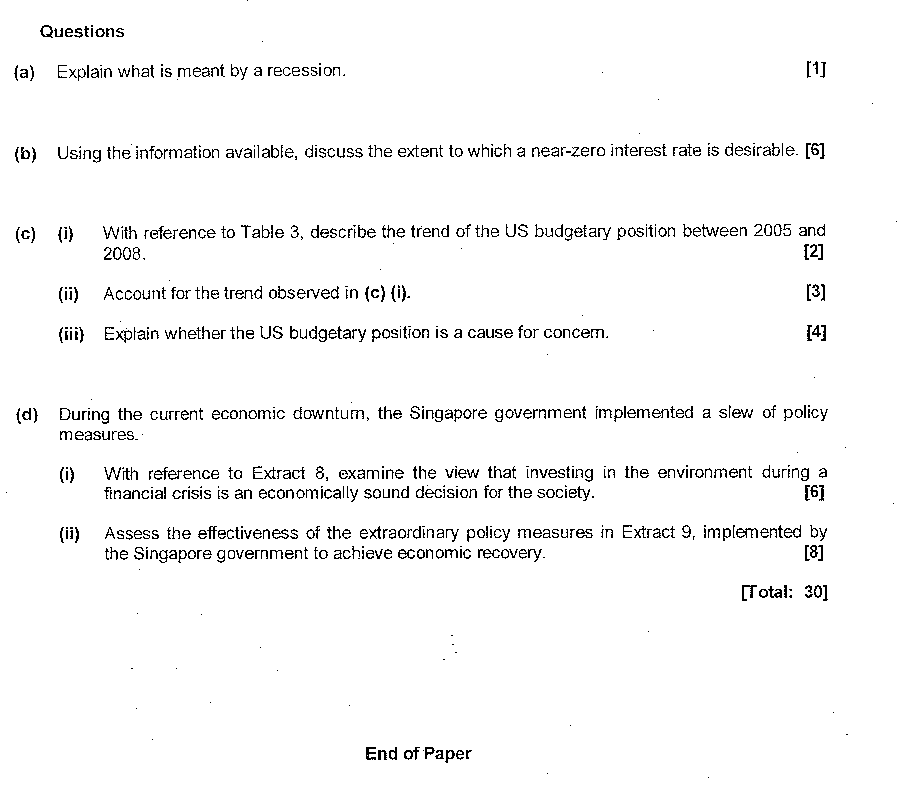

Suggested Answer:

(a) Explain what is meant by a recession. [1]

A recession refers the condition whereby there is fall in real GDP OR negative real GDP growth in two consecutive quarters.

(b) Using the information available, discuss the extent to which a near-zero interest rate desirable. [6]

It is desirable when there is a recession as the economy is experiencing ‘bleak outlook for jobs, investment and growth’ and this reduction in interest rate will "drive down borrowing costs for companies and homeowners’ which will induce an increase in consumption and investment. This will lead to an increase in AD which will cause a rise in national income and employment, and thus promotes economic recovery.

However, it is not desirable as the expansionary monetary has limitations under current situation whereby the borrowed money is used for speculation and the economy has recovered from a recession.

Case Material
1. Low interest rates in 2001 -> inducing households to increase their borrowing ->much of borrowed funds used for consumption and speculation
2. Household savings rate was at levels not seen since the Great Depression, either negative or zero.
3. Zero interest rate will increase risk of price instability.

Analysis
1. Increase speculative dd for housing -> increase price of houses -> further increase in speculative dd -> housing bubble -> collapse of housing bubble -> collapse of financial institutions like Fannie Mae and Freddie Mac ->loss of confidence -> fall in C and I ->recession
2. Fall in savings -> fall in funds available for investments LR -> fall in capital stock -> fall in potential growth
3. When the economy has recovered from a recession, zero interest rates will result in excessive borrowing -> increase in C and I ->increase in AD -> inflation

(c)(i) With reference to Table 3, describe the trend of the US budgetary position between 2005 and 2008. [2]

As seen from table 3, overall budget deficit has worsened. However, the deficit falls until 2007 but increased sharply in 2008. The budget deficit as a percentage of GDP falls but rises sharply from 2007 to 2008.

(c)(ii) Account for the trend observed in (c) (i). [3]

Budgetary Position
-Budget deficit worsen
Substantial increase in US spending and a halt in the growth of tax revenues.

Possible Reasons
Non-discretionarv FP:
•Severe recession: sharp fall in household income and corporate profits -> sharp fall in tax revenue
•Severe recession: sharp increase in G on welfare benefits due to sharp increase in unemployment

Discretionarv FP
•Rapid economic slowdown -> generous tax rebates ->less tax revenue
•Sharp increase in govt spending -> large purchase of banking assets
•Continued spending on Middle East war

(c) (iii) Explain whether the US budgetary position is a cause of concern. [4]

Yes, a concern

a. For the US
From Table 1 -> 4 consecutive years of budget deficit -> deplete reserves Increase borrowing from foreign creditors but foreign creditors may be unwilling to lend as there is fear that US may not be able to repay the debt (US creditors will dump Treasury securities due to a loss in confidence or foreign creditors raised concern over US fiscal mismanagement). Hence, US will have difficulty financing its spending. This will result in a fall in economic growth?

b. Consequences of Higher debt.
•Increase borrowing -> increase interest rate ->crowding out effect
•Increase tax rate to finance deficit -> disincentive effect on savings and work effortfall in potential growth
•Increase foreign debt -> outflow of interest payments + principal sum -> less income available to own residents -> fall in SOL

For US Creditors: Fear that the US may not be able to repay debt

No, not a concern
a. Budget deficit is less than 3% of GDP US still able to finance her loans

b. Many countries still willing to lend to US. US market is still very appealing to foreign creditors as there are limited prospects in other countries".

Hence US government continues to spendable to generate future growth enables them to repay their loans.

(d) During the current economic downturn, the Singapore government implemented a slew of policy measures.

(i) With reference to Extract 8, examine the view that investing in the environment during a financial crisis is an economically sound decision for the society. [6]

1. Economically sound decision: Ability of firms and govt to achieve their respective goals.

2. Firms: Aim to maximise profits (i.e. maximise total revenue or minimise total cost)

•Reduce cost of production

During a financial crisis, there is a fall in global demand↓total revenue of firms↓profits of firms. To buffer this impact of a fall in profits, the firm can aim to reduce its costs of production. Firms will now have greater incentive to incorporate energy saving considerations and adopt energy efficient technologies. This is especially so if firms can tap on some financial subsidies given by the govt who is now actively promoting energy efficiency in industries, as evident in Extract 9↑efficiency in production↓business costs, in both the short and long run. Hence this can benefit the firms to cope with the current fall in profits while at the same time, serve as a long term cost saving measure.

•Potential new energy-saving products to be developed and marketed

During a financial crisis, there is generally a fall in demand for factors of productionfall in prices of factor inputs, which may include R & D costs. Coupled with govt subsidies in promoting energy efficiency, the opportunity costs of engaging in R & D will fall. Hence, firms may take this opportunity to focus on R & D on development of potential energy- saving related productsmay result in creating a new market for these new products expectations of higher demand, revenue and hence profits in the future.

Comments: As time is needed to develop these potential energy-saving products, in the short run it is hoped that the cost savings firms enjoy from the use of energy efficient technologies is substantial enough to offset the fall in revenue so as to help firms stay afloat and sustain operations.

3. Society: Aim to increase efficiency in resource allocation & non-material SOL

•Increase efficiency in resource allocation

During a financial crisis, the govt has brought forward its plans for non-economic concerns such as the environment, as evident in Extract 9.

Besides serving as a means of injecting money to stimulate the economy in the short run, more importantly, if investing in these sustainable development initiatives proves successful in the long run e.g. investing in green transport and clean energycan help to reduce greenhouse gas emission & urban heat↓pollution level↓negative externalities↓deadweight loss↑efficiency in resource allocation & hence SOL

Comments: Opportunity costs in channelling these funds for investing in environment, in terms of foregone government expenditure in other areas to stimulate the economy. Have to ensure that the long terms benefits derived is greater than the costs involved, so as to justify its expenditure on non-economic concerns such as the environment.

•Increase non-material SOL

During a financial crisis ↓global demand ↓production ↓employment more time to spend on leisurely pursuit, visiting parks with family members, bonding etc. Coupled with the increased availability of these amenities for the public which is a result of the increased govt spending to transform S'pore into a City in a garden -> serves as an incentive to make better use of these amenities↑non-material SOL

Comments: If pressure /stress from retrenchment overwhelmingly↑non-material aspect from leisurely pursuit overall SOL may fall.

(d) (ii) Assess the effectiveness of the extraordinary policy measures in Extract 9, implemented by the Singapore government to achieve economic recovery. [8]

Root Cause: Cyclical Unemployment due to global recession (hence fall in AD)

Policies
1. Jobs-Credit Scheme

2. Tax rebates for all, especially more for the lower income group

3. ↑G on healthcare, education

Strength
1. Aim: To retain jobs.
With subsidies from government on wages of workersreduces their cost of retaining and hiring employees↓retrenchment of workersworkers continue to work and have the means to support their familiesShort term stop-gap to tide families through this recession

2. •↑Yd↑C↑AD (adjustment process) via multiplier effectmultiplied increase in production, employment and income
•For lower income group, as their MPC is higher than the higher income group -^ with tax rebates extended to them -^ able to boost C by a greater extent.

3. Aim
• SR:↑G↑ADadjustment processvia multiplier effectmultiplied increase in production, employment and income
• LR: ↑labour productivity ↑productive capacity ↑potential growth.

Effectiveness
1. •But wages are only part of the total cost of doing businessmay not be sufficient to lower COP↓productionretrenchment of workers
•Issue of sustainability due to high OC(cost to the govt S$4.5 billion)
•temporary and not a permanent schemeif global econ downturn were to drag, which is a high possibilityscheme may not be sustainable.

2. May not be very effective in helping S'pore to emerge from the recession, as compared to a large country such as US.

Reason: Spore small sizevery small domestic marketC comprises small % of GDP, as compared to a large country like USA with huge domestic market

• Open economy, very import dependent. Every dollar of spending would result in 51cents leaking out of the economy, as almost all of what Singaporeans buy is imported high MPM large leakages
•People may not be willing to spend due to poor outlook of future. Tendency to save instead
•Hence with MPM and MPSsmall multiplier valuelimit effectiveness of fiscal policy in stimulating AD to increase income as increase in AD will not increase national income significantly
• Hence aim of this policy was to buffer impact of recession, not to emerge from recession

3. • May not solve the immediate effect of AD, as it is positioned for LT growth. Time is needed to train workers. Firms may however not be willing to send workers for training as there will be loss of output during training. Workers also face difficulties in learning new skills especially the elderly
•↑Govt spending comes from taxpayers, thus creating burden on taxpayers. Raising tax rate to finance such areas may lead to disincentive to work, save and invest, which may affect future economic growth.

Conclusion
• Singapore has the resources in terms of her reserves, to respond to the immediate needs of businesses and households. However, there are limitations to the effectiveness of the policy responses implemented by the Singapore government. Being a small open economy that relies heavily on international trade, Singapore has little chance of averting a sharp downturn regardless of the amount of money it pumps into its economy. Singapore has the world's highest trade to GDP ratio, with imports and exports amounting to 3.5 times its GDP. That means the economy is particularly sensitive to changes in the global economy.
• As such, the Resilience Package will not get us out of the recession, as long as the global economy continues to contract. But it will help avert an even sharper downturn, and more lasting damage to the economy. The government will help buffer the impact of the economic downturn on Singaporeans and businesses and hopes to position Singapore to be ready to meet the new demands as the global economy eventually recovers.

