ACJC 2020 Prelim Econ 8823 Paper 1
Suggested Response

(a) Using the information in Table 2, explain which country has the highest living standards. Comment briefly on the effectiveness of these indicators as a measure of living standards. [6]
Question Requirement: Candidates are expected to select the relevant indicators to ascertain that Argentina has the highest living standards. Next, candidates are required to comment on the limitations of each of the identified indicator.

Suggested Response:

Material SOL
- In material terms, living standards is reflected by the amount of goods and services that residents in a country can enjoy.
- GDP per capita (PPP) is suggestive of living standards as it measures average income earned by residents from the production of output. Moreover, GDP per capita (PPP) is an appropriate tool for cross-country comparison. PPP measures the amount of foreign currencies needed to buy the same basket of goods and services in two countries. PPP exchange rate thus equalise the purchasing power of different currencies by removing the different in price levels between different countries.
- Given the above justification, Argentina has the highest material living standards.

Non-material SOL
- In non-material terms, living standards considers factors that are not reflected in national income statistics, such as access to and standard of education and health care.
- Literacy rate measures the percentage of people above 15 years old who is able to read and write basic statements. With that, literacy rate is indicative of access to basic education. Higher literacy rate would suggest that the population has better access to basic education.
- Given the above justification, Argentina has the highest non-material living standards.

Overall comment
- In sum, Argentina has the highest living standards based on GDP per capita (PPP) and literacy rate.
- GDP per capita (PPP) is limited in its effectiveness as a measure of material living standards. GDP data in some countries may be inaccurate due to the ‘shadow economy’ where activities generating income are not reported. With that, GDP per capita (PPP) may underestimate the material living standards of residents within a country.
- Literacy rate is limited in its effectiveness as a measure of non-material living standards. Literacy rate is useful to suggest that a country’s primary education system is effective. However, the indicator is not able to provide information regarding quality of education beyond that level.

(b) Using AD/AS analysis, and with reference to Extract 6, explain how higher wages offered in the US may affect Mexico’s real national income and general price level. [4]
Question Requirement: Candidates are required to explain how higher wages in the US could affect the labor market in Mexico. Next, candidates are required to explain the impact of the above on Mexico’s real national income and general price level.

Suggested Response:

EITHER
Explaining the change in supply of labour:
- According the Extract 5, workers are able to earn much higher wages in the US compared to in Mexico.
- Higher wages in US would incentivize workers in Mexico to migrate to US and Mexico may suffer from a brain drain decrease size of labour force in Mexico.
- In addition, there is a lack of incentive to increase education. This is because Mexican workers are able to go to the US and earn a higher salary.

Impact on Mexico’s economy:
- The fall in quantity and quality of labour leads to a falling/stagnant LRAS.
- May lead to decrease or stagnant national income in Mexico as well as an increase in GPL.

OR
Explaining the change in aggregate demand:
- According the Extract 5, workers are able to earn much higher wages in the US compared to in Mexico.
- Higher wages in US would incentivize workers in Mexico to migrate to US and Mexico may suffer from a fall in population size decrease size of domestic market in Mexico fall in C fall in AD.

Impact on Mexico’s economy:
- The fall in size of domestic market lead to a fall in C; thus, a fall in AD.
- Real national income and GPL would fall assuming Mexico’s economy is near full employment.

Suggested Response:

Explaining the impact of slashing taxes on AD, and hence GPL:
- Extract 9 mentioned that Mexico’s government is reducing corporate and income tax.
- A fall in corporate tax would lead to an increase in after-tax profits. Firms could utilize their after-tax profits to invest in capital goods. As such, investment expenditure would increase.
- A fall in income tax would lead to an increase in disposable income. Consequently, households’ purchasing power would increase thus leading to an increase in consumption expenditure.
- An increase in C and I would lead to an increase in AD as AD = C + I + G + (X-M)
- There will be less idle resource as AD approaches full employment. Firms would then have to bid up prices for factors of production. With that, wages would increase and households would be willing to pay a higher price for goods and services. As a result, GPL increases.

Explaining the impact of doubling minimum wages on SRAS, and hence GPL:
- The increase in minimum wage could correspond to an increase in cost of production if improvements in productivity does not keep up.
- The increase in cost of production would result in a fall in SRAS.
- Firms would pass on the increase in cost of production to households through higher prices; thus, translating to an increase in GPL.
- Therefore, GPL is likely to increase due to an increase in AD and a fall in SRAS in the short run.

Explaining the impact of the change in LRAS on GPL:
- In the long run, the above-mentioned investment expenditure could improve the quantity/quality of factors of production and the level of technology in Mexico.
- More workers returning to Mexico due to min wage doubling increase quantity of labor
- As a result, Mexico’s productive capacity would improve thus translating to an increase in LRAS.
- The increase in LRAS would lead to a fall in GPL as there would be more idle resources and firms do not need to bid up prices of factors of production.

(d) (i) With reference to Figure 1, compare the trends in returns to education for the different levels of education in Mexico from 1996 to 2014. [2]
Question Requirement: Candidates are expected to identify one similarity and one difference regarding the trends of the variable ‘returns to education’.

Suggested Response:

Returns to education for all levels fell from 1996 to 2014. [1]

Returns to university education was always highest, followed by senior high, junior high, and lastly primary education. [1]

OR: Returns to university education experienced the greatest decrease compared to the other levels of education. [1]

Suggested Response:

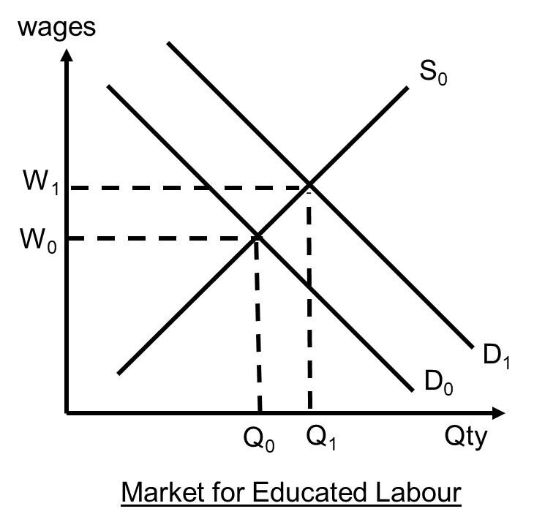
- As small firms merge, they form larger firms that require skilled labour such as accountants and engineers.
- This will increase the demand for labour
- At the original wage W₀, the quantity demanded for labour exceeds the quantity supplied and there is a shortage. There is an upward pressure on wages, increasing the wages of educated workers to W₁.

(e) With reference to Extract 8, assess the impact of a government “encouraging those working abroad to return home” on an economy. [9]

Command Candidates are required to provide a balanced perspective on the impact of return migration on an economy. The impact of on economy could be in terms of any macroeconomic aims of a government. Finally, candidates would need to weigh the relative outcomes.
Content Macroeconomic aims (economic growth, GPL, unemployment rate)
Context Mexico

Suggested Response:

- Introduction Impact on economy refers to how macroeconomic aims of a government would be affected
- The return of residents working overseas would have both positive and negative impact on the home economy
- Positive impact Transfer of knowledge (Extract 8: migrants could bring in knowledge regarding new technology and management of business process) improvement of QQT increase productive capacity translates to potential economic growth
- Returning migrants encourages innovation at firm level Increase in investment expenditure increase in AD firms respond to an increase in AD by increasing production real national output increases translates to actual economic growth
- Increase is size of domestic market + fall in income tax rate increase in number of consumers + increase disposable income; thus purchasing power increase consumption expenditure increase in AD firms respond to an increase in AD by increasing production real national output increases translates to actual economic growth
- The increase in production would lead to an increase in derived demand for labor fall in unemployment rate
- Potential + actual economic growth sustained economic growth create employment opportunities + improve living standards both in the short and long term
- Evaluation Transfer of knowledge and innovation may not lead to productivity gains; particularly if workers (not returnees) are not equipped with the appropriate skills to harness the use of new methods of production.
Negative impact
- Demand-pull inflation in the short term as explained, aggregate demand would increase due to an increase in C and I There will be less idle resource as AD approach full employment level to increase output producers would have to bid up prices of factors of production; wages would increase with higher wages, households are willing to pay more because of low unemployment and strong confidence in the translates to demand-pull inflation
- The introduction of technology into the economy could cause a mismatch between skills and job requirements in the labor market. New technology could change production techniques which results in labour saving or new skills required to hand new and more advanced equipment and machinery create unemployment for those who are not retrained or equipped with new skills structural unemployment
- Evaluation Demand-pull inflation would have an adverse effect on the living standards of household that are without income or living on fixed income. Having said that, demand-pull inflation is a short-term problem and the Mexico economy would experience disinflation or even deflation as its productive capacity improves.
- Impact on unemployment rate would be minimized if the structurally unemployed are provided with retraining opportunities.
- Conclusion In conclusion, there are both positive and negative implications of encouraging citizens based overseas to return home.
- The overall impact on an economy is contingent on a government’s ability to anticipate and mitigate unintended consequence.
- Governments could ensure that the process of encouraging emigrants to return home is gradual. A gradual approach could allow governments to calibrate the policy to minimize any negative outcomes.

(f) Extract 8 states that “if only the supply of human capital could be enhanced and increased, then growth would accelerate.”

Discuss the view that raising the level of education is the best way for Mexico to increase living standards. [12]

Suggested Response:

Introduction
Increasing living standards is a macroeconomic aim of government.
Raising level of education is one possible way for Mexico to raise living standards. However, such an approach does have its limitations and other policies would be needed to ensure the efficacy of raising level of education. Moreover, living standards is multifaceted and no single policy is sufficient to increase living standards across every measure.
Body Paragraph 1: Raising level of education to improve living standards
Impact on material SOL:
- Increasing the level of education enables more Mexicans to obtain better education and qualifications.
- With better education, workers can easily find jobs and are less likely to suffer from structural unemployment.
- They also become more productive, enabling them to obtain higher paying jobs and increasing their wages.
- Overall, there would be an increase in disposable income, allowing for a higher level of consumption, thus increasing the material standard of living.

Impact on non-material SOL:
- Increasing the coverage and quality of education should also improve the literacy rate in Mexico.
- With an improved literacy rate, households are able to make better decisions about their lives, such as seeking medical help where needed. They will be able to follow politics and practice active citizenship, helping to improve social stability.
- All these lead to a better quality of life, improving the non-material standard of living.
Limitations/Unintended consequence
Insufficient demand for educated workers:
- According to Extract 6, Mexico’s economy consists of many small firms that only require workers with basic literacy and numeracy. These firms are unable to utilise high skilled labour effectively. As such, there is a lack of demand and jobs for high skilled labour in Mexico.
- Even if workers obtain higher levels of education, they would be unable to find better jobs, and unlikely to experience any increase in wages.
- Many workers may end up being over qualified and experience under employment.
- According to the data, the literacy rates in Mexico is rather high (compared to Argentina and Brazil) indicates that level of education is not a main concern

Responsiveness of workers:
- Even with the availability of good quality education, workers may not have the incentive to take up these opportunities and improve their level of education.
- Thus improving the coverage and quality of education may not have a significant impact on living standards in Mexico.
Transition
Given the above-mentioned limitations, the Mexico government could consider other policies that could mitigate the abovementioned limitation. Such policies should serve to provide educated Mexicans with employment opportunities.
Body Paragraph 2:
Economic restructuring to increase demand for skilled labor
Mexico government could play an enabling role of encouraging firms to adopt automation and to redesign jobs to improve productivity. The government could do as such by providing funding for firms to build digital capabilities. For example, the government could provide firms with digital solutions related to warehouse management for the manufacturing and trade industry. In turn, firms would require a pool of digital workforce to operate such digital systems.

Impact on material SOL:
- Increase demand for educated workforce
- Increase in equilibrium wage for educated workforce
- Overall, there would be an increase in disposable income, allowing for a higher level of consumption, thus increasing the material standard of living.

Impact on non-material SOL
- Higher wages allow workers to have access to better quality healthcare services. Access to preventive clinical services could detect and prevent serious diseases
- Income tax revenue could increase following an increase in wages among workers. The government could use the tax revenue to finance public services in areas of healthcare and education. All of which would serve to improve non-material SOL; thus paving the way for Mexico to be on par with Argentina in terms of adult literacy rate and life expectancy.
Limitations/Unintended consequence
Government budget position:
- The Mexico government is looking to slash income and corporate tax. The loss in tax revenue could moderate the efficacy of economic restructuring. This is because the government may not have sufficient budget to finance solutions that would bring about an industry-wide impact.
Receptiveness of firms:
- Firms may be resistant to changing their methods of production. Firms may view restructuring as a disruptive process that could hurt their short-term profits/lose clients or customers.
Transition
The above analysis has considered how education and employment opportunities’ could increase living standards can increase through education and employment opportunities. In addition, living environment needs to be considered particularly because of the possible unintended consequences of the Mexico government’s plan to stimulate economic activity (Extract 9)
Body Paragraph 3:
Policies to mitigate possible negative consequences of growth in light of tax reduction
The Mexico government could implement a carbon tax to could lower greenhouse-gas emission. The tax charges a fee on how much carbon firms emit. Firms could be incentivize to find ways to avoid paying the tax. As such, firm may start to use alternative sources of energy that emit less carbon or adopt clean coal technology.

Impact on non-material SOL
- The implementation of a carbon would not only prevent living standards from worsening but could also improve living standards.
- Likelihood of residents having respiratory illnesses due to air pollution would fall
Limitations/Unintended consequence
Enforcement Capacity:
- Efficacy of the policy is dependent on accurate reporting of carbon emissions

Unintended consequence
- Carbon tax could lead to an increase in COP; thus fall in SRAS and real national output
Conclusion
In conclusion, the Mexico government would need to adopt a mix of policies to raise living standards for two reasons. Firstly, a combination of policies is required as the limitations of one policy can be overcome by another policy – as observed in the discussion of the first two policies. Secondly, one policy is not sufficient to improve all aspects of living standards. Having said that, the implementation of the abovementioned policies does not guarantee that Mexico’s living standards would be improved and maintained at a high level. The Mexico government would need to consider how its manufacturing and trade industry could be affected by the uncertainties brought about by the Trump administration. A break down of trade relationship between US and Mexico would lead to a decline in external demand and economy-wide unemployment; thus jeopardizing living standards in Mexico.

