June Intensive Revision 2015
MCQ – Chapter 5 – The private firm as producer and employer

Part A – Types of Businesses
Q1. 39 of the 42 largest Chinese firms are described as state-owned enterprises. What form of organisation will these enterprises have?
- Co-operative
- Partnership
- Public company
- Public corporation
( )

Q2. Two private firms, an iron ore mining company and an iron and steel manufacturer, agree to amalgamate. How would this action be described?
- co-operative
- horizontal take-over
- partnership
- vertical merger
( )

Q3. A group of hotels, owned and operated in France, needs its staff to be able to speak a number of languages so it employs people from different countries. Different firms, providing tours from other countries, send customers to the hotels in France. The hotel group has shares issued on the stock exchange.

What type of company is the hotel group?
- a multi-national
- a partnership
- a private company
- a public company
( )

Q4. Partnerships in the United States of America (US) can now issue tradable shares and can limit the amount of money that shareholders may lose. To which type of business organisation do these changes make US partnerships similar?
- co-operatives
- public corporations
- public limited companies
- sole traders
( )

Q5. Which type of business organisation has its shares quoted on a stock exchange?
- co-operative
- private company
- public company
- public corporation
( )
Q6. Three doctors decide to work together in one health centre. What form of business organisation are they most likely to choose?
- a partnership
- a private company
- a public company
- a public corporation
( )

Q7. In 2006, the Indian company, Ratnagin Gas and Power bought another Indian power company, Dabhol Power. What type of integration is this?
- conglomerate
- horizontal
- vertical backwards
- vertical forwards
( )

Part B – Factors of Production & Economies of Scale
Q1. What is an external economy of scale for a firm?
- agreeing to produce large quantities exclusively for a major retailer
- bulk buying of raw materials
- obtaining discount rates from suppliers
- sharing research from other firms
( )

Q2. What is a reason why firms making similar products sometimes locate near each other?
- competition is decreased
- there are external economies of scale
- there are internal economies of scale
- transport costs may be eliminated

( )

Q3. A butcher has achieved backward vertical integration. What could have happened?
- The butcher bought a cattle farm.
- The butcher employed more workers.
- The butcher merged with another butcher.
- The butcher sold cheese and eggs as well as meat.
( )

Q4. In 2011, the UK-based Rio Tinto, the world’s second largest mining company, decided to bid for Australian Coal and Allied Industries, another mining company. Which economic concepts could be involved in this decision?
- amalgamation and external economies
- international finance and forward vertical integration
- monopoly power and horizontal integration
- multinational company and a more competitive market
( )
Q5. To achieve horizontal integration a record company producing compact discs (CDs) could merge with another firm. What would this firm most likely be doing?
- owning shops selling CDs
- producing CDs
- producing CD players
- producing machinery used in the making of CDs
( )

Q6. A firm opens new branches in four different cities. As a result, it can negotiate a better deal from its foreign suppliers because it purchases larger quantities. However, it finds the distance between branches causes organisational problems. What describes the result for the firm?
- an external economy of scale and an external diseconomy of scale
- an external economy of scale and an internal diseconomy of scale
- an internal economy of scale and an external diseconomy of scale
- an internal economy of scale and an internal diseconomy of scale
( )

Q7. Which is an external economy of scale?
- availability of training facilities in local colleges
- greater production from employees
- increased credit facilities from banks
- lower costs through bulk buying
( )

Q8. In January 2008, ICI, a major UK chemical firm, was bought by its rival, a Dutch chemical firm. What definitely occurred when the Dutch firm bought ICI?
- a partnership
- economies of scale
- horizontal integration
- increased profits
( )

Q9. Mr Jones runs a small shop selling household appliances. His total revenue has declined due to the opening of a large supermarket which sells a similar range of goods. How could Mr Jones compete with the supermarket?
- develop financial economies of scale
- engage in a price-cutting war
- introduce a massive advertising campaign
- provide personal after-sales service
( )

Q10. General Motors, a large multi-national company based in the United States, sold some of its European car assembly plants to other car manufacturers during the world recession (economic downturn) in 2009. Which economic reason would have been most likely to influence this decision?
- to benefit from horizontal integration of manufacturing
- to diversify and expand its product range
- to encourage vertical integration of sales and production
- to reduce its excess capacity in car production
( )

Q11. A milk processing company takes over a group of dairy farms before merging with a chain of supermarkets. Which types of integration have taken place?
- diversification followed by horizontal
- horizontal followed by vertical backward
- vertical backward followed by vertical forward
- vertical forward followed by diversification
( )

Q12. What is usually an advantage of a small firm?
- the ability to benefit from bulk buying arrangements
- the ability to raise finance from a stock exchange
- the ability to respond quickly to changes in consumer demand
- the ability to run a national advertising campaign
( )

Q13. In 2008, XL, the UK’s third largest tour operator went out of business. What would have been the effect of this on the level of competition in the industry, the external economies of scale experienced by the remaining firms and the level of business confidence in the UK?
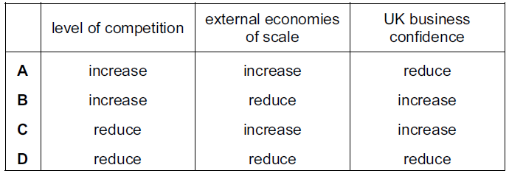
( )
Q14. Which is a diseconomy of scale?
- Bulk buying reduces costs.
- Communications deteriorate.
- Employees are more motivated.
- Technological improvements take place.
( )

Q15. Which statement explains why cars are often repaired by small garages?
- bulk buying of spare parts can take place
- car-repair jobs are varied
- entry to the car-repair industry is restricted
- expensive machinery is required
( )

Q16. Which diagram represents a firm with economies of scale?
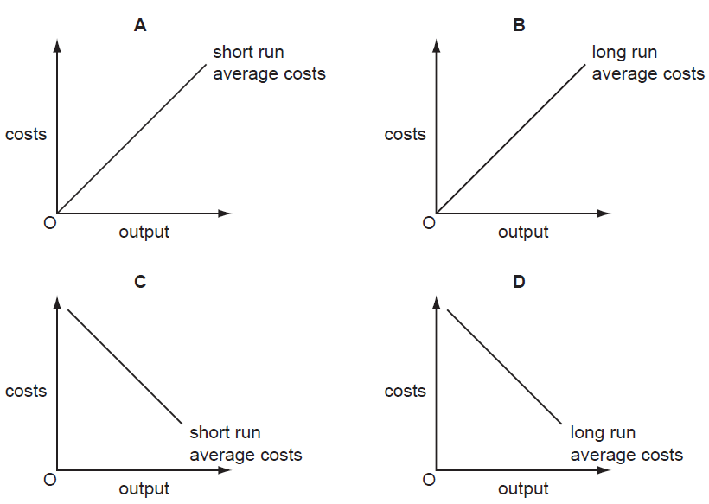
( )

Q17. A British firm, Dyson, moved production of its vacuum cleaners from the UK to Malaysia. Why might it have made this change?
- average costs would fall
- average revenue would rise
- market share would fall
- transport costs would rise
( )

Q18. What is happening when a firm is experiencing economies of scale?
- It has rising long-run average costs.
- It is operating in the short run.
- Its fixed costs are less than variable costs.
- Its output is increasing faster than its inputs.
( )

Q19. What must occur if a firm experiences economies of scale?
- average costs decrease
- profits decrease
- the number of workers increases
- total advertising costs decrease
( )

Q20. What is happening when a firm is experiencing economies of scale?
- It has rising long-run average costs.
- It is operating in the short run.
- Its fixed costs are less than variable costs.
- Its output is increasing faster than its inputs.
( )

Part C – Cost of Production
Q1. When a firm produces 500 units its total variable cost is $1000. Its total fixed cost is $1500. What is the average cost of 500 units?
- $2
- $3
- $5
- $2500
( )

Q2. The diagrams represent total cost curves (TC) of four firms in the short run. Which firm has only fixed costs?

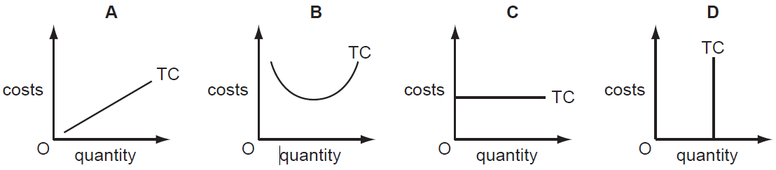

( )

Q3. An entrepreneur started a small business making candles. In the first month 1000 candles were made. The costs were
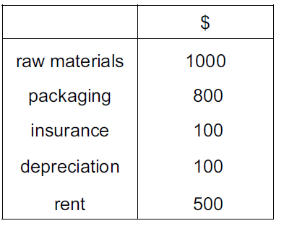
What were the average variable costs for the month?
- $1.00
- $1.80
- $1.90
- $2.00
( )

Q4. As a firm increases its weekly output from 10 units to 20 units, its average cost falls from $15 to $10. Which of its costs have risen?
- fixed costs and variable costs only
- fixed costs, variable costs and total costs
- total costs only
- variable costs and total costs only
( )

Q5. The graphs show the average total cost (ATC) curves of four firms and how they change as output increases. Which firm has the highest fixed costs?

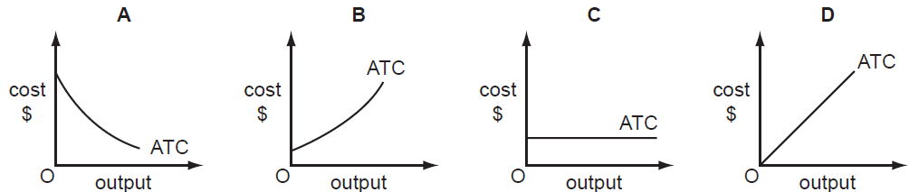

( )
Q6. What is a variable cost to a firm producing bicycles?
- the component parts of the bicycles
- the interest on money borrowed
- the rent of the bicycle factory
- the salaries of the senior managers
( )

Q7. The graphs, drawn to the same scale, show the demand curves of four firms. The market price is $10. The price then falls to $8. Which firm will have the largest increase in total revenue?
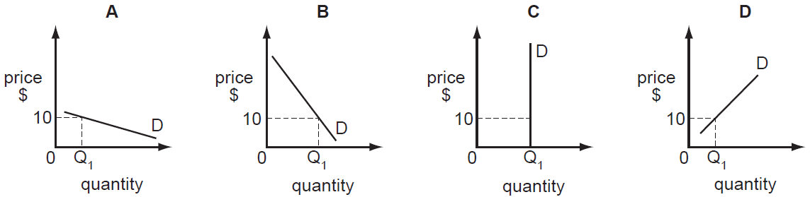

( )
Q8. Which statement about total fixed cost is correct?
- It falls as output increases.
- It is calculated by adding total cost and total variable cost.
- It is calculated by dividing total cost by output.
- It must be paid even if output is zero.
( )
Q9. The table shows how a firm’s total cost rises with changes in output.
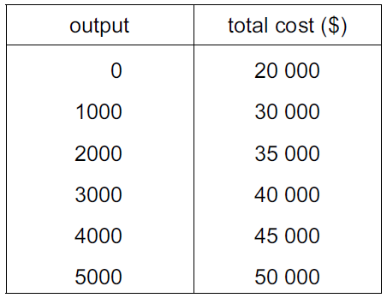

What is the average fixed cost of producing 5000 units?
- $4
- $5
- $6
- $10
( )

Q10. A firm is producing an output which enables it to make more than normal profit.
What must be true at that output?
- Average revenue must be greater than total revenue.
- Average revenue must equal average cost.
- Total revenue must be greater than total cost.
- Variable cost must equal price.
( )

Q11. The table shows a firm’s fixed and variable costs at four levels of output.
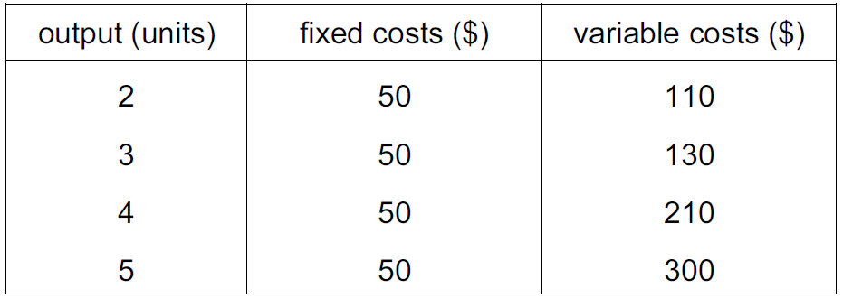
At which level of output is average cost at its lowest?
- 2
- 3
- 4
- 5
( )

Q12. How does a firm guarantee that it makes the maximum profit?
- by maximising the difference between its total revenue and total cost
- by maximising the number of goods that it sells
- by minimising the amount of goods that it keeps in stock
- by minimising the difference between average revenue and average cost
( )

Q13. Some travellers complain about the disturbance caused when other people use their mobile (cell) phones. As a result, a UK train operator announces that it will buy some new trains that will have a device fitted to prevent the use of mobile (cell) phones. What will definitely happen to the train operator?
- Its average revenue will decrease.
- Its total revenue will increase.
- Its fixed cost will increase.
- Its total cost will decrease.
( )

Q14. The diagram shows the fixed costs, variable costs and total costs of a firm.
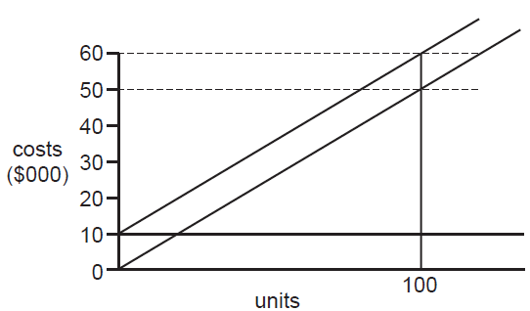
What is the firm’s variable cost at an output of 100 units?
- $500
- $10 000
- $50 000
- $60 000
( )

Q15. An Economics student made the following statements about costs of production.

Statement 1: Average costs remain the same at all levels of output.
Statement 2: Fixed costs can exist when there is no output.
Statement 3: Total costs can include both fixed and variable costs.
Statement 4: Total variable costs fall as output increases.

How many of these statements are correct?
- Statement 1
- Statement 2
- Statement 3
- Statement 4
( )

Q16. A Japanese company which has spare capacity has agreed to refine 20 000 barrels of oil a day for a Chinese company. What is likely to happen in the Japanese firm to fixed cost, to variable cost and to total cost?
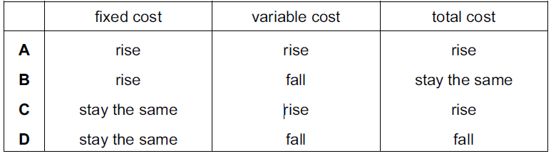
( )

Q17. A firm sells its products for $10 each. It produces 100 units. Its average variable cost is $5 and its average fixed cost is $2.How much profit does the firm make from selling 100 units?
- $1000
- $700
- $500
- $300
( )

Q18. What is a fixed cost of production?
- the commission paid to sales staff
- the cost of using the telephone
- the interest paid on a bank loan
- the money spent on repairs
( )

Q19. What is not equal to the average revenue?
- the price of each unit
- the profit from each unit
- the revenue from each unit
- the total revenue divided by output
( )

Q20. A firm’s average revenue is $10. It sells 2000 units.
What is the firm’s total revenue and the price of the product?

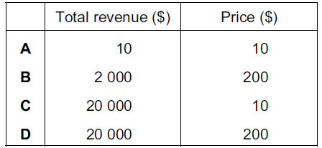
( )

Q21. A Japanese company which has spare capacity has agreed to refine 20 000 barrels of oil a day for a Chinese company. What is likely to happen in the Japanese firm to fixed cost, to variable cost and to total cost?

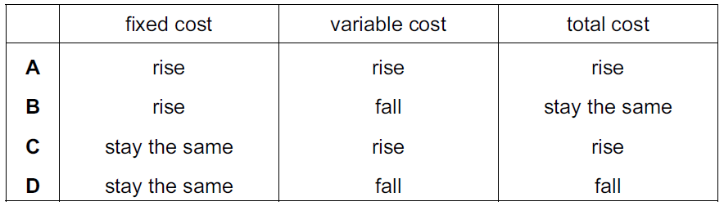

( )

Q22. A firm sells its products for $10 each. It produces 100 units. Its average variable cost is $5 and its average fixed cost is $2.How much profit does the firm make from selling 100 units?
- $1000
- $700
- $500
- $300
( )

Part D – Market Structure
Q1. What is a difference between a monopoly and a perfectly competitive firm?
- A monopoly always has economies of scale and a perfectly competitive firm has diseconomies of scale.
- A monopoly always operates in the public sector and a perfectly competitive firm always operates in the private sector.
- A monopoly is a price maker and a perfectly competitive firm is a price taker.
- A monopoly seeks to maximise profits and a perfectly competitive firm seeks to maximise output.
( )

Q2. In a competitive industry, a firm’s aim is to become a monopoly supplier. Which policy is it most likely to use to eliminate competition?
- adopt price reductions and advertising
- avoid diseconomies of scale
- maximise output and profit
- reduce financial barriers to entry
( )

Q3. Machu Picchu is Peru’s most popular tourist destination. One train company, PeruRail, operatesa monopoly service up to the site.Why might competition on the route increase the fares paid by passengers?
- Competitive firms have more influence on price than a monopoly.
- Competitive firms never make a loss.
- Less advantage may be taken of economics of scale.
- More profit may be available to spend on new technology to reduce costs of production.
( )

Q4. What is unlikely to be a feature of a large firm in a monopoly position in a market?
- It achieves economies of scale.
- It charges high prices.
- It removes barriers to entry.
- It will attract government attention.
( )

Q5. What is unlikely to be a feature of a large firm in a monopoly position in a market?
- It achieves economies of scale.
- It will attract government attention.
- It charges high prices.
- It experiences intense competition in that market.
( )

Q6. Why might a government encourage a monopoly?
- It can have high average costs.
- It can compete against foreign firms.
- It can prevent innovation.
- It can make excessive profits.
( )

Q7. Why might a government discourage monopolies?
- They can achieve low average costs.
- They can compete against foreign firms.
- They can introduce new technology.
- They can make large profits.
( )
Q8. In a popular tourist city there are three large hotels but many smaller guest houses. The company which owns one of the large hotels decides to add more rooms to its hotel and also purchase one of the other large hotels.

What will happen as a result?
- The company will be able to control the price of tourist accommodation in the city.
- The market for hotel accommodation will become less competitive.
- The smaller guest houses will be forced out of business.
- There will be a monopoly supply of tourist accommodation in the city.
( )

