J1 June Intensive Revision 2015
L1 – CSQ – Demand and Supply/Elasticity of Demand and
Supply/Government Regulation – Q1
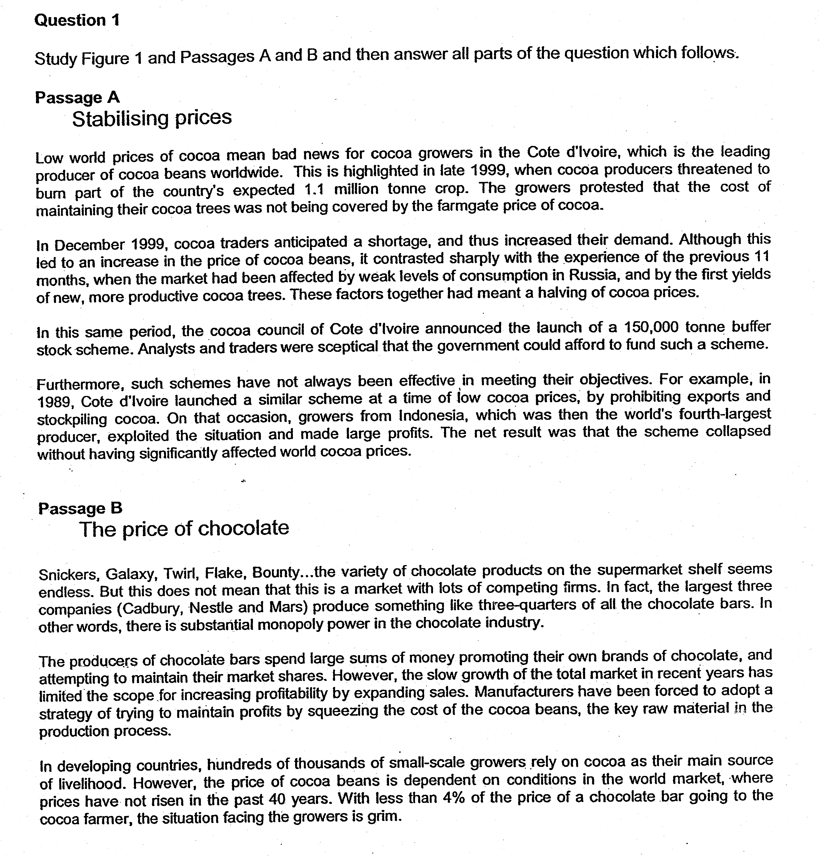

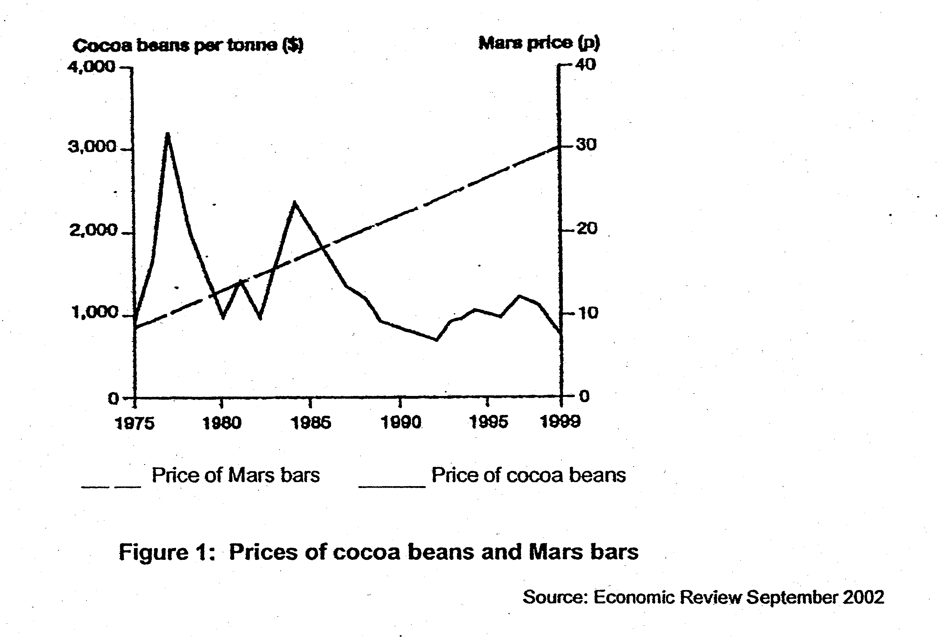

Questions:
(a) (i) Figure 1 shows the price of cocoa beans per tonne, and the price of Mars bars between 1975 and 1999. Compare the trends in the prices of cocoa beans and Mars bars over this period. [2]

(a) (ii) Account for the price trends of mars bars and price of cocoa beans. [4]

(b) In Passage A, there is reference to the changes in the price of cocoa beans during 1999, and a proposed scheme to stabilise the price of cocoa beans.

(i) With appropriate supply and demand diagrams, explain the fall in the price of cocoa beans during the first 11 months of 1999. [4]

(b) (ii) With reference to the information in the passage, comment on the need to stablise the price of cocoa beans. [4]

(c) Explain and evaluate the use of floor price in aiding the stabilising of price in the cocoa bean market. [6]

Suggested Answers

(a) (i) Figure 1 shows the price of cocoa beans per tonne, and the price of Mars bars between 1975 and 1999. Compare the trends in the prices of cocoa beans and Mars bars over this period. [2]

Between 1975 to 1999, the price of cocoa beans fell slightly from around $3000 per tonne to $900 per tonne while the price of Mars bars rose sharply from 10p to 30p.

The price of cocoa beans has fluctuated extensively while the price of Mars bars rose steadily and sharply.

(a)(ii) Account for the price trends of mars bars and price of cocoa beans. [4]

The price of cocoa bean varies extensively as it is an agricultural product where its supply is inconsistent due to the impact of harvest. When the harvest is bad due to poor weather and other factors, the supply will be reduced extensively and when the harvest is good, the supply will be increased extensively. As for the demand, it is constant and is based on market demand of production of chocolate, the price will rise or fall extensively. Furthermore, the supply of cocoa bean is price-inelastic as it is an agricultural product that has long gestation and is subjected to limited production based on limited yield of the land and thus, the rise or fall in demand will contribute to extensive change in price since there will be excessive supply or demand condition when there is an increase in supply or demand respectively.

On the other hand, the price of Mars bars will rise steadily and sharply as it is a consumer good. As population increases and people becomes more affluent, they will consume more of these consumer good, prompting an increase in demand which will lead to rise in price of the Mars bars. Since the demand is price-inelastic, as the proportion of income spent on the good is small, the producer of Mars bars can increase the price and it may still increase the total revenue of the Mars bars. Thus, it is logical for the production of Mars bars to raise price steadily and sharply. From the supply side, the cost of production may have increased as cost of labour and advertisement and other manufacturing cost has risen over the years, it is inevitable for the producers to raise the prices, contributing to the rising price condition. (price elastic – stored and non-perishable – low cost in storage) – can easily increased quantity supplied when the price increases)

(b) In Passage A, there is reference to the changes in the price of cocoa beans during 1999, and a proposed scheme to stabilise the price of cocoa beans.

(i) With appropriate supply and demand diagrams, explain the fall in the price of cocoa beans during the first 11 months of 1999. [4]
The fall in the price of cocoa bean in the 1st 11 months of 1999 is due to an extensive increase in supply of cocoa bean while the demand remains constant or weak.
Price of Cocoa Bean
S₁
S₀

P₀
P₁

Qty of Cocoa Bean
Q₁
Q₀

As seen from the diagram, the increase in supply of cocoa beans from S₀ to S₁ will contribute to excess supply condition which will prompt a reduction in price from P₀ to P₁.

The excessive increase in supply is due to better harvest which creates an excess supply condition which prompted cocoa growers in the Cote d’lvoire to “threaten to burn part of the country’s expected 1.1 million tonne crop.” so as to prevent the excess supply condition to occur to prevent further fall in price level. Furthermore, the better harvest of yields of more productive cocoa trees.” will also contribute to greater increase in supply that contribute to excess supply condition that will cause price of cocoa bean to fall. The lack of control in the supply of cocoa in the world market since producers of different countries are not willing to set limits on their export, as seen in Indonesian exporters, will make it hard to prevent the excess supply condition.

On the other hand, demand remains quite weak and thus, there is no extensive increase in demand or demand may remain the same. Since cocoa bean is a derived demand, its decrease greatly depends on the market demand of chocolate which has not increased much over this period as there is slow growth in the total market for chocolate. Furthermore, the strategy of squeezing the cost of coffee beans by producers of chocolate will also mean that price of cocoa bean will fall.

In addition, the demand of cocoa bean is price-inelastic as the product is a snack and has a high degree of necessity of demand, making it price-inelastic. Therefore, the result of the increase in supply will create excessive excess supply condition that will lead to a more extensive fall in price of the cocoa bean.

Thus, with a weak demand and an excessive increase in supply, the price will fall for the first 11 months, but the extent of its fall will be extensive which the demand is price-inelastic.

(b) In Passage A, there is reference to the changes in the price of cocoa beans during 1999, and a proposed scheme to stabilise the price of cocoa beans.

(ii) With reference to the information in the passage, comment on the need to stabilize the price of cocoa beans. [4]

There is a need to stabilize the price of cooca beans as it has adverse impact on the growth of cocoa beans. As stated, in developing countries, there are ‘hundreds of thousands of small-scale growers who rely on cocoa as their main source of livelihood which means that excessive falling price of cocoa will affect their revenue and undermine their ability to sustain their cost of living. Furthermore, with the strategy of squeezing the cost of cocoa beans by the producers of chocolate, the farmers may not enjoy the benefit or rising price of chocolate like Mars bars as the revenue of the growers is less is less than 4% of the price of a chocolate bar.

There is also a need to prevent the strategy of squeezing the cost of cocoa bean as it is an unfair trade created by the near-monopoly power of the chocolate producers. On the other hand, if the price of coffee beans rises too extensively, the cost of production of chocolate will rise extensively as well, which will affect the growth of the industry, and thus, controlling the price of cocoa beans will ensure higher degree of cost stability for the industry.

From a macro view, the national income of the developing country that export agricultural products like cocoa beans will decrease as the export revenue has fallen due to lower price of cocoa beans. This will further decrease the production of agricultural products which will lead to higher level of unemployment and thus, affecting the standard of living of the people in developing countries. Furthermore, if the price of cocoa beans falls too extensively, it will make it more costly for the developing country to set floor price and increase the cost of maintenance of buffer stock for the developing country. This will reduce the cost of government expenditure which can be used other aspects of economic development.

(c) Explain and evaluate the use of floor price in aiding the stabilizing of price in the cocoa bean market. [6]

Floor price refers to the setting of price above the market equilibrium so as to maintain the revenue for the growers of the cocoa beans. As seen from the diagram, the floor price is set at P_{F} above the market equilibrium at P₀ but at this price level, there is an excess supply condition of Q₁Q₂ in order to ensure that the growers of cocoa bean is able to attain the total revenue Pf_{F}OQ₂A
S₀
Price of Cocoa Bean

A
P_{F}

P₀

D₀
O
Qty of Cocoa Bean
Q₁
Q₂
Q₀

The use of floor price is effective as the impact is immediate and direct assurance in maintaining revenue for growers of cocoa beans. However, the effectiveness is impeded by the lack of support from the international market. The setting of the floor price by Cote d’lvoire is undermined by “the grower from Indonesia which has increased the supply to make large profits’ and consequently, hampered the interest of growers in Cote d’lvoire. The high cost of expenditure in maintaining a buffer stock and its perishability of the cocoa beans will mean that the act of buffer stock to maintain floor price is not feasible. Furthermore, if the supply of the cocoa beans is reduced by bad harvest, the producers of cocoa bean are unable to gain the revenue provided by the buffer stock as the total production is reduced.

Fiscal position – cost of financing for the buffer stock

Nature of product – perishability / cost of storage

