Economics MCQ – Chapter 6 – Economic Indicators

Part A – Prices, Inflation and Deflation
Q1. What is deflation?
- A falling general price level
- A falling wage level
- A rising output level
- A rising profit level
( )

Q2. What is a result rather than a cause of inflation?
- A fall in purchasing power of those on fixed incomes
- Easier credit facilities to purchase consumer goods
- Increases in costs of oil supplies worldwide
- Increases in international competitiveness
( )

Q3. What is not involved in the construction of a retail price index?
- A base year
- A basket of goods
- Incomes
- Weighting of products

( )

Q4. In the measurement of the UK’s Retail Price Index, a greater weight was given to bottled water in 2010 than 2009. What does this change indicate?
- Government statisticians checked the price change of a greater range of bottled water in 2010 than in 2009
- People spent a higher proportion of their total spending on bottled water in 2010 than in 2009
- The price of bottled water increased more in 2010 than in 2009
- There was an improvement in the quality of bottled water in 2010 compared with 2009
( )

Q5.What does not necessarily change with inflation?
- Distribution of income
- Employment income received as a salary
- Revenue from exports
- The value of money
( )

Q6. What is the most obvious sign of inflation?
- An increase in imports
- An increase in productivity
- An increase in retail prices
- An increase in total expenditure
( )

Q7. In Germany’s 2007 retail price index, transport received a higher weighting than clothing and footwear. What does this difference indicate?
- Households spent more on transport than on clothing and footwear
- The price of transport rose by more than the price of clothing and footwear
- Transport is more of a luxury good than clothing and footwear
- Wage rises in the transport industry were higher than wage rises in the clothing and footwear industry

( )

Q8. What is not an important step in the construction of an accurate Retail Price Index?
- Choosing a base year with normal economic conditions
- Comparing price rises with those of international competitors
- Sampling prices from a wide range of retail outlets
- Selecting a typical basket of goods consumed by the average citizen
( )

Q9. What is most likely to lead to inflation?
- A decrease in consumer spending
- A decrease in employment in the public sector
- An increase in the cost of factor inputs
- An increase in income tax
( )

Q10. The table shows some data about an economy.

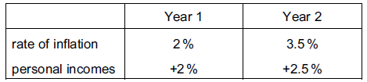

What happened between Year 1 and Year 2?
- Both prices and real incomes fell
- Both prices and real incomes rose
- Prices rose but real incomes fell
- Prices fell but real incomes rose
( )

Q11. The table shows the percentage changes in earnings and consumer prices for four countries for one year. Which country is likely to have experienced the greatest increase in real incomes during the year?
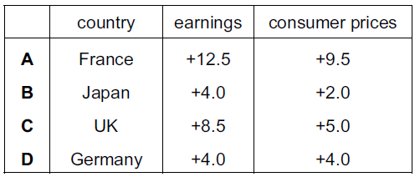

( )

Q12. The citizens most likely to benefit in a period of rapid inflation are those who
- are receiving fixed state benefits
- earn fixed incomes
- have lent money at a fixed rate of interest
- have borrowed money at a fixed rate of interest
( )

Part B – Unemployment
Q1. The table shows the change in the labour force in Bangladesh between 2006 and 2009.

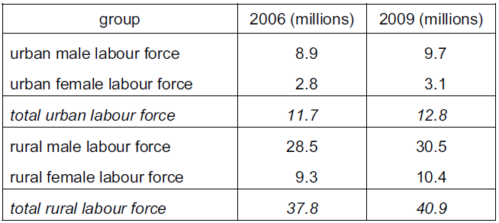

Which statement is most likely to be consistent with these statistics?
- Farming is the major employer in the economy.
- Male workers are more mobile than female workers.
- The absolute increase in the labour force is greater in urban areas than rural areas.
- The supply of female workers has fallen.
( )

Q2. Which cause of inflation is most likely to result in an increase in unemployment?
- An increase in consumer expenditure
- An increase in exports
- An increase in the cost of production
- An increase in the money supply
( )

Q3. Official statistics in 2010 showed South Africa had a very high unemployment rate at around 25%, yet wages were still double those in Brazil. What might be a reason for South Africa’s high wages in a time of unemployment compared with Brazil?
- A skilled workforce in Brazil
- High levels of savings in South Africa
- Increased use of labour-intensive production in Brazil
- Strong trade unions in South Africa
( )

Q4. The government pays a subsidy for each worker employed by a firm in an area of high unemployment. When would this policy be most successful in reducing unemployment?
- When the firm is capital-intensive
- When the firm is labour-intensive, requiring mainly unskilled labour
- When the firm provides goods to the domestic market
- When the firm requires mainly specialist, skilled labour
( )

Q5. An increase in online banking by customers using home computers has reduced the level of employment in the banking sector of developed countries. What describes this kind of unemployment?
- Frictional
- Regional
- Seasonal
- Technological
( )

Q6. The number of people unemployed in an economy fell by 600,000 and the number employed rose by 400,000. Which change could explain this difference?
- Some of the unemployed have entered full-time education.
- Some of the unemployed have experienced a loss of skills.
- The length of the working week has declined.
- The size of the labour force has increased.
( )

Q7. The table shows unemployment and inflation statistics for the US, Japan and Sweden for year 1 and year 2.
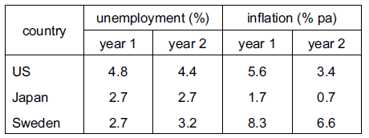

Which conclusion can be made from the table?
- In year 1, the same number of people were employed in Sweden and Japan.
- In year 1, the cost of living rose in the US.
- The number of unemployed people decreased in all three countries.
- Unemployment and inflation moved in the same direction in Japan.
( )

Q8. Many fishermen are unemployed owing to long-term legislation to conserve fish stocks in the North Sea. What type of unemployment is this?
- Demand-deficient
- Frictional
- Seasonal
- Structural
( )

Q9. Which of the following is an example of cyclical unemployment?
- An airline cuts jobs in a world recession.
- Cleaners lose their jobs as more machines are used.
- Fishermen sell their boats owing to a reduction in fish stocks.
- Hotels employ fewer people in the rainy period.
( )
Q10. The information below relates to selected countries in 2012.

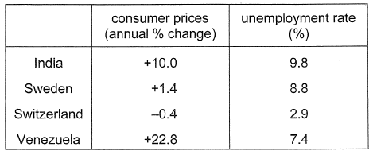

What can be concluded from this information?
- Inflation is a possible cause of unemployment.
- Inflation is the only cause of unemployment.
- Low unemployment is linked to high inflation.
- There is a uniform link between the rate of inflation and unemployment.
( )

Part C – Output & Economic Growth
Q1. An economy is said to have a high economic growth rate. What is most likely to be found when this occurs?
- A decrease in inflation and a budget deficit
- A decrease in the exchange rate and a fall in savings
- An increase in GDP and low unemployment
- An increase in inflation and a reduction in investment
( )

Q2. Which would best indicate the start of an economic recession?
- Falling interest rates
- Fluctuating levels of employment
- Negative growth of GDP
- Steadily increasing price levels
( )

Q3. A country’s Gross Domestic Product (GDP) falls, while its population falls. What happens to GDP per head?
- It falls.
- It is uncertain.
- It remains constant.
- It rises.
( )

Q4. What is GDP divided by to calculate Gross Domestic Product (GDP) per head?
- The adult population
- The non-dependent population
- The total population
- The working population
( )

Q5. What is a long-term advantage of economic growth?
- Employment falls
- Incomes rise
- Prices rise
- Savings fall
( )

Q6. What is typical of a recession?
- Falling Gross Domestic Product
- Falling unemployment
- Rising living standards
- Rising retail price index
( )

Q7. A newspaper reported that there were signs of economic growth and inflation in an economy. What would not be evidence of such a situation?
- An increase in employment
- An increase in the general price level
- An increase in the income tax rates
- An increase in the standard of living
( )

Q8. What is likely to increase with economic growth?
- Cyclical unemployment
- Income per head
- Budget deficit
- Conservation of natural resources
( )

Q9. What might cause a decline in economic output?
- A decrease in income tax
- A decrease in sales tax
- An increase in company investment
- An increase in unemployment
( )

Q10. A closed economy has both a private sector and a public sector. Gross Domestic Product (GDP) consists of total consumer expenditure plus gross investment plus
- The value of exports
- The value of exports minus the value of imports
- Total government expenditure
- Total government expenditure minus total taxation
( )

Q11. What is likely to be an advantage of economic growth?
- The country’s resources will be depleted
- The price level will increase
- The rate of employment will fall
- The standard of living will increase
( )

Q12. The table gives information on Gross Domestic Product (GDP) growth rates, inflation and the unemployment rates for a number of countries in 2006.
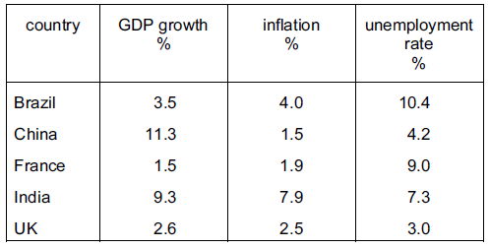

What can be concluded from the table about 2006?
- Any particular product would cost most in India
- Economic growth was highest when unemployment was lowest
- Low inflation always causes low unemployment
- On average, the Chinese people were likely to have had an increase in real income
( )

Q13. The table gives information on the rate of economic growth in a country from 2001 to 2004.
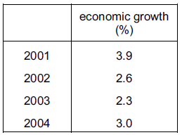

What is likely to have fallen in this period?
- Gross Domestic Product
- Imports
- Prices
- Unemployment
( )

Q14. Botswana has achieved high rates of economic growth. What is most likely to have fallen as a result of this economic growth?
- Employment
- Income per head
- Infant mortality rate
- Literacy rates
( )

Q15. Which of the following is likely to be a disadvantage of economic growth?
- Government tax revenue falls
- Resources are depleted
- The level of unemployment rises
- The standard of living of the population falls
( )

