Economics CSQ – Economic Indicators – Economic Growth

Economic Problems in Bulgaria

Bulgaria is the poorest of the 27 countries (as of May 2013) in the European Union (EU). It joined the EU in January 2007. Average wages are only US$4.50 an hour and average monthly salaries are only US$465. The rate of unemployment in Bulgaria in 2012 was estimated at 12%, compared to an EU average of 9.4%. This level of unemployment, however, was much less than that in some EU countries, such as Greece, where the rate of unemployment was twice as high.

The population of Bulgaria is 7.5 million and yet over a million Bulgarians have left the country in recent years to work abroad, especially in Spain and Greece. The value of the money they have sent back home, known as migrant remittances, has risen from US$900 million in 2008 to US$990 million in 2012. Much of the work that these people do in Spain and Greece is seasonal and so there have been particular problems of seasonal unemployment, with some of the migrants losing their jobs and having to return home.

Within Bulgaria, a lot of workers have lost their jobs in the construction industry. It had been planned that a large number of hotels and holiday flats would be built along Bulgaria’s Black Sea coast. Since 2008, there has been a dramatic fall in the demand for these properties and many construction firms have gone out of business, having failed to obtain sufficient funds from financial institutions.

The Gross Domestic Product (GDP) of Bulgaria has only been growing by 1.7% per year in recent years. In 2012 the GDP was US$48.0 billion. One of the problems in measuring GDP in Bulgaria is that it has been estimated that as much as 30% of the economy goes unrecorded. There is a great deal of activity in what has been termed the hidden or informal economy. Not all income earned is declared for tax purposes, there is some smuggling (illegal importing) and much of agricultural output is subsistence farming.

It is noticeable that the death rate in Bulgaria is considerably higher than the birth rate (see Table 2 for details). A survey of Bulgarians found that about 70% of them expected the economic situation in the country to worsen in the next 12 months, not something that would be likely to bring about an increase in the birth rate. This has meant that Bulgaria now has the second most rapidly declining population in the world, as shown in Table 1.

Table 1: The world’s most rapidly declining populations, 2005–2010

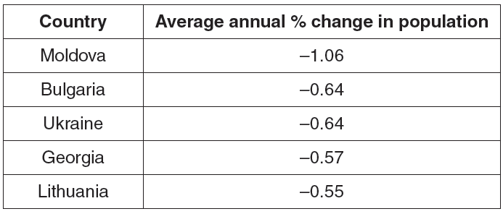

It is also noticeable that in many indicators Bulgaria is worse off than the European Union average, as shown in Table 2.

Table 2: A comparison of Bulgaria and the EU average in 2012

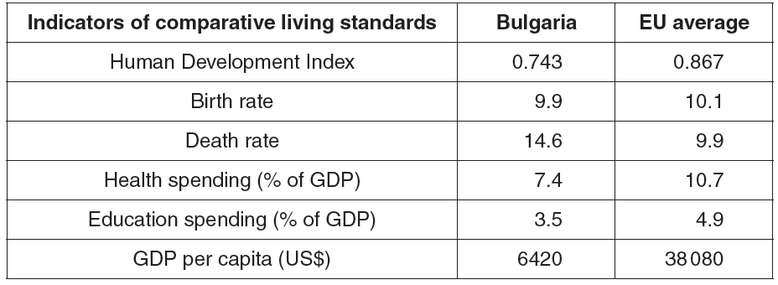

Questions
(a) Explain what is the difference between the rate of unemployment and the level of unemployment. [2]

(b) Analyse three ways a government could reduce the rate of unemployment in a country. [6]

(c) Using information from the extract, calculate the percentage increase in migrant remittances sent home by Bulgarians between 2008 and 2012. [2]

(d) Using information from the extract, calculate what would have been the estimated size of the informal economy in Bulgaria in 2012 in US$. [1]

(e) Using information from the extract, explain why such a large percentage of the Bulgarian Gross Domestic Product goes unrecorded. [3]

