Lesson No 1 – CSQ 1 – Central Economics Problems
Extract 7: A City Transformed

Since winning its bid for the 2016 Olympic Games seven years ago, Brazil’s Rio de Janeiro has undergone a construction boom, including new sports venues, subway connections, and more infrastructure. One of the flagship transportation efforts, Rio built a new subway extension linking popular beach areas with the neighbourhood where the Olympic Park is located. Enormous investment has been pumped into transportation infrastructure projects throughout the city, including the VLT Carioca (the Rio de Janeiro Light Rail) in the port district. The rail connects Rio’s domestic airport to a bus terminal and is aimed at revitalising the area.

The construction of the golf course, however, has stirred controversy. Golf is not widely played in Brazil, and though there is one small public course on the northern outskirts of Rio, Brazilian officials have touted the fact that after the Olympics, the course would become the first professional-quality public course in Brazil. But it was partially built on a protected nature reserve, angering local activists.

Source: The Wall Street Journal, August 2016

Figure 2: Selected economic indicators for Japan

Unemployment Rates

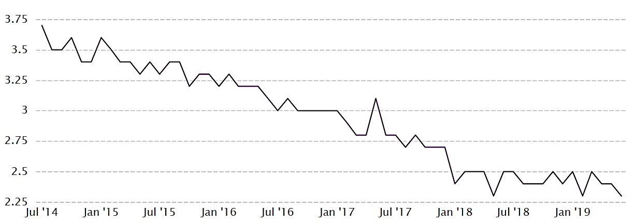

Gross Domestic Product
Sources: CEIC data, Organisation for Economic Co-operation and Development

CSQ – Lesson 1 – Central Economics Problems

a) Explain how the concept of opportunity cost is explained through the production possibility curve. (3)

b) Identify two factors that will affect how actual growth of the Brazilian economy through the Olympic games. (6)

c) Using extract 7 and a production possibility curve diagram, identify and explain two benefits of hosting the Olympics to the host economy. (6)

d) In a capitalistic economy like Brazil, why should certain game facilities be built by the government? (9)

e) Based on figure 2 and the production possibility curve, explain why the unemployment rate and GDP per capita and GDP per hour worked falls. (6)

- Explain how the concept of opportunity cost is explained through the production possibility curve. (3)
Opportunity cost is defined as the cost of using resources for a certain purpose, measured in terms of the next best benefit it can derive when it is used for another alternative. The concept of opportunity cost can be illustrated using the production possibility curve where certain assumptions must be held constant. From the PPC, we can observe that the increase in the production of one good will lead to the reduction of another good and thus, the value of opportunity cost of the increase in production of the first good is seen in terms of the value of reduction in the production of the second good.

The increase in production of more guns will mean that there is a decrease in production of butter. Therefore, the opportunity cost for production of guns is seen in terms of the reduction in quantity of butter. The opportunity of Go G1 units of guns will be the reduction in units of Bo B1 of butter.
- Identify two factors that will affect how actual growth of the Brazilian economy through the Olympic games. (6)
Actual growth refers to the greater utilization of resources to produce goods and services and this is attained when there is a higher degree of economic activities that affect the production and the rate of growth of national income. Thus, the factors that affect the economic activities would be the factors that affect the actual growth of Brazilian economy.

One factor that affect that affect the economic activities in the Brazilian economy would be the growth of population size. If population size is expanded, there will be a larger consumer base, and this would raise the value of consumption and the amount of consumption. Fortunately, the population of Brazil is quite big, and this would lead to higher consumer base but the level of affluence of the population is low, and this may affect the value of consumption. During the Olympic games, the economic activities will be low in a poor country.

Another reason is the market confidence which determines the value of consumption and investment in the Brazilian economy. When the consumers and investors hold a more negative outlook, they are unlikely to spend on economic activities and this lower the production and consumption which slows down the rate of actualization of resource for production to raise actual growth.
- Using extract 7 and a production possibility curve diagram, identify and explain two benefits of hosting the Olympics to the host economy. (6)
Based on the PPC, the organization of Olympic games would lead to rise in the level of output and the outward shift of the PPC which leads to both actual and potential growth. The benefits of actual and potential growth will benefit the host country.

One benefits from the actual growth is the increase in output which enables the citizens to enjoy, and this means that there is improvement in standard of living as there is a higher level of material comfort. The production of more consumer goods like condo and café to entertain the tourists continue to operate and would improve the lives of the people after the games.

There is also an increase in the level of employment, and this raises the income of the people. As there are more economic activities during and after the Olympic games, the lives of the people will be better. More people may visit the countries again and this raises the economic activities of the country. With more economic activities, there is higher level of production and demand for level. Consequently, the employment is higher.

- In a capitalistic economy like Brazil, why should certain game facilities be built by the government? (9) This is a qn on market failures – focus on Why should government provide merit good
Source of points:
- The issue of positive externality – to attain efficient resource allocation
- Government has the funding to finance the production of the merit good like game facilities
- The government has the legal rights to allocate resources like land for the building of the game facility
- It is the duty of the government to be responsible for the production of the game facility during the Olympic Games.

e) Based on figure 2 and the production possibility curve, explain why the unemployment rate and GDP per capita and GDP per hour worked falls. (6)

