Economics MCQ – Chapter 8 – Developed and Developing Economies

Q1. What is most likely to be found in a developing country?
- A good education sector
- A small average family size
- A small percentage of very old people
- High spending on entertainment
( )

Q2. What will increase the level of economic development in a country?
- A higher infant mortality rate
- A higher inflation rate
- A higher interest rate
- A higher literacy rate
( )

Q3. In some developing countries a large percentage of the population is involved in subsistence farming. What can be concluded from this?
- Each family will be able to produce enough to live on
- Production is unlikely to be capital intensive
- Production will be efficient
- There will be a high level of trade
( )

Q4. The Human Development Index (HDI) measures more than just average incomes. What are two additional measures it includes?
- Access to clean water; number of doctors
- Life expectancy; years of schooling
- Number of doctors; poverty rate
- Years of schooling; poverty rate
( )

Q5. Developing countries have, relatively, far more poor people than developed countries. What is the reason for this?
- Developing countries have much higher fertility rates.
- It is not possible for migrants from developing countries to work in developed countries.
- The natural increase in population is lower in developing countries.
- There is an ageing population in all developing countries.
( )

Q6. The table shows statistics for four countries in Southern Africa. From the information given, which country has the lowest standard of living?

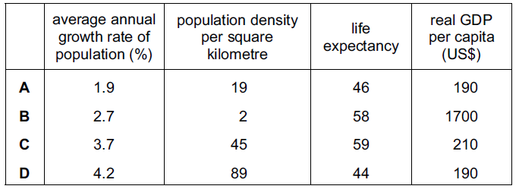
( )

Q7. As a country develops, what is most likely to happen?
- There will be an increase in productivity.
- There will be an increase in the birth rate.
- There will be an increase in the death rate.
- There will be reduced occupational mobility.
( )

Q8. The diagrams show the approximate age distributions of four economies. Which diagram resembles the age distribution of a developed economy?

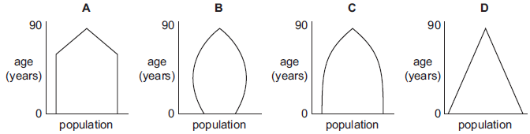

( )

Q9. As a country develops, its provision of medical care for babies and old people improves. Why might this cause a problem in raising living standards?
- Gross Domestic Product will fall.
- The dependency ratio will become higher.
- The number of workers will fall.
- The size of families in the short run will be smaller.

( )

Q10. A country has a falling birth rate and a rising death rate while an increasing number of its working age adults (16-60 years) are seeking employment abroad. How will this probability affect the numbers in the different age groups in the country?

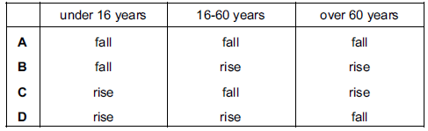
( )

Q11. The gap in incomes between rich and poor countries continues to widen in many countries. Who would be in absolute poverty?
- Those in the population without any formal employment income
- Those on very low incomes compared with the rest of the population
- Those who live without financial assistance from the government
- Those with just the minimum level of resources needed to sustain life

( )

Q12. The government of a developing country allows a multinational mining company to mine minerals in order to improve the standard of living of the local people. Which action by the multinational company will not lead to an improvement in the standard of living of the local people?
- Building roads to assist transport
- Exporting mineral ore
- Providing skills training
- Returning profits overseas
( )

Q13. Which changes usually result when a country develops and is able to provide free health care and good living conditions?
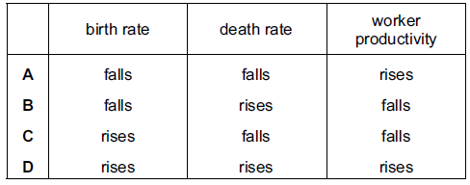
( )

Q14. What is not likely to be used to measure the difference in the standard of living between countries?
- Gross Domestic Product per head
- Human Development Index
- The rate of poverty
- The rate of interest
( )

Q15. In the developing economies of southern Africa, both infant mortality and life expectancy have fallen. Life expectancy now averages only 41 years. What is the result of these changes?
- Current labour supply has fallen
- Fewer primary schools are needed
- Governments will pay for more retirement pensions
- Less will need to be spent on healthcare
( )

Q16. The table shows the percentages of consumer spending on different items in four countries, which have similar geographical conditions and climate. Which country is likely to have the highest standard of living?

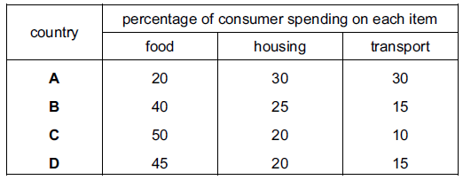
( )

Q17. What is usually true of workers approaching retirement when they are compared with new entrants to the workforce?
- They will be more adaptable
- They will be more experienced
- They will be more mobile
- They will be physically stronger
( )

Q18. In 2010, Nigeria had a birth rate of 36 and an infant mortality rate of 94. What can be concluded from this information?
- Nigeria experienced a natural decrease in population
- Nigeria’s population increased
- 36 children were born per hundred of the population
- 94 babies died before their first birthday out of every thousand babies born

( )

Q19. The Ivory Coast is sometimes referred to as a developing country. What would be likely to support the opinion that a country is a developing country?
- A balance of trade surplus
- A high birth rate
- A highly mechanized farming sector
- A large population
( )

Q20. The table gives information about four countries. Which country is likely to have the lowest standard of living?

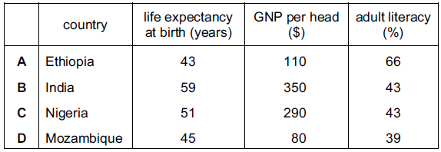
( )

Q21. What is most likely to happen if there is a fall in the death rate while the birth rate and migration remain unchanged?
- The population structure will remain the same
- The population will increase
- There will be a change in the proportion of men to women
- The standard of living will increase
( )

Q22. Developing countries are sometimes given aid by charities and foreign governments. Which aid programme would be least likely to lead to long-term economic growth?
- The building of an irrigation system
- The construction of a new airport
- The distribution of gifts of food
- The training of technical staff
( )

Q23. In 2008, the Peruvian Government set itself the target of reducing the number of its people in poverty to 30% of the population. Which change would be most likely to indicate that the Peruvian Government had made progress towards this objective?
- A fall in employment
- A fall in infant mortality
- A lower level of adult literacy
- A lower life expectancy
( )

Q24. What will be the likely effect on the remaining population of a developing country when newly trained, skilled workers migrate to developed countries?
- Its average age will increase
- Its mobility will increase
- Its productivity will increase
- Its total size will increase
( )

Q25. What is most likely to indicate that an economy is developed rather than developing?
- A high birth rate and a low death rate
- A large primary sector and a high population growth
- A large service sector and capital intensive production
- A low level of investment and a high rate of savings
( )

Q26. How is the pattern of employment likely to change when a country becomes more developed?
- From rural employment to urban employment
- From skilled employment to primary employment
- From technical employment to manual employment
- From tertiary employment to secondary employment
( )

Q27. Japan has an ageing and declining population. Fewer workers have to support more retired people. Which government policy is most likely to reduce the support that has to be given by the working population?
- Lowering state pensions
- Lowering the retirement age
- Raising income tax
- Subsidising the emigration of workers
( )

Q28. What combination of events is most likely to cause an ageing population?
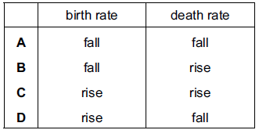
( )

Q29. Zambia is sometimes spoken of as a developing country. What would be most likely to confirm that a country is developing rather than developed?
- A balance of payment deficit
- A high proportion of the population in subsistence agriculture
- A lack of natural resources
- A large population
( )

Q30. What is likely if the proportion of retired people in a country increases?
- A reduction in income from direct taxation
- A reduction in the dependency ration
- An increase in the total number of jobs available
- A reduction in spending on medical treatment
( )

Q31. Which country is likely to have the lowest standard of living?
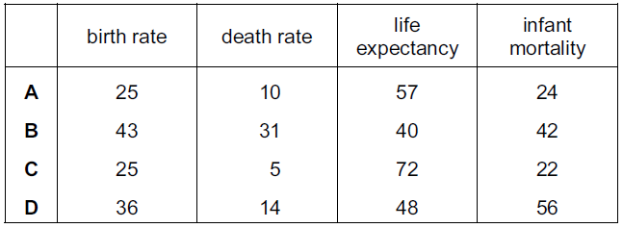
( )

Q32. In 2005, world population had grown to 6.5 billion with an increase of more than 4 billion since 1950. What is most likely to have been the cause of this?
- An increase in the death rate in developed countries
- An increase in the birth rate in developing countries
- An increase in migration from developing to developed countries
- An increase in the death rate in developing countries
( )

Q33. At the G8 Economic Summit in 2005, it was decided to cancel much of the debt which African countries owed to European and North American countries. This will have the same effect as a transfer of resources from _____________.
- developed countries to developing countries
- developing countries to developed countries
- market economies to planned economies
- planned economies to market economies
( )

