J2 June Intensive Revision 2014

Market Failures – Q2

Health Issues

Extract 1: The British National Health Service (NHS)

Competitive principles cannot be applied to healthcare. Medical treatment is regarded as a basic human right in all modern societies, which means that the State must become involved in providing it to those who cannot pay. There is a huge inequality of knowledge between consumers (patients) and the suppliers of medicine (doctors). The consequences of making a wrong decision in choosing medical treatment can be so catastrophic that it becomes impossible for patients to shop around for another supplier, since by then they are dead. Our lives and the lives of our families are so valuable that our willingness to pay for even a small chance of survival knows no rational limit. Finally income inequality puts the ability to pay for adequate medical treatment beyond the means of poorer households. As a result, a completely free market in healthcare can never work properly.

However, future state provision will be subject to growing pressures. Firstly, rising expectations result in unlimited demands for health. As people get richer they not only expect to live longer and feel better; they also want their medical care delivered comfortably and conveniently. The other pressure is on the supply side. The main cost of providing healthcare is wages paid to doctors and nurses. As wage costs rise faster than prices in the long run, the cost of treatment keeps going up in real terms.

As Britain's health expenditure rises towards the levels in other European countries, the replacement of the NHS by a private or insurance-based system will become a serious option.
Adapted from The Times, 23/03/2000 & 22/03/2001

Figure 1: United Kingdom average annual health expenditure increases (%)
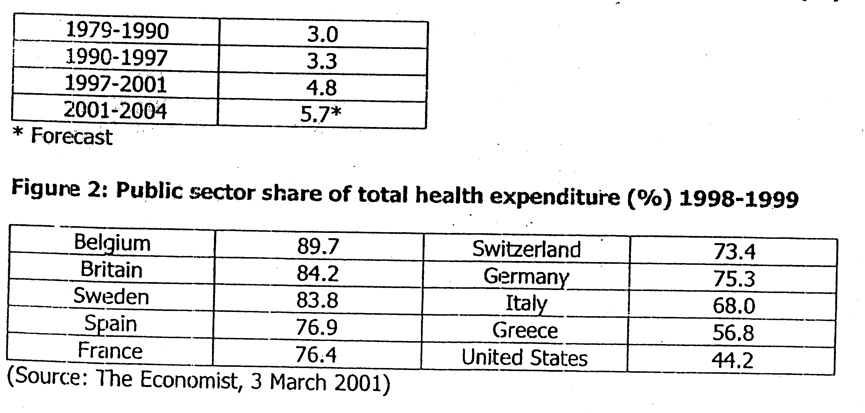

Questions:

(a)(i) Explain what might be meant by “a completely free market” in health care. [2]

(ii) With the aid of a diagram, explain how healthcare provision by the government may help to improve resource allocation? [4]

(b) Describe the trend in the UK average annual health expenditure from 1979-2004. [2]

(c) Examine one reason why public sector share of health care differs between countries. [2]

(d) The '”uture state provision (of healthcare) will be subject to growing pressures”.
(i) Explain the economic implications of this growing pressure on the country. [4]

(ii) Discuss the option of replacing the British National Health Service (free medical service provided by the government) by a private insurance-based system. [6]
[Total: 20 marks]

Suggested Answers
(a)(i) Explain what might be meant by ‘completely free market' in healthcare. (2)

In 'a completely free market' in healthcare, the allocation of resources and services of healthcare is based on market forces of demand and supply. The distribution of these services will be determined by the price signal whereby a higher price level will lead to the increase in the provision of medical services while the quantity demanded for the services will reduce.

(a)(ii) With the aid of a diagram, explain how healthcare provision by the government help improve resource allocation? (4)

As healthcare is a merit good which give rise to positive externalities, the production and consumption will lead to the rise of positive benefit which will disrupt the social efficient level of production and consumption. As seen from the diagram 1, without the consideration of external benefit, the market equilibrium is at Qm where SMC=PMC=SMB=PMB. However, when external benefit is taken into account, the social equilibrium is at Qs where SMC=PMC=SMB=PMB+EMB. Consequently, there will be underproduction as output at social equilibrium is less than output at market equilibrium, giving rise deadweight loss in term of welfare the society fails to reap.

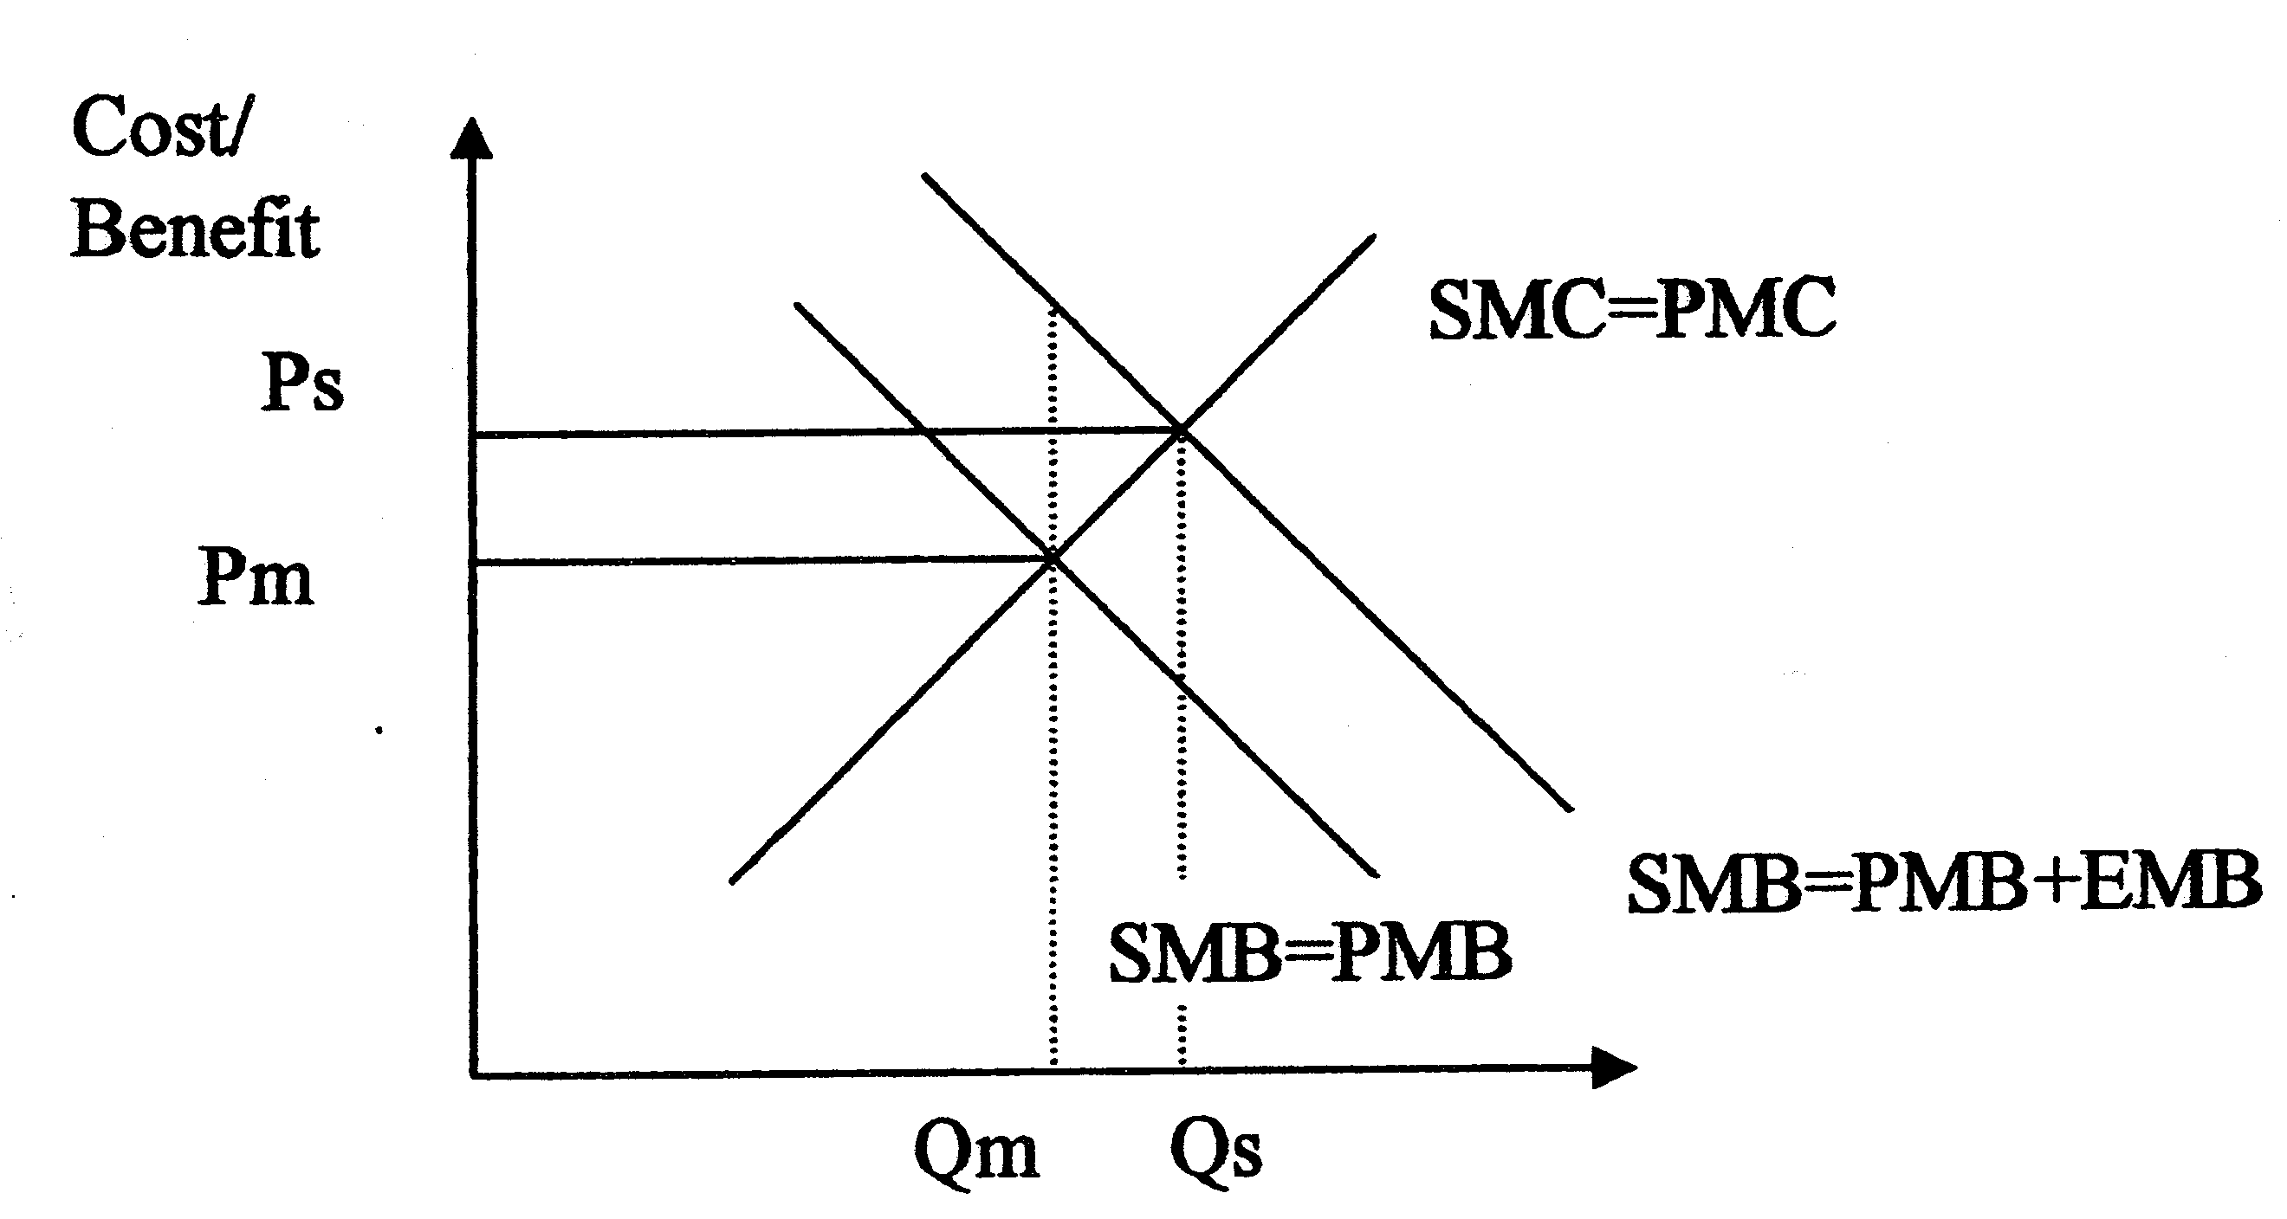
Diagram 1 - Provision of healthcare by government

With the provision of medical care by government, the production will be provided at Qs, allowing the production to be attained at social efficient level where SMC=SMB (PMB=EMB).

(b) Describe the trend in the UK average annual health expenditure from 1979 to 2004. (1)

It has increased at an increasing rate. The average annual expenditure is highest at the period 2001 to 2004.

(c) Examine two reasons why public sector share of healthcare differs between countries. (3)

- different cost of living
- expectations of citizens differ
- Population structure
- Amount of government intervention

(d) The “future state provision (of healthcare) will be subject to growing pressure.”
(i) Explain the economic implications of this growing pressure on the country. (4)

This growing pressure on the country can be seen from both the demand and supply aspects. There will be greater demand for better healthcare as the population of Britain become older and the people become richer. The opportunity cost of the fund allocated to healthcare will rise as other areas of government expenditure must be reduced. Secondly, there will be strain on government budget, demanding the government to borrow more from the private sector. This will deny the private sector fund for private investment (crowding out effect) and contribute to the need to raise taxation which will create a contractionary effect on the economy.

On the other hand, the cost of the provision of such services will increase as the wage of nurses and doctors and other medical resources will rise. This will induce an increase in the prices of the medical services, which will lead to higher cost of living and lower standard of living.

(d) (ii) Discuss the option of replacing the British National Service (free medical service provided by the government) by a private insurance-based system. (6)

It will reduce the government's burden and allow the government more resources to focus on other macroeconomic aims. The insurance-based system will influence the provider to be more cost-efficient as the insurer's focus in on profit maximization. The insurer will also ensure that consumption is necessary and there will be no over- consumption which will contribute to wastage. Other the hand, the provision of medical services may be compromised as they cannot pay for quality services or attain the services at lower cost.

Only the rich can benefit as they are willing to pay for it under the market approach. The concern of profit margin may lead to the reduction of the quality of services as wage cost and cost of resources are minimized. Since the cost of services is paid by the insurer, the hospital may over-charge the consumers, leading to the rise of premiums which will affect consumers' interest.

