Part B – Unemployment
Q1. The table shows the change in the labour force in Bangladesh between 2006 and 2009.

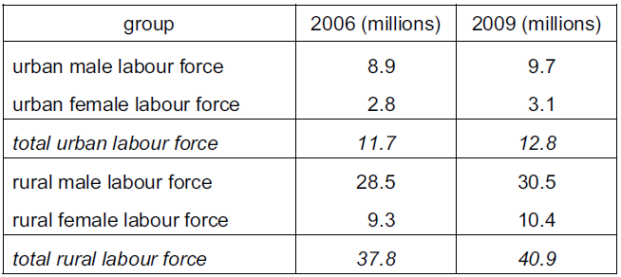

Which statement is most likely to be consistent with these statistics?
- Farming is the major employer in the economy.
- Male workers are more mobile than female workers.
- The absolute increase in the labour force is greater in urban areas than rural areas.
- The supply of female workers has fallen.
( )

Q2. Which cause of inflation is most likely to result in an increase in unemployment?
- An increase in consumer expenditure
- An increase in exports
- An increase in the cost of production
- An increase in the money supply
( )

Q3. Official statistics in 2010 showed South Africa had a very high unemployment rate at around 25%, yet wages were still double those in Brazil. What might be a reason for South Africa’s high wages in a time of unemployment compared with Brazil?
- A skilled workforce in Brazil
- High levels of savings in South Africa
- Increased use of labour-intensive production in Brazil
- Strong trade unions in South Africa
( )

Q4. The government pays a subsidy for each worker employed by a firm in an area of high unemployment. When would this policy be most successful in reducing unemployment?
- When the firm is capital-intensive
- When the firm is labour-intensive, requiring mainly unskilled labour
- When the firm provides goods to the domestic market
- When the firm requires mainly specialist, skilled labour
( )

Q5. An increase in online banking by customers using home computers has reduced the level of employment in the banking sector of developed countries. What describes this kind of unemployment?
- Frictional
- Regional
- Seasonal
- Technological
( )

Q6. The number of people unemployed in an economy fell by 600,000 and the number employed rose by 400,000. Which change could explain this difference?
- Some of the unemployed have entered full-time education.
- Some of the unemployed have experienced a loss of skills.
- The length of the working week has declined.
- The size of the labour force has increased.
( )

Q7. The table shows unemployment and inflation statistics for the US, Japan and Sweden for year 1 and year 2.
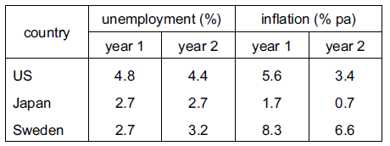

Which conclusion can be made from the table?
- In year 1, the same number of people were employed in Sweden and Japan.
- In year 1, the cost of living rose in the US.
- The number of unemployed people decreased in all three countries.
- Unemployment and inflation moved in the same direction in Japan.
( )

Q8. Many fishermen are unemployed owing to long-term legislation to conserve fish stocks in the North Sea. What type of unemployment is this?
- Demand-deficient
- Frictional
- Seasonal
- Structural
( )

Q9. Which of the following is an example of cyclical unemployment?
- An airline cuts jobs in a world recession.
- Cleaners lose their jobs as more machines are used.
- Fishermen sell their boats owing to a reduction in fish stocks.
- Hotels employ fewer people in the rainy period.
( )

Q10. The information below relates to selected countries in 2012.

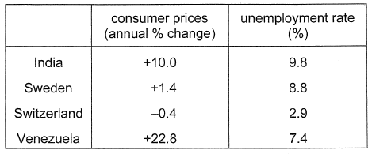

What can be concluded from this information?
- Inflation is a possible cause of unemployment.
- Inflation is the only cause of unemployment.
- Low unemployment is linked to high inflation.
- There is a uniform link between the rate of inflation and unemployment.
( )

