Economics CSQ – Wage Differences, Inflation and Unemployment

Workers in Sri Lanka

More people are being employed in Sri Lanka’s service sector. A number of skilled workers are, for instance, employed in the country’s banking industry. The manufacturing sector is also growing in importance. For example, the country’s clothing industry employs more than a quarter of a million workers out of a labour force of eight million people. Most of the workers in the clothing industry are young women, some of whom are relatively unskilled. In recent years, the industry has employed more capital goods, which has raised fixed costs as a proportion of total costs. The rise in investment has unsettled the industry and caused workers to become more concerned about their job security. Wage rates in the industry are low although bonuses increase the amount clothing workers can earn.

The largest clothing company in Sri Lanka is Brandix Lanka Limited. It uses its resources to produce both clothes and clothing accessories such as hangers. It sells its products to clothes shops in the European Union and in the United States of America. Brandix Lanka provides its workers with good medical facilities, as do many other clothing firms.

Sri Lankan workers and trade unions are pressing for wage rises for clothing workers. However, Brandix Lanka and the other clothing firms are concerned that higher wages may reduce their competitiveness against clothing firms in other countries, including Bangladesh, where wages are lower. The firms claim that increasing the wage they pay may cause unemployment and inflation. In 2010 there were half a million unemployed workers in Sri Lanka and its inflation rate was 5.9%.

Receiving higher wages might influence clothing workers in a number of ways. It might cause them to reduce the large amount of overtime they work. It may reduce the gap between their pay and the pay of bankers who, on average, are older than clothing workers. In addition, it might change their spending and saving patterns. Table 1 shows the income per head and the average amount saved per head in Sri Lanka from 2005 to 2010.

Table 1: Gross Domestic Product (GDP) per head and
the average amount saved per head in Sri Lanka 2005 – 2010

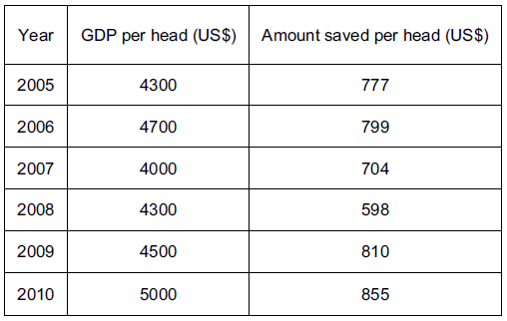

Questions
(a) What is meant by ‘fixed cost’? [2]

(b) Using a production possibility curve, explain how Brandix Lanka may allocate its resources between clothes and clothing accessories. [5]

(c) Using Table 1, comment on whether economists would expect to see the relationship shown between the changes in GDP per head and amount saved per head. [3]

(d) Using information from the extract, identify three reasons why someone may choose to work for a clothing firm despite the low wage. [3]

(e) Using information from the extract, calculate Sri Lanka’s unemployment rate in 2010. [2]

(f) Discuss whether trade unions increase unemployment. [5]

(g) Using information from the extract, explain two reasons why clothing workers are paid less than bankers. [4]

(h) Discuss whether an increase in wages paid to clothing workers will cause inflation. [6]

