Question 1

The Market for Steel

Figure 1: World price of steel
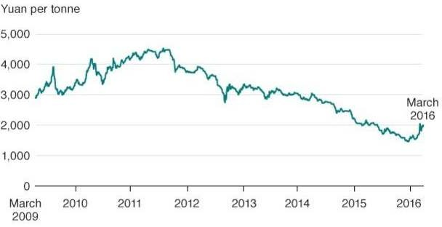

Source: Bloomberg

Extract 1: Global steel demand set to fall again in 2016: Worldsteel

Global steel demand will continue to fall this year before a slight pick-up in 2017, the World Steel Association forecast on Wednesday.

Falling demand has plunged the global steel market into crisis, with excess capacity taking a heavy toll on producers, including those in China - leading to plant closures and job losses.

Global apparent steel use - deliveries minus net exports of steel industry goods - is expected to fall 0.8 percent in 2016 to 1.488 billion tonnes after a 3 percent fall last year, according to Worldsteel.

China, which produces about half the world's steel, is under increasing international pressure to tackle a local supply glut that has led to accusations of China flooding markets with cheap steel. However, China is reluctant to do so as cutting industrial capacity will force China to lay off probably 1.8 million workers from steel and related sectors.

"The key to this year's figure is the decline in demand from China, which is responsible for half of the global demand, where a surplus in residential properties is a problem, but also weaker demand from Brazil and Russia," Worldsteel Director General Edwin Basson said.

Source: Reuters, 13 April 2016, the Straits Times, 8 March 2016

Extract 2: China tackles pollution woes

Worried by the social and political impact of pollution, China has vowed to crack down on lawbreaking companies and the local governments that protect them. As part of its war on pollution, China's traditionally underpowered environment ministry was granted new powers to send inspection teams to local regions without warning, and was also given the authority to summon senior provincial officials to explain their conduct.

During a nationwide investigation of 1,019 steel enterprises across the country, the Ministry of Environmental Protection inspectors found that 173 firms were found to have violated the country's environmental rules, with 62 firms involved in illegal construction and 35 exceeding state emission limits. 23 of the offending firms had been asked to cut production, while another 29 had been shut down temporarily to "rectify" their problems. Fines totaling 18.9 million yuan have been imposed and three officials have been detained.

Source: Reuters, 10 Oct 2016, South China Morning Post, 2 Apr 2017, FORES Study 2012:1

Questions

- i) With reference to Figure 1, describe the trend in the world price of steel between March 2009 and March 2016.

[2]

  - With reference to the case material, account for the change in world price of steel in 2015.
  - Explain and justify the value of price elasticity of supply. (2)
[4]

- i) Explain one example of negative externality which could result from steel production.
[2]

  - Explain how negative externality in steel production could lead to market failure.
[5]

  - As an economic advisor, evaluate the measure undertaken by the Chinese government (from Extract 2) in tackling the negative externalities associated with steel production and recommend an alternative policy option to the Chinese government. Justify your answer.

[10]

[Total: 25]

