J2 June Intensive Revision
CSQ – Lesson 2 – Market Failures Q2

Land transport in Singapore

Figure 1: Daily Trips Generated (1997, 2004, 2008)

Table 1: Singapore Population, GDP per Capita,
Economic Activities and Daily Trips Made

Year | Population (mil) | GDP per capita ($’000 at 2000 prices)¹ | Resident unemployment rate² | Daily trips per capita
1997 | 3.8 | 36.2 | 3.5%³ | 1.98
2004 | 4.2 | 44.2 | 4.4% | 1.97
2008 | 4.8 | 48.3 | 3.2% | 2.18
Note: Numbers are rounded off
¹From Singapore Department of Statistics website
²From Ministry of Manpower’s website
³This is 1998’s unemployment rate as the 1997 figure is not available.

Source: Land Transport Authority, Journeys, May 2010

Extract 1: Ensuring Singapore is not a city in a carpark

A good public transport system in itself will not ensure that our roads are free-flowing. Without an effective traffic management system, our roads will still be congested. This is why, in addition to the various measures that we pursue, such as road building a better transport system, we also need Electronic Road Pricing (ERP) or congestion charging. Of all the different measures to deal with congestion, ERP is the only one that deals directly with the problem by requiring individuals to take into account the costs of congestion caused by their driving to others.

Furthermore, with the introduction of ERP in 1998, the Government has been able to rely more on car usage charges and less on car ownership taxes to manage traffic demand. Vehicle ownership taxes have been reduced and, as a result, annual vehicle ownership revenue fell from $3.4 billion in 1997 to $1.7 billion in 2006 compared to about $90 million in annual ERP revenue collected during that period. ERP has thus proven to be a more effective approach to managing traffic demand, and it costs motorists much less overall. Indeed, ERP is meant to be a congestion, not a revenue measure, so if motorists drive less and the roads are smooth-flowing, the Government will be happy to collect less. In effect, ERP rates can be adjusted down as much as up, depending on the traffic speed on the roads.

Adapted from Minister for Transport, Mr. Raymond Lim’s speech, 25 August 2007

Extract 2: Small cars COE down 30%

The Certificate of Entitlement (COE) policy has sought to cap the annual increase in the car population to around 3 per cent. The supply of COEs is based on projections of how many vehicles will be scrapped in the current year.

COE prices for small cars plummeted 30% yesterday to $9,501, hitting their lowest levels in over a year. The fall follows months of softening demand which dealers say has been driven by soaring inflation. They blamed rising prices for everything from rice to fuel, along with a growing number of Electronic Road Pricing (ERP) gantries, for keeping budget-conscious small car buyers out of showrooms.

‘This group of buyers is the hardest hit by the softening economy so they may reconsider big purchases like a car,’ said Mr. Vincent Ng, the product manager for Kah Motor in Ubi.

In the latest bidding results released yesterday, the COE for cars under 1,600cc dropped from $13,289 to $9,501. It was the lowest mark since August last year, when it dove to $8,118. Some analysts blamed high petrol prices, currently at $1.963 a litre for 92-octane fuel. That is roughly a 30% rise over this time last year. Motorists have also faced about a 10% rise in parking charges over the last year.

The president of the Motor Traders Association of Singapore said new ERP gantries and a recent increase in charges may have also discouraged potential small car buyers. ‘Perhaps some marginal buyers decided not to buy a car,’ said Ms. Tan Kheng Hwee.
In July, several gantries were opened near the Singapore River and the Government announced plans to build another six across the island by November. The move was part of a wide-ranging plan to relieve congestion and encourage more Singaporeans to use public transport.

The rising costs seem to be encouraging people to hang onto their cars for longer. In the first six months of this year, about 22,400 small cars were taken off the roads, compared with over 25,800 during the same period last year. Next month, the Government is expected to reduce the COE supply to compensate for the fact that fewer cars are being taken off the roads. Industry watchers say that will likely result in higher prices.

Adapted from The Straits Times, 4 September 2008

Questions
(a)(i) With reference to Figure 1, describe the main features in the generation of trips between 1997 and 2008. [2]

(a) (ii) Using Table 1, suggest possible reasons for the features observed. [4]

(b) With the help of a demand and supply diagram, account for the change in the price of Certificate of Entitlement (COE) in Extract 2. [6]

(c) (i) What is meant by price elasticity of demand? [2]

(c) (ii) To what extent is the car sellers' revenue affected by the new COE quota? [6]

(d) Evaluate the relative effectiveness of the COE system and Electronic Road Pricing in managing traffic congestion in Singapore. [10]

Suggested Answers
(a)(i) With reference to Figure 1, describe the main features in the generation of trips between 1997 and 2008. [2]

The number of trips grew rapidly with private transport trips growing faster than public transport trips.

(ii) Using Table 1, suggest possible reasons for the features observed. [4]

Increase in population
According to Table 1, Singapore's population had grown from 3.8 million to 4.8 million between 1997 and 2008, a 26 percent increase. This has led to increase in total ridership.

Economic growthz
Real GDP per capita grew by 33 percent between 1997 and 2008. Private transport is perceived to be more of a luxury good than public transport. With higher income, the increase in demand for private transport is greater than the increase in demand for public transport. Hence, this explains why private transport trips grow faster than public transport.

(b) With the help of a demand and supply diagram, account for the change in the price of Certificate of Entitlement (COE) in Extract 2. [6]

Price of COE fell. In particular it fell by 30% for small cars (Extract 2, para 2).

Demand for COEs falls
Fall in demand for cars due to soaring inflation, rise in cost of car usage (fuel, parking charges, ERP) (Extract 2 para 2) → demand for COEs also falls.

Supply of COE is perfectly price inelastic and unchanged
Supply is perfectly price inelastic. The total number of COEs allotted is based on projections of how many vehicles will be scrapped in the current year (Extract 3 para 1) of which a certain number would be released every month for bidding

It is unchanged at the moment because it would only be next month that the supply of COE be adjusted by the Government (Extract 2 para 7)

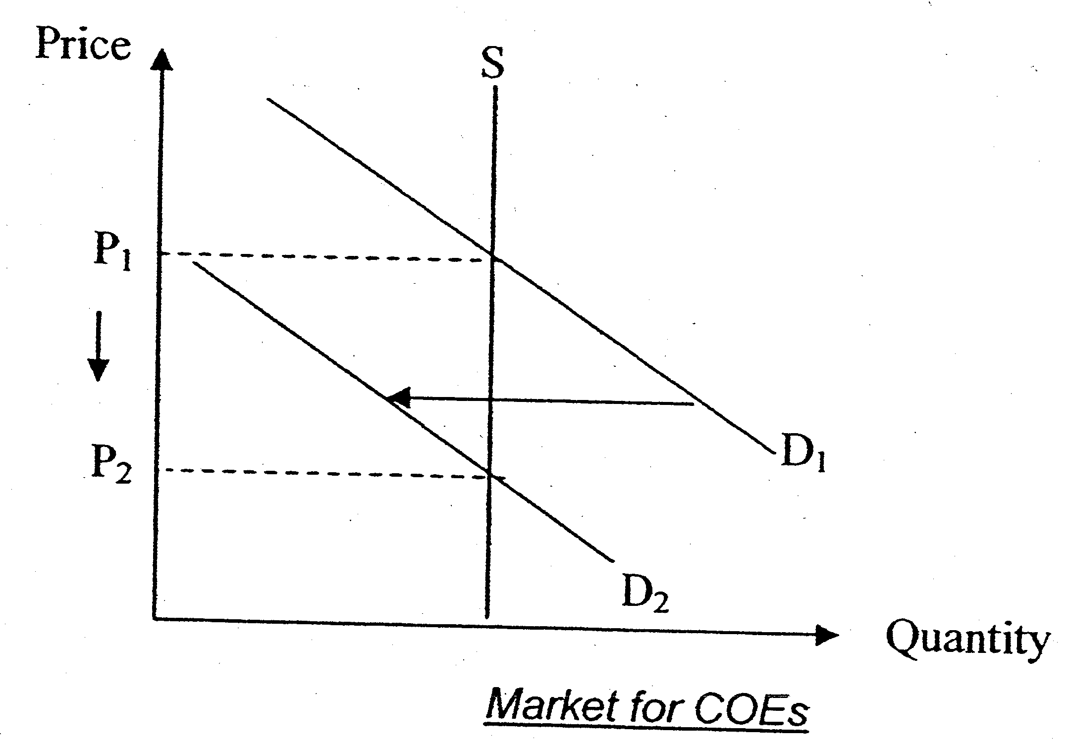

Note: Supply curve needs to be vertical to reflect the fixed amount of COEs supplied (0m for the diagram if the supply curve is upward sloping)

(c) (i) What is meant by price elasticity of demand? [2]

Price elasticity of demand measures the degree of responsiveness of quantity demanded of a good to a change in its own price, ceteris paribus.

It is measured by taking the ratio of the percentage change in quantity demanded of the good to the percentage change in the price of the good itself.

(ii) To what extent is the car sellers' revenue affected by the new COE quota? [6]

1) Explain why the new COE quota would affect the car sellers' revenue based on the price elasticity of demand of cars

In Extract 3, the new COE quota would be nearly 30 per cent smaller. This translates to higher prices of cars.

For motor traders of smaller cars, a rise in the price of cars is likely to reduce their total revenue. Demand for smaller cars (less than 1600cc) tends to be price elastic. This is because buyers of smaller cars are likely to be less affluent. As such, the cost of buying a car takes up a much larger proportion of their income. Hence, with a rise in the price of cars, the quantity demanded for smaller cars will fall more than proportionately leading to a fall in total revenue for the motor traders.

For motor traders of larger cars, a rise in the price of cars is likely to increase their total revenue. Demand for larger cars (1600cc and above) tends to be price inelastic. As buyers of such cars are richer, the cost of buying a car takes up a relatively smaller proportion of their income. Hence, with a rise in the price of cars, the quantity demanded for larger cars will fall less than proportionately, leading to a rise in total revenue for the motor traders instead.

2) Explain why the car sellers' revenue can also be impacted by other factors
However, there can be other factors, besides the new COE quota (hence higher car prices) that can affect car sellers' revenue. These are factors that shift the demand curve and are due to changes in tastes and preferences and income levels.

With a softening economy (Extract 2 para 3), the level of income falls. This would cause the demand curve to shift to the left hence reducing total revenue for all the motor traders. However, motor traders of smaller cars are likely to be impacted more as demand from buyers of smaller cars is likely to fall relatively more since this group of buyers are the hardest hit. Moreover, there can be changes in tastes and preferences towards driving.

With more new ERP gantries and a recent increase in parking charges (Extract 2, para 5), people may have shifted their preferences towards public transport instead. This would reduce the demand for cars and subsequently total revenue
for all the motor traders.

Evaluation
In conclusion, the impact on car sellers’ revenue has to be analysed from many factors, not just the new COE quota.

(d) Evaluate the relative effectiveness of the COE system and Electronic Road Pricing in managing traffic congestion in Singapore. [10]
Why manage traffic congestion in Singapore? [Brief]
- How traffic competition leads to market failure in road industry
- Road competition negative externalities
- ↑rise of external costoverproduction rise of DWL
- Correct market failure due to congestion

Explain how COE and ERP work
i) COE:
- Quota system which limits the growth of the car population based on the number of vehicles taken off the road in the preceding six-month period (Extract 3)
- Targets at car ownership to reduce traffic congestionreduce Qty of road usage from Q_{m} to Q_{s} (↓size of car population)
- It is a lump-sum payment to increase the fixed cost of driving. It does not vary with number of trips made.

ii) ERP
- ERP raises the cost of road usage↓SS of road usage↑P ↓Qty dd from Q_{m} to Q_{s}
- Works by charging drivers an amount when they enter congested areas/roads during peak hours
- Targets at car usage as it allow people to own cars but only penalises those who enter congested roads
- It is a pay-per-use principle to increase the private marginal cost of driving
- Illustrate with externalities diagram how ERP works to bring the level of road usage closer to the socially optimal level
COE is more effective than ERP in managing traffic congestion
COE directly controls the car population in Singapore which will manage the number of cars using the road and enabling the government to control road usage while ERP merely directs the traffic congestion to alternative routes.

Setting the size of car population will make it easier for the government to see the output of road usage at social optimal level while the ERP is unable to ensure that road usage is at social optimal level since the tax duty may not adjust to internalize the external cost as the government can estimate the extent of external marginal cost.

COE can be a strong deterrence to car ownership and thus reduces the size of car population which will lower demand for road usage especially after the introduction of huge percentage upfront cash payment which will raise the financial cost for car ownership. On the other hand, ERP may not be effective to reduce demand for road usage as ERP charge occupies only a small percentage of proportion of consumers’ income (demand for road usage is price-inelastic).

ERP is more effective than COE in managing traffic congestion
ERP can conduct allocation of road usage based on time and route allocation but COE cannot control the allocation. ERP is more effective as it tackles the root cause of traffic congestion.

ERP can be adjusted to the external marginal cost as it is a variable cost that adjusts to the nature of demand. However, COE will only encourage me road usage as it is a fixed charge whereby drivers will drive more to reduce the average COE charge per trip.

Evaluation
Both methods have their strengths and weaknesses. But in controlling congestion, it would be more effective if we were to target car usage and to reduce the incentive for commuters to travel by car or if they still wish to travel by car, to choose to go by a different route instead. Moreover, as mentioned in Minister's speech, ERP is the only one that deals directly with the problem by requiring individuals to take account the costs of congestions.

However, this does not mean that these are the only methods to manage traffic congestions. The government needs to supplement these with road building/widening and better public transport system.

COE is more effective than ERP in managing traffic congestion
COE directly controls the car population in Singapore. On the other hand, ERP does not control the car population in Singapore. It merely reduces traffic congestion in areas with ERP and diverts the problem to other roads along alternative routes not covered by ERP, hence causing traffic congestions elsewhere.

It is easier to determine the allotment of COEs as there is a "formula" to follow. On the other hand, it is difficult to estimate the extent of external marginal cost for ERP and thus the tax rate may not be accurately determined.

Relatively lower cost of implementing COE system as opposed to high costs of setting up the gantries.

As price of the COE is of a much larger amount, people are more likely to be deterred from buying a car. On the other hand, once a car is bought the amount deducted by ERP may seem relatively "insignificant" and people may not feel the pinch. Hence, demand for travel on affected roads becomes price inelastic after a while as the convenience outweighs the ERP charge. This result in a less than proportionate fall in quantity demanded for road usage given a rise in ERP charges.

ERP is more effective than COE in managing traffic congestion
COE does not control the usage of cars (which is the main cause of congestion) as car owners may view COE as a fixed cost and may wish to spread out the cost over more trips. It may encourage more usage. On the other hand, ERP is more effective as it tackles the root of the problem which is excessive usage of some roads.

Moreover, the determination of allotment of COE can be flawed. The previous system of allotting COE had led to an almost 25% increase instead of the target annual 3% increase in vehicle population in the past five years. On the other hand, ERP is a more flexible and responsive instrument which can be periodically adjusted down or up depending on the traffic speed on the roads (Extract 1).

Evaluation
Both methods have their strengths and weaknesses. But in controlling congestion, it would be more effective if we were to target car usage and to reduce the incentive for commuters to travel by car or if they still wish to travel by car, to choose to go by a different route instead. Moreover, as mentioned in Minister's speech, ERP is the only one that deals directly with the problem by requiring individuals to take account the costs of congestions.

However, this does not mean that these are the only methods to manage traffic congestions. The government need to supplement these with road building/widening and better public transport system.

