Question 2
The economics of ageing population

Extract 5: Young people wanted in Europe

Population projections published by the European Commission in 2015 highlighted that between 2013 and 2030 the euro zone’s working-age population will decline by 6%. As the working-age population falls, the ranks of pensioners will be growing. Both these forces will push up the old-age dependency ratio which is defined as those aged 65 or more relative to 20-to 64-year-olds. The demographic change is especially intense in Germany, where the number of pensioners will rise by 5 million (an increase of 30%) even as the working-age population falls by over 6 million. That will drive up its dependency ratio from 34% to 52% in 2030—the highest in Europe. Ageing population is threatening Europe’s largest economy.

Figure 4: Demographic indicators: old-age dependency ratio & working population changes (%), 2013 - 2030

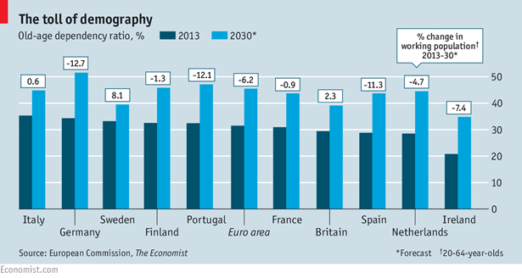

Source: The Economist, 6 June 2015

Extract 6: The Japanese solution
Many governments are watching keenly as Shinzo Abe, the Prime Minister elected in 2012 on a platform of economic rejuvenation takes on Japan’s economic mess. What the economy needs is not simply growth, but growth fast enough to allow Japan to come to grips with its massive public debt.
Japan will run a structural budget deficit of more than 5% of GDP this year. After a rise in the country’s consumption tax in April of 2014, from 5% to 8%, both household spending and GDP tumbled, leading the government to postpone a second rise to 10% that had originally been scheduled for October of this year. An analysis published in 2013 estimated that stabilising Japan’s debt would require tax revenues of between 30% and 40% of total consumption, equivalent to a consumption tax rate of about 60%. As more Japanese workers retire, domestic saving is falling and spending on the old soaring. Even a modest rise in borrowing costs could bring insolvency.
At current growth rates, any big tax rises or spending cuts would tip Japan straight back into recession. Yet generating faster growth is a tall order. Supply-side reforms could be more vigorous. Yet the scope to improve productivity in Japan is smaller than might be imagined.
Source: The Economist, 7 Nov 2015

Extract 7: Ageing population has macroeconomic benefits?
A paper from Morgan Stanley reckons that there may be positive dramatic impacts from ageing population in the developed world. Ageing population will create additional demand for labour, as illnesses such as dementia will require more care workers. This will start to push real wages higher, raising labour’s share of national income and reducing inequality. Also, as the elderly save less and spend more of their income, savings are bound to fall. In a slow-growing economy there will be fewer profitable investment opportunities but the paper argues that investment will not fall as fast as savings because rising wages will encourage companies to substitute capital for labour. Also, because the elderly tend to stay put in their homes, residential investment will not fall significantly due to demand from new families.
Source: The Economist, 6 June 2015

Extract 8: Ageing population poses both challenges and opportunities
Prime Minister Lee Hsien Loong urged world leaders to see an ageing population as a force that can power economies. While the phenomenon of ageing population poses challenges to many countries, it also brings opportunities for societies that are willing to look at longevity with more friendly eyes. He said “we need to transform our societies and economies to become more age-friendly, and turn longevity into a positive force for economic and social development."
To adapt to ageing trend, Singapore is transforming in three ways. Firstly, to help seniors stay active and healthy for longer, the government is raising the re-employment age further, to 67 years old, and is also providing financial incentives for companies to make jobs and workplaces more senior-friendly. The SkillsFuture initiative for example gives workers credits for courses they can take to upgrade themselves at any age.
Second, safety nets in housing, retirement adequacy and healthcare were also strengthened to give seniors peace of mind. The Central Provident Fund (CPF) ensures retirement adequacy, and the Medishield Life, is a universal healthcare insurance which will help to cover large hospitalisation expenses for life. Lastly, infrastructure - in public transport, public housing, and parks - are being refreshed for the elderly to move around the city independently, confidently and freely. Source: The Straits Times, 19 Nov 2015

Extract 9: With population ageing, Singapore must become a manpower-lean economy
Manpower Minister Lim Swee Say says Singapore must become a manpower-lean economy due to its ageing population. The government is trying to spread the mind-set of lean enterprises, industry and services. He noted that small and medium enterprises (SMEs) must become manpower-lean because they employ two-thirds of the Singapore workforce.
Source: The Straits Times, 27 April 2016

Questions

(a) (i) With reference to Figure 4, identify the country which appears to face the least challenge to the size of its future labour supply. Explain the basis of your choice. [2]

(ii) Using AD/AS analysis, explain two ways in which ageing population in Germany might threaten the country’s future economic growth. [6]

(b) Explain why it is likely that the government and not the private sector would finance the provision of infrastructure for the elderly population. [4]

(c) With reference to Extract 7, comment on the view that ageing population would reduce income inequality. [4]

(d) With reference to Extract 8, discuss the macroeconomic opportunities which ageing population might bring about to Singapore economy. [6]

(e) In light of the problems of massive public debt and weak economic growth which the Japanese economy is facing, discuss the merits of raising consumption tax to tackle these problems. [8]
[Total: 30 marks]

